DATE: December 5, 2023

TO: David Stoms (CEC CAM)

FROM: Leroy Westerling, Workgroup #4 Lead, Pyregence Project (and Workgroup #4 members)

RE: Summary of Scenarios and Climate Simulation Used for Pyregence Long-term Wildfire Models

The purpose of this this memo is to summarize vegetation management and urban growth scenarios that will be used for modeling long-term wildfire hazards and the rationale used to select climate model simulations.

Background
Workgroup 4 of the Pyregence project has initiated model simulations to generate projections of wildfire hazards, biomass, urban land cover, and carbon. The models and approach used for projecting future conditions related to these outputs have been updated since the Fourth California Climate Change Assessment but will similarly simulate potential future wildfire vulnerabilities under a range of projected climate scenarios, and under different land use and vegetation management scenarios. Pyregence is undertaking this work through an EPIC grant (#EPC-18-026) administered by the California Energy Commission, with the goal of producing outputs related to projected wildfire hazard, vegetation, and carbon for use in California’s Fifth Climate Change Assessment.

Future Climate Conditions and Relevance to Planning Discussion
Long-term CO2 emissions scenarios provide useful context on the direction and severity of potential GHG emissions, atmospheric and temperature changes by the end of the century (Figure 1). However, utility and State planning time frames to manage California’s exposure to (and ability to adapt to) climate change tend to be shorter - extending only through mid-century at most (e.g., 2065). With respect to anticipating future conditions, exploring the effects of variability in drought and precipitation extremes coupled with nearer-term trends in temperature more generally are most meaningful to stakeholders.

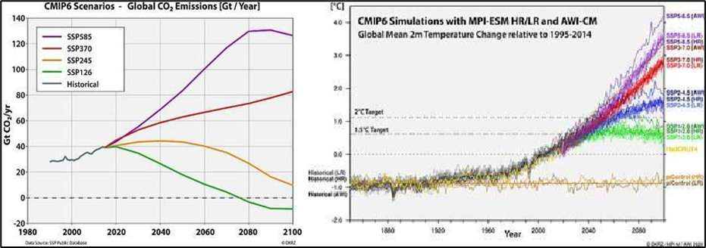
Figure 1: Coupled Model Intercomparison Project 6 (CMIP6) Emissions (left panel) and Temperature (right panel) Scenarios through End of Century.

Over a longer term, uncertainties related to unanticipated changes in population and urban development (e.g., people moving from urban to rural areas during a pandemic) and global emissions trajectories can dramatically impact end of century wildfire risks and our exposure to them. These uncertainties can limit the usefulness of planning now for end-of-century fuels management. Part of the challenge in designing future scenarios related to urban development patterns and the pace and scale of vegetation management is to balance information from end-of-century projections, with mid-century planning horizons, and with the realities of even nearer-term issues that need to be addressed now. For example, long term trajectories of global emissions scenarios vary a great deal (Figure 1, left panel). Emissions change the timing and end point of global temperature increases and they have a similar relationship with global mean temperature outcomes (Figures 2). The range of temperatures is most striking at the end of the century. Over the next several decades, however, the impact is modest compared to the potential impact on wildfires of different scenarios for drought over the same time period. Regional and more local scenarios for variability in precipitation will help us to explore impacts of drought variability coupled with temperature trends on wildfire through mid-century (Figure 3).

Because stakeholders are more interested in relatively shorter planning horizons and due to timing and funding considerations, Workgroup 4 plans to model more simulations through mid-century than to the end of the century.

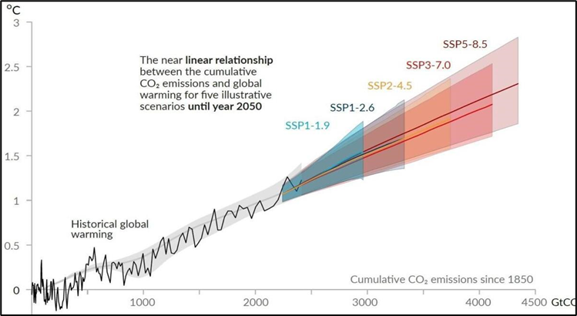
Figure 2. Global Temperature Increase as a Function of Cumulative CO2 Emissions

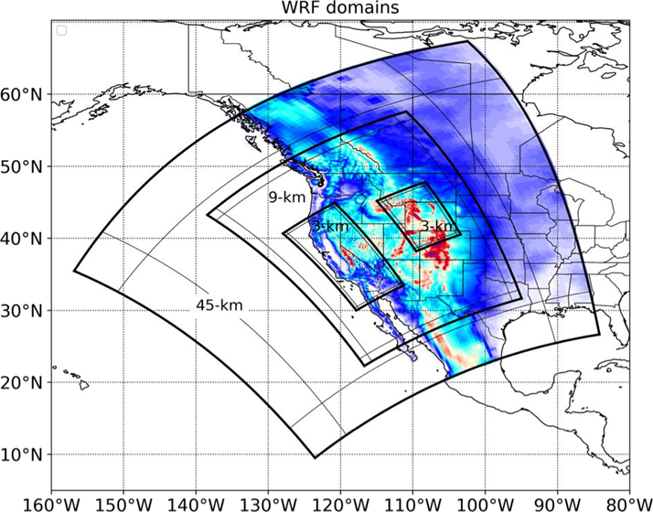
Figure 3. Granularity of Climate Scenarios

Summary of Vegetation and Urban Growth Scenarios
The state and federal governments are working together to manage vegetation to improve the health of forests, protect rural communities, and reduce the risk of megafires through thinning and prescribed fire. Because this vegetation management is expected to profoundly affect wildfire risk, the options for it are incorporated into the wildfire modeling workflow. For vegetation management, we vetted the following two scenarios with the project’s Technical Advisory Committee and other stakeholders:

- High Ambition Vegetation Management Scenario - This scenario models forest treatments to meet a goal of one million acres treated per year, a goal identified in a 2018 Executive Order and emphasized in the 2021 California Wildfire and Forest Resilience Action Plan; the plan prioritizes reducing fuels (i.e., through vegetation management) in areas classified by Pyrologix as “high” or “very high” wildfire hazard potential.
- Business-As-Usual (BAU) Vegetation Management Scenario - This scenario represents an attempt to sustain the vegetation management/treatment approach/effort from the previous decade (2010-2019). As such, the total average annual treatment rate across the state is approximately 440,000 acres per year, or 55 percent less activity than the high ambition scenario.

Under each scenario noted above, the model will prioritize reducing wildfire risk through vegetation management at the wildland-urban interface (WUI) and in areas designated with high wildfire threat. Under this vegetation management prioritization scheme, WUI areas with high fire threat classification would be prioritized for fuels reduction treatment first. As those acres are completed, areas beyond the WUI that are classified as high fire threat would be addressed next and so on. For the Fourth Climate Assessment, only “large” fires over 1,000 acres in size were simulated. For the Fifth Assessment, we will use a smaller fire size threshold for large fires since we are mapping our own burn severity products and using fire perimeter data from CAL FIRE, which spans a broader fire size range. In either case, we are excluding most observed fires because most fires are very small and quickly controlled and have a modest overall impact.

In addition to vegetation management scenarios, we have identified two development footprint scenarios for use in wildfire model simulations, including:
- “Sprawl”: a scenario based on historic urban growth patterns and represents ‘business as usual’ urban sprawl development pattern. Under this scenario, development would be allowed to occur throughout areas designated as the Wildland Urban Interface (WUI).
- “Concentrated/Infill”: this scenario represents a concentrated/infill development pattern that limits development to within or directly adjacent to existing development.

Urban growth scenarios are based on the anticipated magnitude of new development (“transition targets”), the adjacency of new urban development relative to existing developed areas (“spatial adjacency”), and the concentration of growth relative to land use type (“spatial multiplier”). Transition targets for scenarios would be based on historical rates of development that are specified for each county based on California Farmland Mapping & Monitoring Program (FMMP) data. Future projections would draw stochastically from the full range or a subset of years (to emphasize a future with high growth or low growth) in each time step. This determines “how much” or the “demand” for newly developed lands to be modeled. Figure 4 and 5 shows the resulting total developed lands (Figure 4) and annual new urbanization (Figure 5) from LUCAS model, with the amount of new development in each year between 2021–2050 as sampled from the full historical record of urban development patterns.
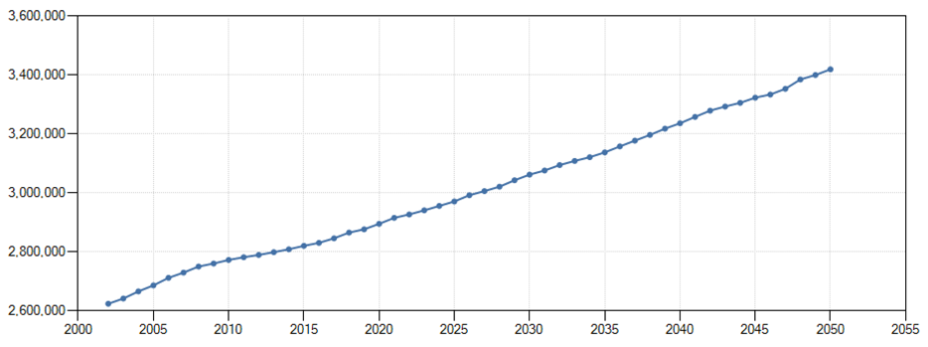
Figure 4. Total state classes area developed (hectares)

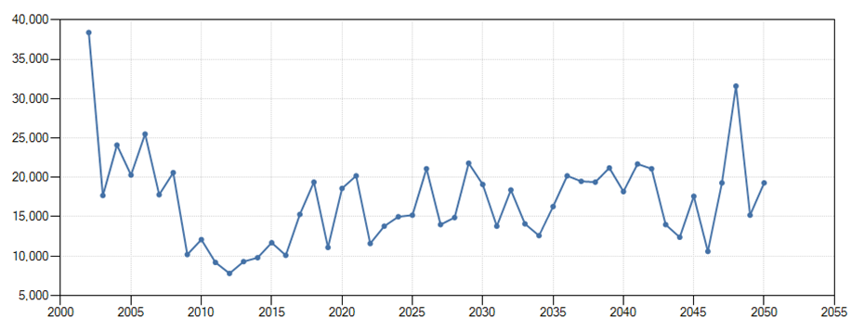
Figure 5. Annual Statewide Transitions Area to Urbanization (hectares)

The developed demand for each urban growth scenario will be allocated to the landscape within each county. Allocation of urban development for each scenario will be determined by the spatial adjacency parameters and spatial multipliers.

Selection of Climate and Emission Simulations
The following describes the rationale that the Pyregence team used for selecting climate model simulations as inputs for wildfire risk projection models. In selecting climate scenarios to prioritize for wildfire simulations, we applied the following principles to filter 129 downscaled climate simulations produced by UCSD Scripps:

- Weather variables (e.g., temperature, precipitation) that are required for wildfire simulation models must be available in climate scenario datasets (this filter reduced the number of climate scenarios from 129 to 68).
- The final number of climate scenarios should be tractable for wildfire simulations to be produced over the next year.
- Climate simulations must span most of the climate scenario outcomes through mid-century (through 2064) and will be classified as “Tier 1” scenarios, n=5.
- Climate simulations include mid-century climate extremes, such as drought and precipitation extremes (and classified as Tier 1 & 2a).
- Climate simulations represent high-quality/skilled models as determined by Scripps (Tier 1 & 2a, n=8).
- Climate simulations include at least scenarios that have been dynamically downscaled (i.e., hourly WRF data) and have necessary variables available in both dynamical and statistical downscaling (Classified as “Tier 2b,” n = 1).
- Climate simulations represent significant variability in end of century climate (Tiers 1, 2, and 3).

Guided by these principles and an evaluation of GCM simulations (below), a total of 11 priority climate simulations, representing a range of available emission scenarios, were prioritized for wildfire simulations (Table 1). The remaining climate simulations, classified as “Tier 4,” were not prioritized for the Pyregence project but have the full suite of variables downscaled that are needed wildfire models (n = 57 climate simulations). Notably, we did not explicitly select different Shared Socioeconomic Pathways (SSP) as a principle to include for priority GCM simulations but instead plotted temperature and precipitation values for mid-century and end of century for two locations in California (Lake Tahoe and San Diego) to confirm representation of a full range of possible future conditions, regardless of SSP. Nonetheless, the finalized prioritized list of climate simulation resulted in good representation of SSPs (Table 1).

Table 1. List of downscaled climate model simulations that meet selection principles and associated SSP.
Tier | Climate Simulation/Scenario | Associated SSP
1 | ACCESS-CM2_ssp245_r1i1p1f1 | SSP2-4.5
1 | EC-Earth3-Veg_ssp245_r5i1p1f1 | SSP2-4.5
1 | MPI-ESM1-2-HR_ssp245_r1i1p1f1 | SSP2-4.5
1 | MRI-ESM2-0_ssp370_r4i1p1f1 | SSP3-7.0
1 | HadGEM3-GC31-LL_ssp585_r3i1p1f3 | SSP5-8.5
2a | ACCESS-CM2_ssp585_r1i1p1f1 | SSP5-8.5
2a | INM-CM5-0_ssp245_r1i1p1f1 | SSP2-4.5
2a | HadGEM3-GC31-LL_ssp585_r1i1p1f3 | SSP5-8.5
2b | EC-Earth3-Veg_ssp370_r4i1p1f1 | SSP3-7.0
3 | CNRM-ESM2-1_ssp585_r1i1p1f2 | SSP5-8.5
3 | EC-Earth3-Veg_ssp585_r4i1p1f1 | SSP5-8.5

The following figures help to illustrate the range of selected priority GCM simulations that will be used for projecting mid- and end-of-century wildfire hazards across the range of available SSPs.

Figure 6 compares mid-century changes in precipitation and daily maximum temperature of different GCM simulations at Lake Tahoe across 68 downscaled climate scenarios, highlighting the range of selected GCM simulations by tier group.

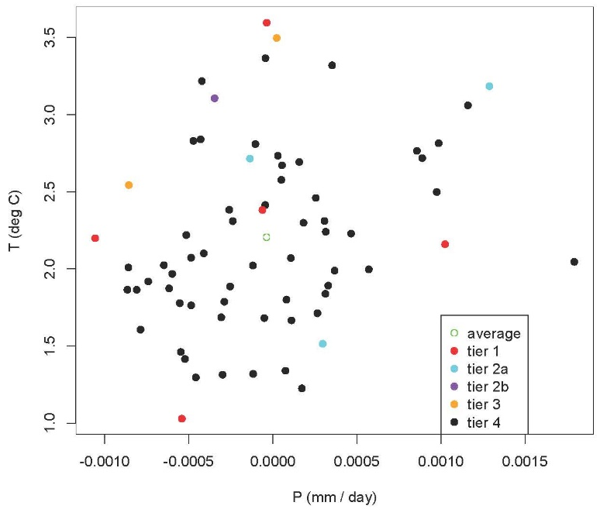
Figure 6. Comparing mid-century changes (1961 to 1990 vs 2035 to 2064) in precipitation (mm/day) and daily maximum temperature (degree C) at Lake Tahoe, California across 68 downscaled climate scenarios.

Figure 7 compares end-of-century changes in precipitation and daily maximum temperature of different GCM simulations at Lake Tahoe across 68 downscaled climate scenarios, illustrating the range of selected GCM simulations by tier group.

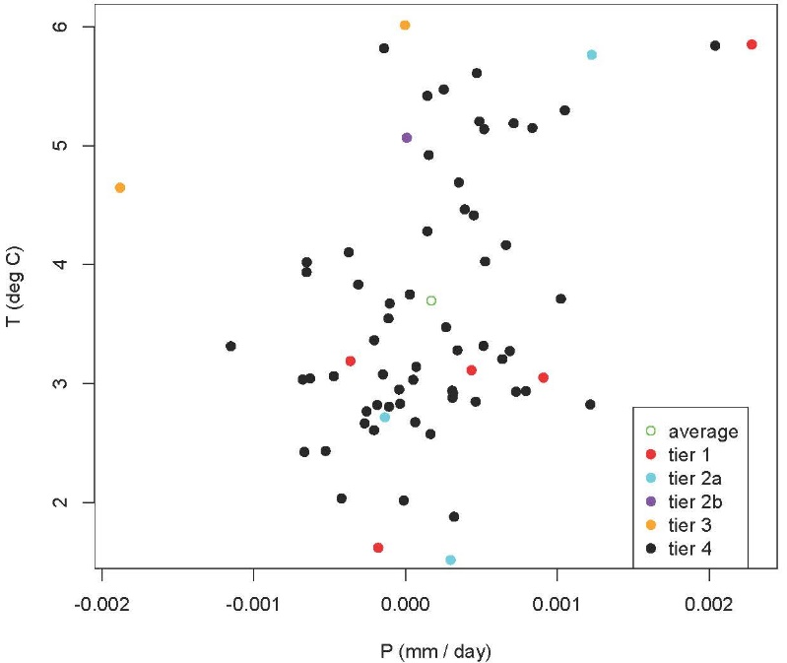
Figure 7. Comparing end-of-century changes (1961 to 1990 vs 2065 to 2100) in precipitation (mm/day) and daily maximum temperature (degree C) at Lake Tahoe, California across 68 downscaled climate scenarios.

Figure 8 compares mid-century changes in precipitation and daily maximum temperature of different GCM simulations at San Diego, CA across 68 downscaled climate scenarios, illustrating the range of selected GCM simulations by tier group.

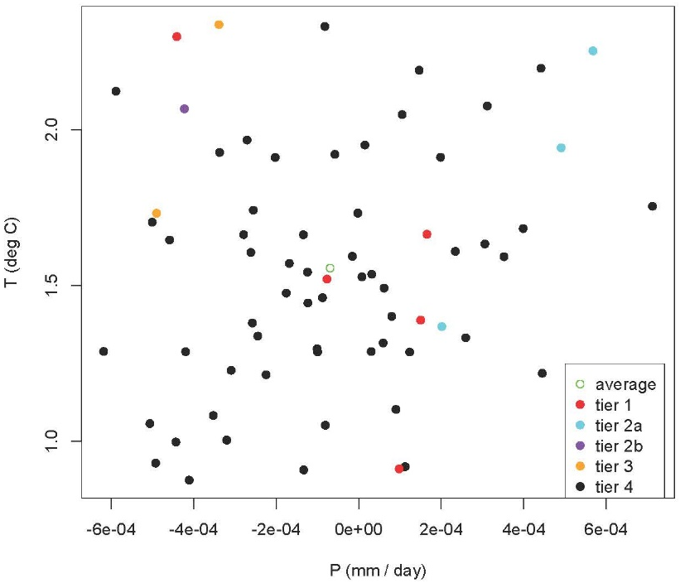
Figure 8. Comparing mid-century changes (1961 to 1990 vs 2035 to 2064) in precipitation (mm/day) and daily maximum temperature (degree C) at San Diego, California across 68 downscaled climate scenarios.

Figure 9 compares end-of-century changes in precipitation and daily maximum temperature of different GCM simulations at San Diego across 68 downscaled climate scenarios, illustrating the range of selected GCM simulations by tier group.

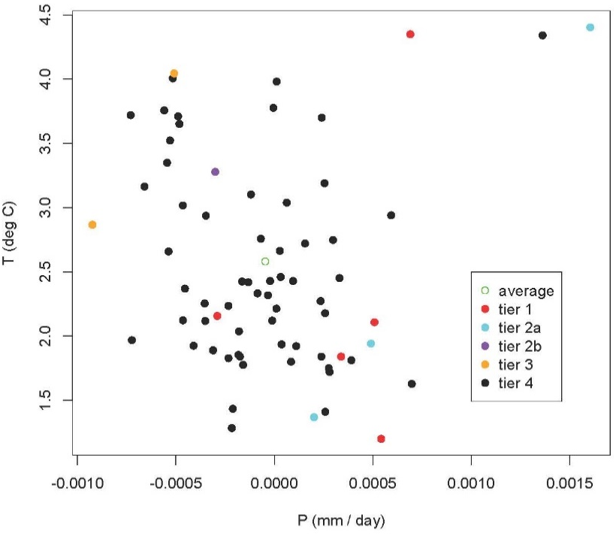
Figure 9. Comparing end-of-century changes (1961 to 1990 vs 2065 to 2100) in precipitation (mm/day) and daily maximum temperature (degree C) at San Diego, California across 68 downscaled climate scenarios.

Running average maximum temperature (Figures 10 and 11) and annual precipitation (Figures 12 and 13) from 1950 to 2100 at Lake Tahoe and San Diego, CA for priority GCM simulations (Tier 1 through Tier 3) helped to further demonstrate the range of conditions that will be used to model wildfire hazards across California.

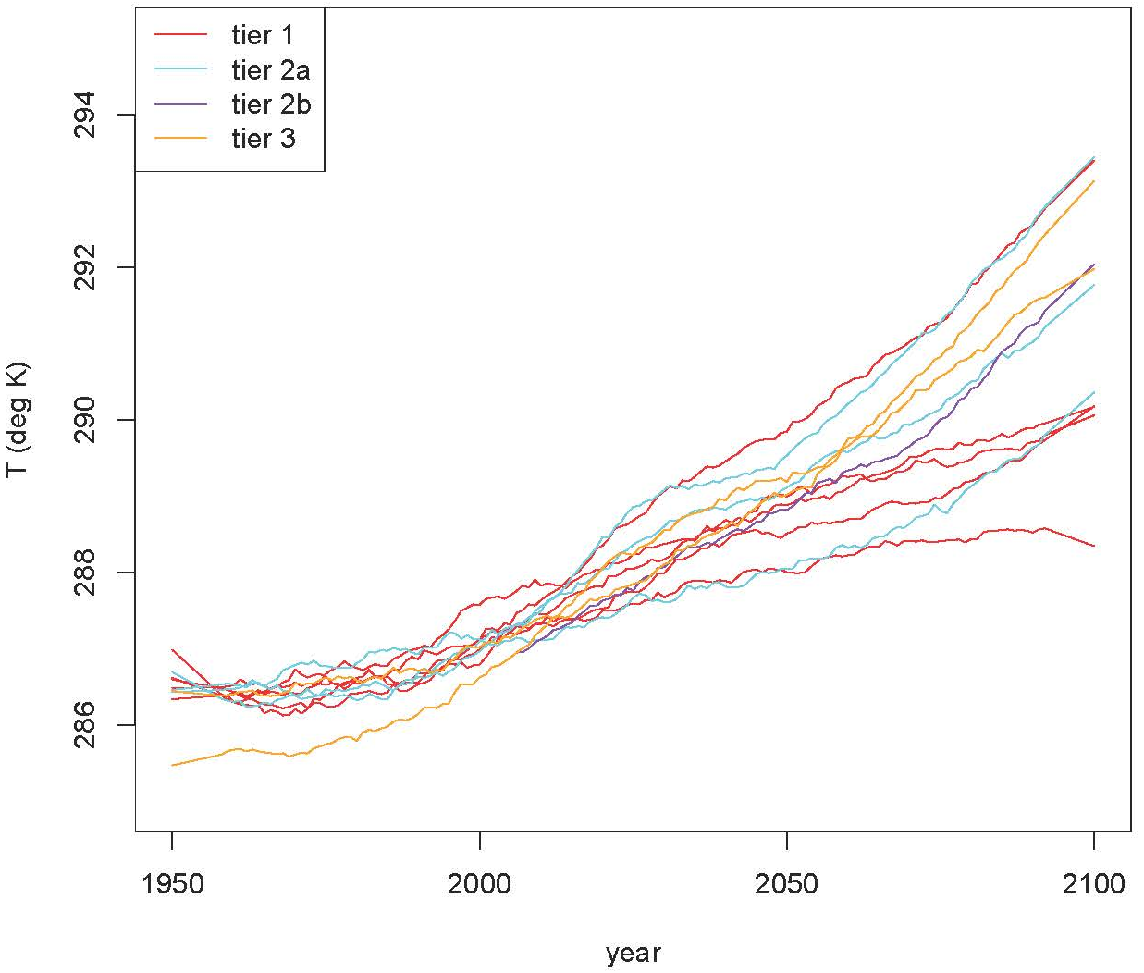
Figure 10. Annual average maximum temperature (degree C) for 11 priority climate scenarios at Lake Tahoe, CA, smoothed with a 15-year window to reduce year-to-year noise (1950 to 2100).

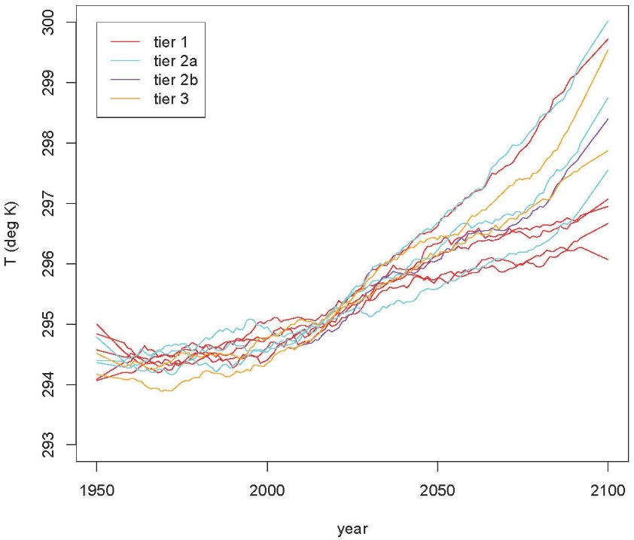
Figure 11. Annual average maximum temperature for 11 priority climate scenarios at San Diego, CA, smoothed with a 15-year window to reduce year-to-year noise (1950 to 2100).

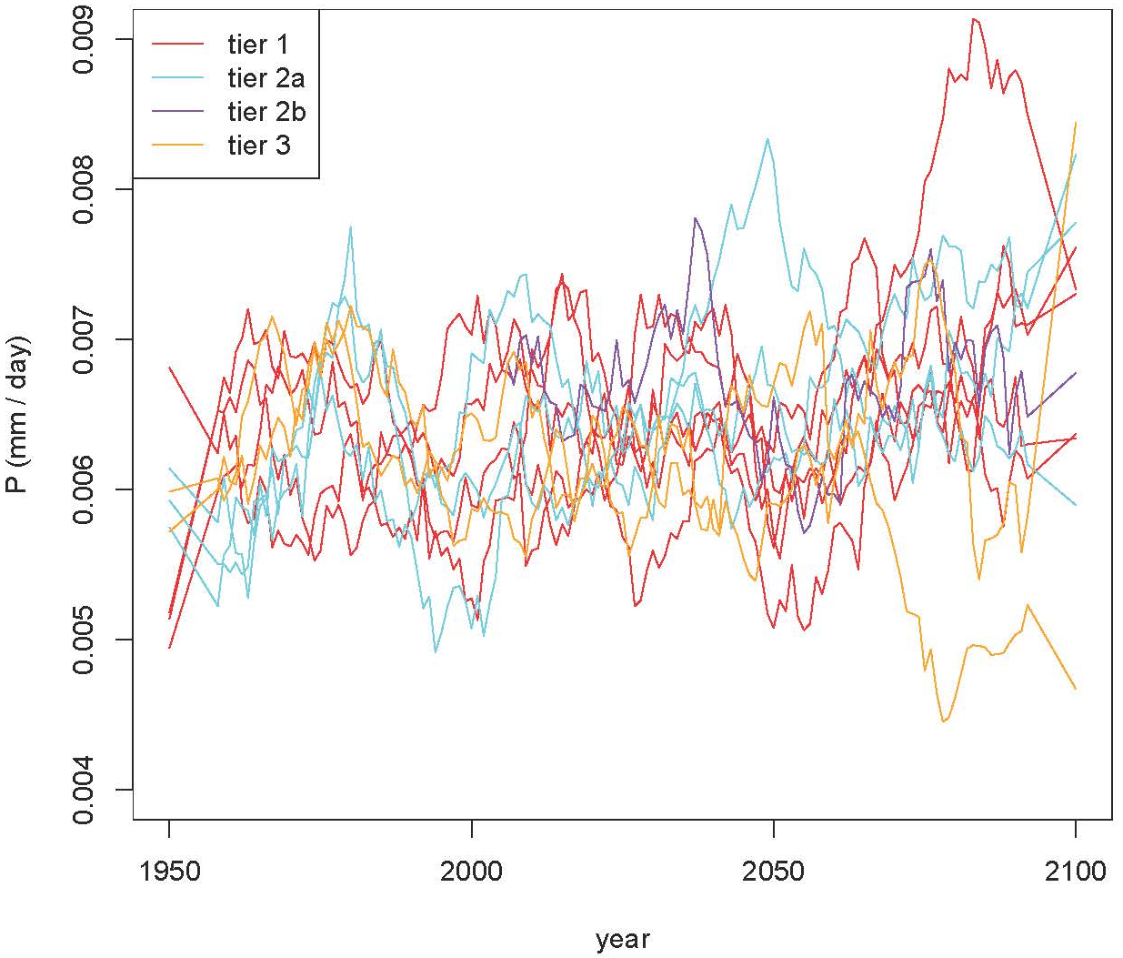
Figure 12. Annual average precipitation (mm/day) for 11 priority climate scenarios at Lake Tahoe, CA, smoothed with a 15-year window to reduce year-to-year noise (1950 to 2100).

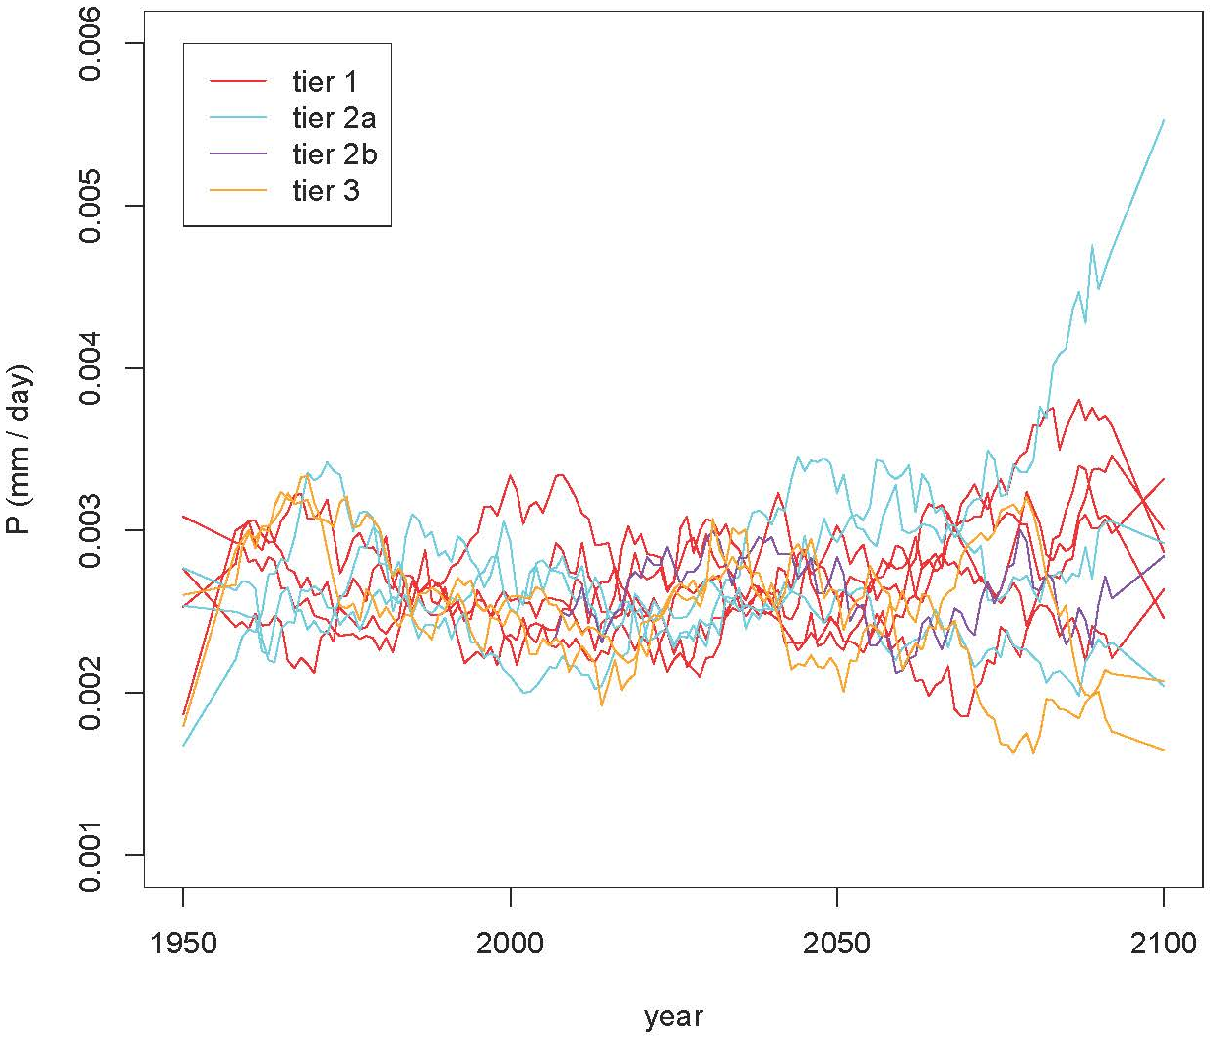
Figure 13. Annual average precipitation (mm/day) for 11 priority climate scenarios at San Diego, CA, smoothed with a 15-year window to reduce year-to-year noise (1950 to 2100).

A full factorial of climate simulations (n = 11), and development (n = 2) and vegetation treatment (n = 2) scenarios using identified Tiers 1-3 climate scenarios, would result in 44 wildfire model simulations, which is likely not tractable given time and budget constraints for the project (Table 2). Instead, we plan to focus on the production of wildfire simulations using Tier 1 climate simulations (n = 5) in combination with urban growth and vegetation management scenarios, with a resulting factorial of wildfire simulations as follows:

- 5 climate “Tier 1” climate scenarios x 2 development x 2 vegetation treatment scenarios = 20 combined scenarios (Table 1).

Table 2. List of downscaled climate model simulations that meet selection principles identified by the project team and the scale of wildfire modeling that will be conducted for the Pyregence project. Full factorial will model each climate simulation with two vegetation management scenarios and two urban growth scenarios.
Tier | Climate Simulation/Scenario | Scale of Wildfire Modeling Effort
1 | EC-Earth3-Veg_ssp245_r5i1p1f1 | Full Factorial
1 | MPI-ESM1-2-HR_ssp245_r1i1p1f1 | Full Factorial
1 | HadGEM3-GC31-LL_ssp585_r3i1p1f3 | Full Factorial
1 | ACCESS-CM2_ssp245_r1i1p1f1 | Full Factorial
1 | MRI-ESM2-0_ssp370_r4i1p1f1 | Full Factorial
2a | INM-CM5-0_ssp245_r1i1p1f1 | Concentrated Urban Growth/High Ambition Vegetation Management
2a | HadGEM3-GC31-LL_ssp585_r1i1p1f3 | Concentrated Urban Growth/High Ambition Vegetation Management
2a | ACCESS-CM2_ssp585_r1i1p1f1 | Concentrated Urban Growth/High Ambition Vegetation Management
2b | EC-Earth3-Veg_ssp370_r4i1p1f1 | Concentrated Urban Growth/High Ambition Vegetation Management
3 | CNRM-ESM2-1_ssp585_r1i1p1f2 | Concentrated Urban Growth/High Ambition Vegetation Management
3 | EC-Earth3-Veg_ssp585_r4i1p1f1 | Concentrated Urban Growth/High Ambition Vegetation Management

In addition, for Tiers 2a, 2b, and 3, we anticipate simulating these six climate scenarios with the “concentrated” development scenario and the “high-ambition” treatment scenario (for a total of 6 additional combined socio-climate scenarios; Table 2). We chose the business as usual (high sprawl) and concentrated development growth scenarios to highlight how concentrating future development footprints could reduce the risk of losses to property and infrastructure in the future. We had originally proposed using high sprawl and concentrated development pattern scenarios, with stakeholders indicating that the ‘high sprawl’ scenario should be considered as the Business-as-Usual growth scenario (i.e., representing an extrapolation of current practice/policy - which engenders high sprawl) rather than a hypothetical (and perhaps unrealistic) case with even greater sprawl than historically observed. We believe the two approaches represent plausible future conditions, with a spectrum of outcomes possible between them. It should be noted that for each time a simulation is run using one of these approaches, it has a different time and spatial evolution of the development footprint because the urban growth model is stochastic. So even with just these two scenario types (BAU and concentrated), analysis of the resulting simulations will provide detail about the impact of development in any one location.

In the end, we are prioritizing 26 initial combined vegetation/urban/climate scenarios for mid-century wildfire risk simulation by June 30, 2024. The selected climate simulations and scenarios span a wide range of climates at mid- and end-of-century, including different timing and intensity of persistent precipitation extremes over the next few decades, as well as exploring a range of policies regarding urban development density and the scale of fuels treatment efforts. Of these 26, we will select approximately 4 for wildfire simulation, representing a range of possible futures, through the end of century, with the remainder simulated through 2064.

Anticipated Model Outputs
Outputs produced for this effort will be based on output generated by 3 different models including Landis II, LUCAS, and UC Merced - Westerling’s statistical wildfire projection model (“Fire Risk Simulation Model” or FRSM). The following is a list of expected data outputs that will be produced by the Pyregence Team.

UC Merced (Westerling) Fire Risk Simulation Model Outputs:
Outputs listed below will be produced for California state boundaries for each combination of 1) climate simulations, 2) urban scenarios, and 3) vegetation management scenarios identified in Table 1.

Simulated Fire-related Outputs
- Fire Size/Area - 3 km gridded monthly simulated large fire area burned by ignition point.
- Number of Fires - 3 km gridded annual per pixel enumeration of model fire occurrence.
- Fire Presence - 3 km gridded monthly simulated large fire ignitions and 3 km gridded monthly probability of large fire presence.
- Fire Severity - 3 km gridded monthly simulated large fire areas burned by severity class (distribution of low, moderate, and high severity fire fractions), mapped by ignition point.
- Smoke Emissions - 3 km gridded monthly simulated smoke emissions (does not include transport estimates).

Land Use and Carbon Scenario Simulator (LUCAS) Model Outputs
The LUCAS model tracks changes in land use, land cover, land management, and disturbance, and their impacts on ecosystem carbon storage and flux. LUCAS will be coupled with the UC Merced Fire Risk Model to produce fire related outputs under different urban growth, vegetation management and climate simulations. Outputs will be available as tabular summaries (summarized by ecoregion, county, and ownership) as well as spatial maps (on an annual timestep).

LUCAS specific output will be 1-km resolution annual maps and probabilities of the following:
- Land Use and Land Cover
- LULC Change
- Carbon
- Forest Age
- Carbon Stocks (for 11 pools),
- Carbon Fluxes (all flows between pools),
- Net Carbon Fluxes
  - Net Primary Productivity (NPP)
  - Net Ecosystem Production (NEP)
  - Net Ecosystem Carbon Balance (NECB)

Landis II Outputs:
Outputs listed below will be produced for each region at an annual cadence using the Landis II model, including: 1) Southern Sierra Nevada, 2) Northern Sierra Nevada, 3) Modoc, 4) Klamath, 5) Mendicino, and 6) Central/Southern California Coast (Figure 14). Notably, Landis II is not being run with the same coupling to the statistical wildfire model because the revisions to this version of Landis II would require revising Landis II software language. However, we are conducting test runs of LUCAS (coupled and uncoupled with the statistical fire model), Landis II (uncoupled), and LUCAS coupled with the fire module built into the Landis II model and comparing the results/outputs for both fire and vegetation. If we learn anything from that with regards to Landis II that makes us think the fires are not behaving as we would expect, we could revisit that decision, but in any event, we will publish a thorough comparison of how the models behave in the various modes.
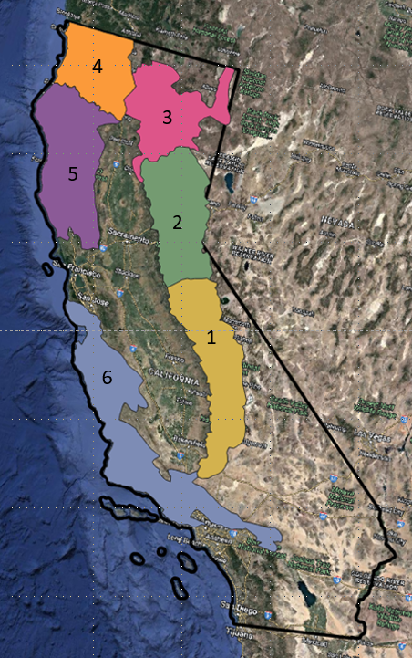
Figure 14. Regions that will be modeled with Landis II - 1) Southern Sierra Nevada, 2) Northern Sierra Nevada, 3) Modoc, 4) Klamath, 5) Mendicino, and 6) Central/Southern California Coast

Tabular Outputs
Biomass
- Treelist (aboveground biomass by species and age cohort for each cell)

Carbon pools:
Live
- Leaf
- Wood
- Fine root
- Coarse root
Dead
- Wood
- Coarse root
- Fine root metabolic
- Fine root structural
- Leaf metabolic
- Leaf structural
Soil
- SOM1 surface (duff)
- SOM1 soil (0-20cm depth)
- SOM2 soil (21-150cm depth)
- SOM3 soil (>150cm depth)
Landis II Fire Outputs:
- Initial ignition weather conditions
- Number of cells burned
- Average fire intensity
- Biomass mortality
Insect Outputs:
- Insect type
- Biomass mortality
- Climate thresholds
Harvest Outputs:
- Harvest by management area
- Harvest by prescription
- Cohorts harvested
- Total biomass harvested
- Biomass by species harvested

Mapped Outputs (at 150m resolution)
Live:
- Total Carbon
- Total aboveground biomass
- Species level Aboveground Biomass Carbon (ABG, 42 different species)
Dead:
- Dead wood (biomass)
- Litter (biomass)
- Duff (biomass)
Soil:
- Total Soil Carbon
- Soil Nitrogen
Other Map Outputs:
- Net Primary Production (NPP)
- Net Ecosystem Exchange (NEE)
- Leaf Area Index (LAI)
- Available water
Fire Map Outputs (using Landis II Fire Sub-model):
- Julian day-of-year of fire event
- Fine fuels consumed by fire
- Ignition type
- Differenced Normalized Burn Ratio (dNBR)
- Fire intensity
- Fire spread probability
- Biomass consumed by flaming front (used in calculating emissions)
- Biomass consumed by smoldering (used in calculating emissions)
Harvest map outputs:
- Harvest event by prescription type
- Total biomass removed by harvest event.

Volger, K. C., A. Brough, C. J. Moran, J. H. Scott, and J. W. Gilbertson-Day. 2021. Contemporary Wildfire Hazard Across California. Prepared by Pyrologix, LLC. for the Pacific Southwest Region, USDA Forest Service.
Spatial Adjacency: A stationary set of variables which dictates that new developed cells are more likely to occur next to existing developed cells, based on time-distance decay theory. Spatial adjacency multipliers are updated every 5 timesteps within a model simulation.
Spatial Multipliers: A custom spatial map (or time series) developed exogenous to the LUCAS model which provides complete control over how pixels within the study area may be affected by new development.

