Projected Surface Fuels from Tree Mortality in the Sierra Nevada
Forest diebacks linked to extreme droughts are expected to increase as the climate dries and warms. An example is the 2012–2016 hotter drought in California that induced widespread tree mortality in the Sierra Nevada, California. The sudden increase in snags (i.e., standing dead trees) raised concerns about their impact on wildfire hazard and longer-term questions about their effect on ecosystem structure and function. WG2 quantified the likely progression of snag fall and fuel succession following the recent extensive mortality event in the southern Sierra Nevada mixed conifer forest.
They used data from two complementary studies in Yosemite, Sequoia, and Kings Canyon national parks: the Drought Mortality Network and the Forest Demography Study (Study areas shown in Figure 2). The Drought Mortality Network installed tree and fuel inventory plots across the Sierra Nevada to monitor the consequences of the 2012-2016 drought mortality event (Axelson et al. 2019). A major objective of this monitoring effort was to quantify how recently dead trees influence fuel loads and fire hazard. The Forest Demography Study includes long-term forest plots where trees are censused annually for mortality and periodically for diameter growth (Das et al. 2016). To answer the questions posed, they integrated results from both datasets. They used the extensive, long-term snag database from the Forest Demography Study to develop high quality snag fall models. Results from the Drought Mortality Network allowed them to document the immediate and predict future impacts of drought-induced tree die-back.

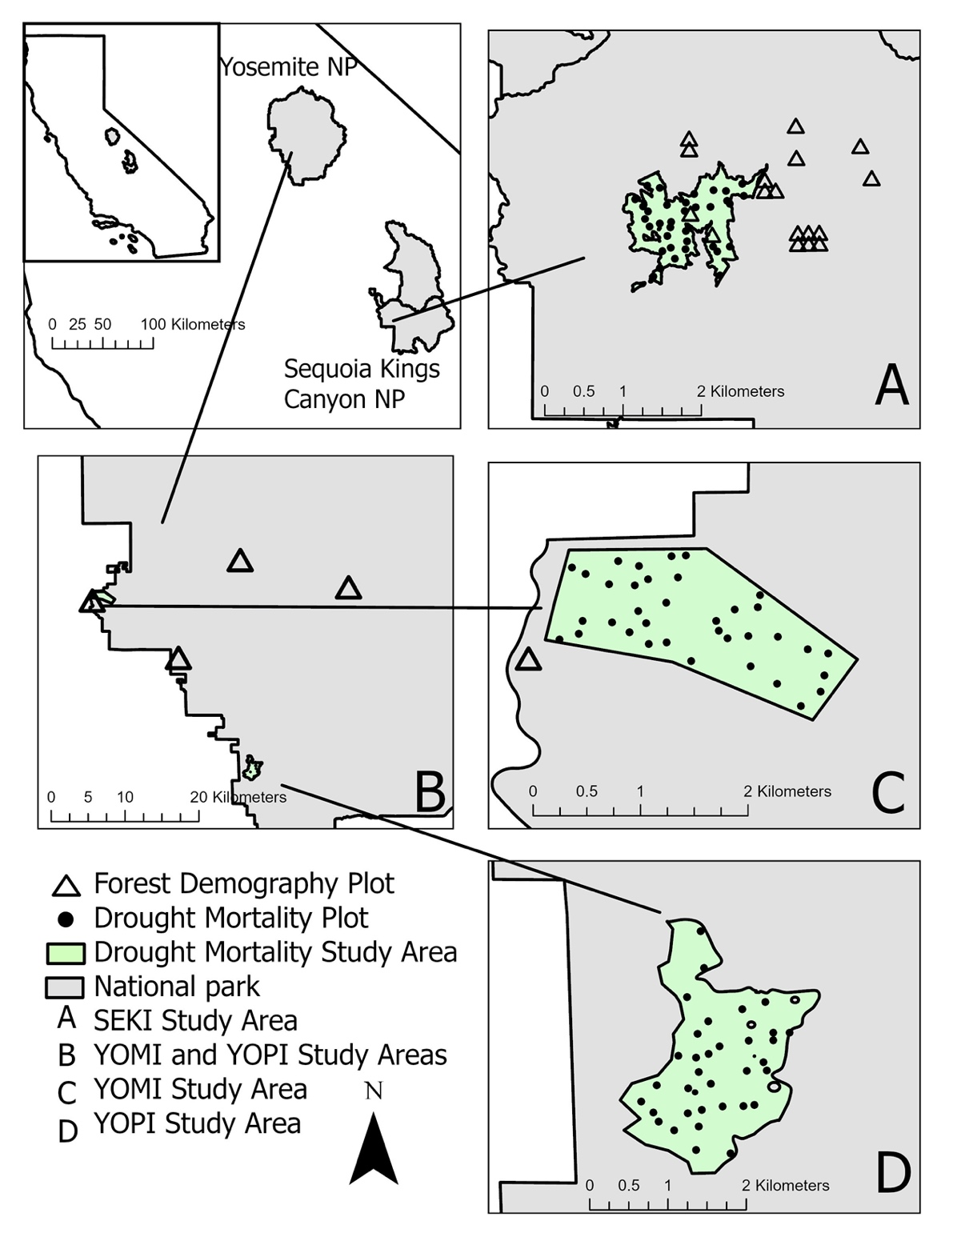
Figure 2. Location of study areas and plots from the two datasets used in this study: the Forest Demography Study (0.9 to 2.5 ha) and Drought Mortality Monitoring plots (0.05 ha). Northrup et al. 2023).
In the short term (2017–2021), fine woody debris and litter plus duff significantly increased across all three Drought Mortality sites (>145% and >55%, respectively); coarse woody debris increased significantly at one site (48.6%); and total fuel loads increased significantly at two of the three sites (38% and 69%). Snag (standing dead trees) longevity increased with size, with the relationship varying by species. Yellow pine was a notable outlier: size played a small role in influencing its fall rates. Overall, species-specific snag fall rates in the southern Sierra Nevada were 20% to 40% slower than previously reported. By 2040, projected median cumulative inputs of biomass from future snag fall range from 49.4 Mg ha⁻ ¹ to 136.1 Mg ha⁻ ¹ across our three sites, which exceeds the amounts currently present (47.2 – 90.0 Mg ha⁻ ¹) and is well above estimates of historical coarse woody debris amounts in the Sierra Nevada (17.7 Mg ha⁻ ¹). These results provide a robust empirical basis to refine the snag fall algorithm in vegetation simulation models (e.g., Forest Vegetation Simulator [FVS]). Options to manage the impact of extreme number of snags and their large surface combustible biomass include salvage operations and prescribed burning, with both methods having operational, financial, and legal limitations that need to be considered. Additional details of this research can be found in Northrop et al. (2024).
To quantify how fuel loading varies as function of tree mortality, they used the models developed in Hudson et al. (2024) to estimate fuel accumulation rates across stands with different levels of drought mortality. They focused these efforts on one intensively studied landscape in Sequoia Kings Canyon National Parks (SEKI). Specifically, the area of interest (AOI) is a 17 km² site dominated by Sierra Nevada mixed conifer forest. The AOI is located in the Kaweah River watershed in Sequoia National Park (approximately 36.76° N by 118.80° W) between 1,500m and 1,850m elevation (Stephenson et al., 2019; Figure 3). The climate is Mediterranean, with mean annual temperature approximately 10°C and annual precipitation of 110-140cm falling approximately half as snow (Stephenson et al., 2019). Based on the CALVEG classification system (Vegetation Classification and Mapping, 2022), the AOI is dominated by the following vegetation alliances: “Mixed Conifer – Pine” (1,160 ha, 68% of the AOI), “Black Oak” (224 ha, 13%), and “Canyon Oak” (130ha, 8%). For this study, we restricted sampling to the “Mixed Conifer – Pine” alliance, the most widespread conifer alliance in the southern Sierra Nevada. Constituent species of this alliance are ponderosa pine (Pinus ponderosa) and sugar pine (Pinus lambertiana), alongside white fir (Abies concolor), incense-cedar (Calocedrus decurrens), knobcone pine (Pinus attenuata), and various hardwoods such as black oak (Quercus kelloggii). Mountain misery (Chamaebatia foliosa), whitethorn ceanothus (Ceanaothus cordulatus), whiteleaf manzanita (Arctostaphylos viscida ssp. mariposa), and greenleaf manzanita (Arctostaphylos patula) are important understory shrub species (USDA Forest Service, 2009). Mixed conifer forests across the southern Sierra Nevada experienced extensive tree mortality following a severe drought from 2012-2015 Fettig et al., 2019; Stephenson et al., 2019).
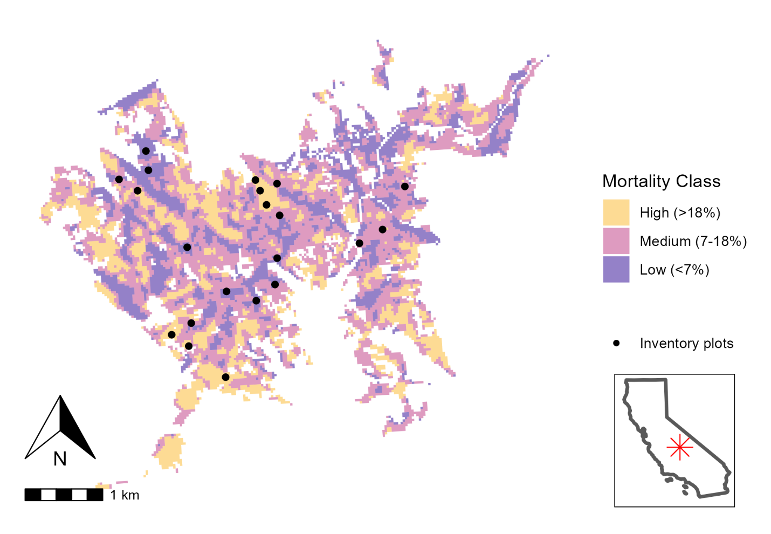
Figure 3. Area of interest, drought mortality classes, and plot locations. Area of interest (CALVEG-mapped mixed conifer forest - pine from 1,500-1,850 m elevation) shown with colors indicating the level of cumulative drought mortality from 2012-2016 as mapped by the (smoothed) eDaRT data product. Plot locations shown as black points. Plots were randomly located within the core area of each zone of drought mortality and limited to locations 50-600m from a road or trail. Inset shows position of the study site within California state boundaries. Foster (2023).

Geospatial analysis of remote sensing data was used to randomly place twenty-one inventory plots across three levels of drought mortality severity within the AOI using a random stratified sampling design. Drought mortality severity was assessed using the magnitude of mortality index (MMI) data product from the Ecosystem Disturbance and Recovery Tracker (eDaRT) system. eDaRT uses a time series of LANDSAT data to detect and quantify mortality events of overstory vegetation (Koltunov et al., 2020). MMI provides an estimate of cumulative overstory percent-cover mortality at a 30m resolution for a specific 5-year period. Given the importance of drought-induced mortality, they used the 5-year period that bracketed the start and end of the historic hotter drought in California, namely 2012 - 2016 (Stephenson et al., 2018). The MMI raster was smoothed by taking the mean over a 90m-by-90m window and clipped to just the Mixed Conifer – Pine vegetation alliance. Continuous MMI values were binned into low (<25th percentile, 0-7% cumulative mortality), medium (25-75th percentile, 7-18% cumulative mortality), and high (>75th percentile, 18-100% cumulative mortality) categories (Figure 3). Finally, pixels of the same category were aggregated into polygons and a 30m inward buffer on each polygon was used to identify core zones of each mortality class.
They summarized contemporary fuel loads (2021) and projected fuel input (sensu Northrup et al. 2024) by mortality class using plots in our Drought Mortality Plot Network. In our AOI, approximately 25% of the mixed conifer forest was in the low and high mortality classes; the remaining 50% was in the medium mortality class (Table 1). The distribution of plots roughly followed the distribution of mortality classes: they had 9 plots each in the low and high mortality areas and 13 in the medium mortality areas (Table 2). This gradient in drought-induced mortality translated into an order-of-magnitude difference in standing dead woody tree biomass. The low mortality class sites had on average 20 Mg ha⁻¹ of woody biomass in drought-killed snags while the high mortality class sites had 176 Mg ha⁻¹ of snag biomass (Table 1).

Table 1. Drought-induced mortality gradient at the intensive research site at Sequoia Kings Canyon National Park. Snag mass results from 2021 forest and fuel inventories.
Mortality Class | Area (ha) | Proportion (%) | Snag Mass (Mg ha⁻¹)
High | 295 | 25 | 176
Moderate | 585 | 50 | 77
Low | 287 | 25 | 20

Table 2. Ground and surface fuel loads (Mg ha⁻¹) by mortality class. Results for 2021 from the intensive research site at Sequoia Kings Canyon National Parks.

The contemporary fuel loads across the mortality gradient in the AOI are among the highest observed in the Sierra Nevada (Table 2, Vilanova et al. 2024). Total fuel loads (ground and surface) ranged from 133.4 Mg ha⁻¹ in the low mortality stands to 161.8 Mg ha⁻¹ in the medium mortality stands. However, across all mortality classes, so called heavy fuels (duff and 1000+hr) account for more than 2/3 of the total fuel load (69% to 74%) with duff and 1000+hr fuels contributing equal proportions. In absolute terms, woody fuel loads range from 68.1 Mg ha⁻¹ in the medium mortality class stands to 54.5 Mg ha⁻¹ in the low mortality class stands (Table 2).
Woody fuel input from snag fall and degradation in the high mortality sites increased the woody fuel load from 60.7 Mg ha⁻¹ in 2021 to 100.7 Mg ha⁻¹ in 2030 – an increase of 40 Mg ha⁻¹ (Figure 3). In contrast, the net increase in woody fuel load in the low mortality sites was only 2.3 Mg ha⁻¹. Note that these predictions of woody fuel accumulation not only account for the decay of snags with time (Northrup et al. 2024) but also account for the decay of downed wood using estimates of loss rates from Harmon et al. (2005). Woody fuel inputs for all mortality classes peaked between 2031 (moderate mortality) and 2034 (low mortality). The maximum fuel observed was 146 Mg ha⁻ ¹ in 2039 in the high mortality sites (Figure 4).

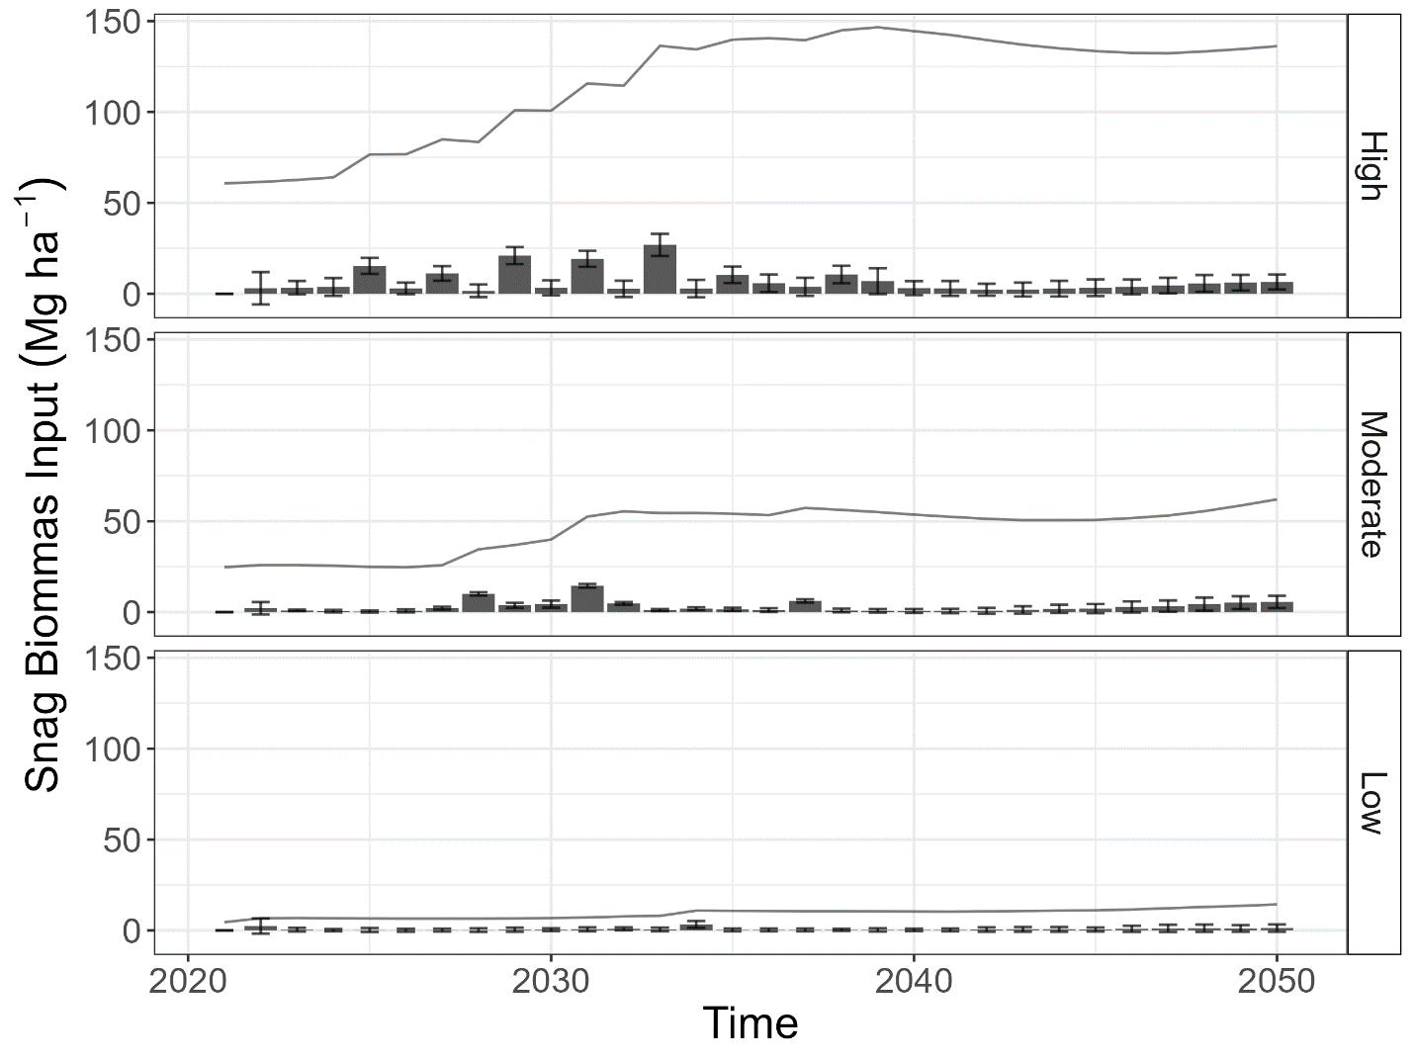
Figure 4. Forecasted biomass inputs over time based on standing snags in 2021 and model predictions by Mortality Class, based on median modeled fall rates and wood decay rates. Bars depict forecasted annual biomass input from snag fall, the error bars depict standard error of annual biomass input, and the lines depict total woody fuel load. Mortality classes defined as: High > 18% cumulative mortality; Medium = 7-18% cumulative mortality, and Low = < 7% cumulative mortality.

