ENERGY RESEARCH AND DEVELOPMENT DIVISION
Extreme Weather Historical Analysis Report
March 28, 2025


PREPARED BY:

Janice Coen
University of San Francisco/ NSF National Center for Atmospheric Research)

Andreas Prein
ETH, Zurich (formerly NSF National Center for Atmospheric Research)

David Saah, Ph.D.
Principal Investigator
Spatial Informatics Group, LLC

Shane Romsos
Project Manager
Spatial Informatics Group

David Stoms, Ph.D.
Contract Agreement Manager
California Energy Commission

Agreement Number: EPC-18-026

Alex Horangic
Branch Manager
SUSTAINABILITY AND RESILIENCE BRANCH

Jonah Steinbuck, Ph.D.
Director
ENERGY RESEARCH AND DEVELOPMENT DIVISION

Drew Bohan
Executive Director

DISCLAIMER
This report was prepared as the result of work sponsored by the California Energy Commission (CEC). It does not necessarily represent the views of the CEC, its employees, or the State of California. The CEC, the State of California, its employees, contractors, and subcontractors make no warranty, express or implied, and assume no legal liability for the information in this report; nor does any party represent that the uses of this information will not infringe upon privately owned rights. This report has not been approved or disapproved by the CEC, nor has the California Energy Commission passed upon the accuracy or adequacy of the information in this report.

Acknowledgements
Funding for this project was provided by the California Energy Commission under contract agreement number EPC-18-026. The project team would like to sincerely thank the California Energy Commission for its support of this research and in particular Susan Wilhelm (Program and Project Supervisor, Sustainability and Health Energy Research and Development Division) and Commission Agreement Managers Alex Horangic and David Stoms for their guidance throughout the project.

Pyregence Project Team
The Pyregence Project Team (often referred to as the “Pyregence Consortium”) is advancing scientific knowledge of wildfires and building next generation forecasting tools. Guided by an open-source philosophy, the Consortium is making the tools free and available to all, while also providing access to all underlying model inputs and datasets. Largely funded by a grant from the California Energy Commission, the Consortium is composed of leading researchers from 18 institutions across industry, academia, and government, as well as software developers and designers. Learn more about our work at https://pyregence.org/.

Table of Contents
1
Acknowledgements i
Key Findings 1
Executive Summary 3
1. Introduction 4
2. Methodology 5
2.1 Extreme Weather and Fire: Identifying Fire Weather Types in California 5
2.2 Microscale Analysis of California Wildfire Events 6
3. Results 8
3.1 Historical Weather Type Analysis 8
3.2 Microscale Analysis of California Wildfire Events 10
3.3 Integrated Multiscale Interpretation of Factors Contributing to Exceptional Fire Growth and Implications for Trends in Fire Risk 13
4. Addressing User Needs and Stakeholder Engagement 15
4.1 Methodology for Identifying Optimal Location and Configurations of Weather Stations 15
5. Discussion: Rethinking Climate-Wildfire Relationships - Beyond Heat and Drought 17
6. Conclusions: Advancing Wildfire Resilience Through Integrated Fire-Weather Research 18
7. References 19

Key Findings
The goal of this work was to identify and understand the extreme weather patterns that have historically driven major wildfires in California and assess how those patterns might shift under climate change. The research supports grid resilience and wildfire preparedness. A multiscale approach was used with the following highlighting key findings

Large-Scale Analysis:
- Identified region-specific Fire Weather Types (WTs) using historical fire data and climate simulations (1900–2100).
- Found 2–4 high-impact WTs per California region, tied to seasonal and geographic fire behavior trends.
- Projected changes:
  - Some fire types (like Santa Ana and Diablo winds) may decline due to greenhouse gas impacts.
  - Others (like thermal low-pressure systems) may increase, particularly in summer and coastal regions.

Microscale Analysis:
- Simulated 22 historic wildfires using the CAWFE model, which integrates terrain, wind, and fire dynamics at ~370m resolution.
- Revealed wind “hot spots” and fine-scale airflows (e.g., canyon winds, pulsing gusts) that are invisible to standard models or station networks.
- Demonstrated that wind patterns - not just fuel loads - drive extreme fire behavior.

Major Findings
- Extreme fire growth occurs when multiple factors align: dry fuels, specific weather patterns, terrain-driven airflow, and ignition timing.
- Standard weather stations and forecasting tools are too coarse to capture dangerous, small-scale wind phenomena.
- Localized wind pulses (e.g., in Tubbs and Camp Fires) were critical to fire spread but are poorly represented in existing tools.
- Climate change is altering when and where certain fire-supportive weather conditions occur, not just making things hotter or drier.

Forecasting & Preparedness Recommendations
- Expand high-resolution modeling like CAWFE for operational use.
- Optimize weather station placement in topographic hotspots (e.g., canyons, ridgelines) to capture key wind dynamics.
- Standardize station configurations and integrate vertical wind profiling to improve data quality.
- Improve coordination for station siting and permitting, especially in high-risk areas.

Executive Summary
This workgroup sets out to identify the typical weather patterns that have historically contributed to major wildfire growth across California. By understanding the environmental conditions behind past high-impact fire events and the mechanisms through which they grew, the goal was to build a framework for anticipating future wildfire risk—both in the short term (where and when dangerous fire weather is likely to occur) and long term (how climate change may shift the frequency of these conditions).

A key barrier to progress has been the disconnect between two common approaches: event-scale fire modeling, which examines specific fires in detail, and broad-scale statistical analyses, which assess long-term climate trends. To bridge this gap, the team used a two-scale approach. At the large scale, the project analyzed decades of historical weather data to identify major fire-supportive weather patterns in eight distinct California regions. These patterns were then evaluated against future climate projections to assess how their frequency might change due to natural variability, greenhouse gas emissions, and aerosol effects.

In parallel, the team conducted high-resolution coupled weather - fire behavior simulations of dozens of past fires, capturing the fine-scale interactions between terrain, wind, and fire behavior. These simulations revealed specific wind-driven scenarios—such as localized wind extrema in mountain valleys or atop lesser hills —that played a central role in fire ignition and spread. Critically, these dangerous airflow patterns often occurred at scales too small for traditional forecast models or weather station networks to detect. In several cases, these wind “hot spots” aligned with known utility ignition locations, underscoring the importance of fine-scale fire weather modeling for grid safety.

One of the study’s key insights is that extreme wildfire risk is not merely a matter of hotter and drier conditions. Instead, it arises when multiple factors align - fuel conditions, localized weather, and ignition timing and location - under broader shifts in climate patterns such as changes in the jet stream. This integrated, multiscale view offers a more realistic foundation for forecasting, planning, and adapting to future wildfire challenges.

1. Introduction
This report summarizes the methodologies and key findings developed under project CEC EPC-18-026: Comprehensive Open Source Development of Next-Generation Wildfire Models for Grid Resiliency. The primary objective of this research was to analyze and model how extreme weather influences wildfire behavior, with a particular focus on historical wildfire events in California.

Unlike prior analyses, this report explicitly addresses the intricate relationship between weather patterns and wildfire occurrences. By emphasizing the complexity of these interactions, we underscore the necessity for advanced modeling approaches to enhance both our comprehension and predictive capabilities regarding wildfire risk, especially in the context of climate change and its impacts.

2. Methodology
The team used a two-pronged approach to analyze extreme weather and wildfire events:
- Coarse-Scale, Automated Analysis: Utilizing historical weather data to identify regional weather patterns and correlations with major fire events across California.
- Manual, Fine-Scale, Targeted Analysis: Conducting detailed examinations of specific fire events to understand the intricate dynamics and environmental factors at play.
Finally, by integrating these two approaches, the team aimed to provide a comprehensive analysis that captured both the large-scale patterns and the finer details essential for understanding wildfire behavior and its impact on the electrical grid, both the past and future.

2.1 Extreme Weather and Fire: Identifying Fire Weather Types in California
To better understand and anticipate wildfire risk, the project team developed a method to identify specific weather patterns—referred to as fire weather types (WTs)—that are associated with days with large wildfire growth across California. This work combined fire data, weather reanalyses, and climate model simulations and built on methods described in Prein et al. (2022).

Fire Activity Data
To support this effort, the team assembled a comprehensive dataset of wildfire behavior from 1980 to 2018, including fire size, location, and daily growth. More recent burned area estimates (2001–2019) were sourced from satellite fire detection data provided by the Global Wildfire Information System (GWIS).

Weather and Climate Data
To identify the weather conditions associated with rapid fire spread, the team analyzed daily weather patterns using the ERA5 global reanalysis dataset, a leading source of historical atmospheric data. From this, they evaluated 31 weather variables known to influence fire behavior. To examine how these weather patterns have changed—and may change in the future—the team analyzed trends across eight key fire regions using long-term climate datasets (spanning 1900 to 2100) and considered both historical trends and climate change scenarios, including the influence of greenhouse gases and aerosols.

Identifying Extreme Fire Weather Types
Using statistical and machine learning techniques, the team grouped days with similar atmospheric conditions to identify which weather patterns were most strongly linked to major fire growth. They selected the most effective fire weather types based on how well they distinguished large fire days from others.

Regional and Extreme Fire Weather Typing
The analysis followed a two-track approach:
- Regional Typing: For each major California fire region, the team identified typical weather patterns associated with significant wildfire growth, using both recent fire records and weather data.
- Extreme Weather Classification: A machine learning approach was used to isolate 2–4 Weather Types (WTs) per region—those most often associated with the largest fire growth days.

Outcomes
This work provided a foundation for refined fire risk forecasting, tracking regional changes in fire-conducive weather, and understanding how climate change may alter wildfire behavior over time.

2.2 Microscale Analysis of California Wildfire Events
In addition to identifying fire-prone weather patterns across California, the project team conducted and revisited detailed simulations of 22 significant wildfire events from 2002 to 2025. These case studies were designed to better understand the specific environmental conditions and mechanisms that drive extreme daily fire growth. To carry out this work, the team used CAWFE™ (Coupled Atmosphere-Wildland Fire Environment), an advanced modeling system that integrates fire behavior with atmospheric processes.

The CAWFE model, developed by Workgroup 1 lead Janice Coen, was specifically designed to simulate airflow at sub-kilometer resolution in complex terrain, capturing the two-way interactions between fires and weather. Unlike traditional fire behavior models, CAWFE accounts for fire-induced winds, terrain-driven airflows, gust fronts, and transient phenomena such as pyro-convective updrafts - features essential to understanding how fires behave during extreme events, especially when rapid growth is driven by dynamic, localized wind conditions.

Using detailed input data including terrain elevation, vegetation and fuel maps, and ignition points, the team reconstructed the conditions surrounding key historical wildfires. These simulations yielded valuable insights into how microscale winds and topography shape fire behavior. For instance, the 2017 Tubbs Fire showed rapid nighttime growth driven by strong downslope winds and ember transport, while the 2018 Camp Fire showed how atmospheric shear instabilities generated wind surges that accelerated fire spread. In both cases, fire growth was amplified by subtle but powerful atmospheric dynamics often missed by broader-scale prediction models.
These case studies served a dual purpose. First, they exposed microscale airflows and wind extrema associated with grid ignitions and rapid fire spread - phenomena not reflected in mountain meteorological literature used by IOU meteorological operations. Second, they tested CAWFE’s ability to reproduce the most complex, fast-evolving fire behavior, reinforcing its potential value for forecasting, operational planning, and testing cause-effect relationships for risk mitigation. Collectively, the simulations strengthen the case for incorporating advanced fire-atmosphere modeling into both research and real-time decision-making frameworks.

3. Results

3.1 Historical Weather Type Analysis
As part of the broader research effort, the project team analyzed the atmospheric conditions most closely associated with large wildfire growth in California. This work, published by Prein et al. (2022), was able to identify distinct weather types (WTs) - recurring regional weather patterns that influence wildfire behavior, identifying 2 to 4 high-impact weather types across each of eight California regions, each defined by their typical duration, frequency, and seasonality (months of occurrence). These are also tied to specific fire-driving mechanisms, such as strong winds or plume-driven fire-induced winds. For instance, in Los Angeles, major fire events often occurred under intense, dry offshore wind conditions, while other regions such as the Sierra East experienced plume-driven fires linked to low-pressure anomalies and topographic channeling.

The research confirmed that extreme fire growth days are typically associated with archetypal weather patterns, including well-known events like Santa Ana and Diablo winds, which bring strong, dry offshore flow in the fall. These wind-driven events have historically played a major role in large fires, especially in Southern California. Interestingly, while their frequency increased in areas such as San Diego and the Bay Area in recent decades, future climate projections suggest a decline in infrequency of Santa Ana and Diablo events due to rising greenhouse gas (GHG) concentrations. Conversely, thermal low-pressure patterns—which support plume-driven fire behavior—are likely to become more frequent, particularly in coastal and inland regions. These plume-supporting conditions are particularly relevant for summer wildfires along the California coast and western-facing slopes of the Sierra. The increase is largely driven by climate change impacts, including enhanced ocean-land temperature contrasts and reduced humidity caused by aerosol and GHG forcing. Northern California is expected to see a decline in pressure systems historically associated with large fires, but with regional variability. For example, thermal low events may increase even as traditional wind-driven WTs decline. These shifts suggest a nuanced, sometimes counterintuitive future where summer fire risk increases, even as some fall fire risks decline, specifically due to GHG and aerosol emissions.
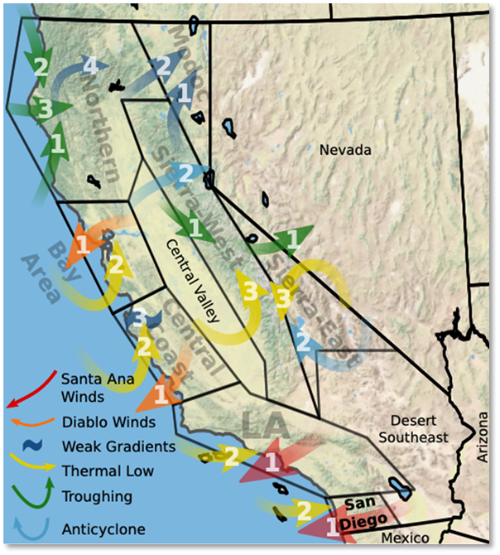
Figure 1. Map showing weather regions and weather types in California. (Prein et al. 2022)

These findings have significant implications for wildfire management, emergency response planning, and community resilience. They indicate that California may face a changing mix of fire types, driven by evolving weather patterns under climate change. Importantly, these changes are region-specific and seasonally nuanced. In some areas, such as the western slopes of the Sierra, subtle shifts in the timing of offshore wind events may push them later into fall, increasing the chances they occur after season-ending rainfall, thereby reducing their fire risk potential. In other areas, peak fire seasons may lengthen or shift in intensity.

Overall, the study emphasizes the importance of regionally tailored adaptation strategies and ongoing monitoring of fire-conducive weather patterns. The WT framework developed here provides a valuable tool for long-term planning and may also enhance short-term fire weather forecasting, complementing existing systems like Fire Weather Watches. This methodology could be extended beyond California, offering a structured approach to diagnosing and projecting wildfire risk in other fire-prone regions across the western United States.

3.2 Microscale Analysis of California Wildfire Events
CAWFE was applied to 22 wildfires across California between 2002 and 2025 (see Table 1), reproducing a wide range of fire behaviors, including rapid fire spread, wind-driven fire fronts, fire-induced convective complexes, and localized wind maxima aligned with known ignition points. A visual overview of many simulations is available at https://pyregence.org/extreme-weather-and-wildfire-ct/wildfire-simulations/. Notable insights emerged from simulations of the 2017 Tubbs Fire’s rapid downslope-driven spread into urban areas, the pulsing wind surges that accelerated the 2018 Camp Fire, and the formation of a large fire whirl during the Carr Fire.

Table 1. Simulated wildfires contributing to the study.
Wildfire Name | Year | Location
Caldor | 2021 | El Dorado County, CA
Camp | 2018 | Paradise, CA
Carr | 2018 | Redding, CA
Creek | 2017 | Sylmar, CA
Eaton | 2025 | Altadena, CA
Esperanza | 2006 | Cabazon, CA
Getty | 2019 | Los Angeles, CA
King | 2014 | Pollock Pines, CA
Maria | 2019 | Ventura County, CA
McKinney | 2022 | Klamath National Forest, CA
Mosquito | 2022 | Placer & El Dorado Counties, CA
North Complex | 2020 | Plumas & Butte Counties, CA
Redwood Valley | 2017 | Mendocino County, CA
Rim | 2013 | Stanislaus National Forest & Yosemite National Park, CA
Saddle Ridge | 2019 | San Fernando Valley, CA
Simi | 2003 | Simi Valley, CA
Slater | 2020 | Siskiyou County, CA
Thomas | 2017 | Ventura & Santa Barbara Counties, CA
Troy | 2002 | San Bernardino County, CA
Tubbs | 2017 | Santa Rosa, CA
Witch Creek | 2007 | San Diego County, CA
Woolsey | 2018 | Malibu, CA

The simulations’ high spatial resolution (370 m) and detailed atmospheric-fire coupling allowed CAWFE to resolve critical terrain-influenced airflow patterns, including microscale wind extrema in canyons and on secondary hilltops—patterns invisible at grid spacings typically used for forecasts and to existing weather station networks. For example, the 2025 Eaton Fire produced wind maxima exceeding 40 m/s near the fire’s origin in an area that spanned less than 1 km wide (Figure 2). These pulses, recurring at intervals of 4–13 minutes, can exceed design thresholds for utility infrastructure and may contribute to mechanical fatigue and failure.

Simulations showed that these fine-scale meteorological dynamics—more than fuel characteristics—play a decisive role in extreme fire behavior. For instance, the explosive growth and pyrocumulus development in the 2020 Creek Fire were reproduced using standard fuel inputs. Additional tests incorporating coarse woody debris (CWD) - a fuel load concern linked to climate-induced tree mortality—showed minimal impact on fire spread, but enhanced vertical growth, including plume strength, smoke lofting, and rotation. This suggests that fuel-driven impacts on fire behavior may be highly case-specific and secondary to wind dynamics in many scenarios.

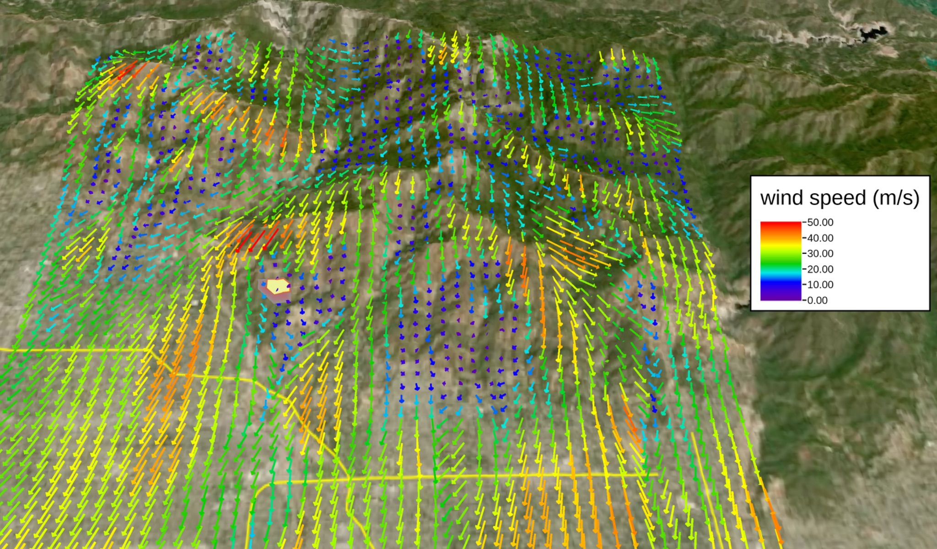
Figure 2. CAWFE simulation of the weather and fire during the Eaton Fire at 6:23 PM PST.

Despite its capabilities, CAWFE's operational adoption has been limited by the specialized expertise needed to configure and operate simulations. However, the emergence of Pyregence’s data microservices is making these high-resolution tools increasingly accessible for forecasting applications.

Crucially, CAWFE revealed systemic blind spots in current wildfire forecasting infrastructure. Standard weather station networks and mesoscale forecast models used in wildfire mitigation planning (e.g., for IOU Wildfire Mitigation Plans and PSPS decisions) lack the spatial resolution to detect or simulate terrain-induced wind hotspots and pulses, which appear only in simulations with grid spacing under 1 km. In many high-impact fires, CAWFE identified wind hotspots that were missed by conventional tools.

This body of work highlights the urgent need for high-resolution modeling to inform fire risk assessments and utility infrastructure planning. CAWFE demonstrated that fire spread, and wind extremes are predictable - if simulations are run at appropriate spatial scales. Routine models that under resolve terrain or depend heavily on “calibration” risk obscuring key fire-driving dynamics. Moving forward, this modeling approach provides a roadmap for integrating microscale weather-fire interactions into both strategic fire planning and next-generation forecasting systems.

Key Findings:
- Wind extrema in wind-driven events result from the interaction of the thermodynamic structure of the Santa Ana/Diablo downslope wind profile – that of a very stable, extremely fast-moving layer of air in the lowest 1-1.5 km of the atmosphere - with variously sloped, oriented, and bisected mountainous ridges.
- Topography matters: As Santa Ana/Diablo winds cross lower-relief terrain (e.g., Witch Creek Fire), winds are strong but less gusty. In steeper terrain, wind pulsing intensifies—potentially fatiguing infrastructure.
- Extreme cases, like the Camp Fire, involve shear instabilities atop stable layers, producing “backward-breaking wave” phenomena that bring high-momentum air to the surface and spur rapid spread.
- Such scenarios are rare but archetypal, requiring specific combinations of slope, wind, and stability—but many other damaging fine-scale airflow patterns were found.
- Canyon winds are poorly captured by station networks. Dense, stable surface air during wind events is channeled by canyon geometry and its own resistance to vertical motion.
- Transient, pulsating wind flows, and localized wind extrema only appear in high-resolution simulations (< 1 km grid spacing). Pulses may induce fatiguing in electrical infrastructure.
- These exceptional microscale wind patterns, such as those observed in the 2017 Tubbs Fire, where wind pulses streamed off lower hills including the ignition area - are not currently represented in standard mountain meteorology literature, thus, dissemination to forecasters is needed.
- Existing weather station networks and mesoscale forecast models (e.g., those used in utility wildfire mitigation planning and PSPS decision-making) are much coarser than topography and, despite expansion of station networks, still do not indicate the strength of wind maxima.
- Current operational models, including WRF, often fail to replicate key microscale dynamics—such as those that drove the explosive spread of the 2018 Camp Fire—due to inherent numerical smoothing of small-scale motions and gradients. As a result, these models systematically underestimate fire-driving wind behavior in complex terrain.

3.3 Integrated Multiscale Interpretation of Factors Contributing to Exceptional Fire Growth and Implications for Trends in Fire Risk
By integrating large-scale climate pattern analysis with fine-scale fire behavior modeling, this study provided a comprehensive view of the drivers behind extreme wildfire growth. This integrated, multi-scale approach underscored the need to understand the dynamic interplay between atmospheric circulation and local fire behavior—moving beyond simplistic metrics like temperature or dryness alone.

The research reveals that the most consequential impact of climate change on wildfire behavior is not merely increased heat or aridity, but a reorganization of atmospheric circulation patterns. Shifts in the jet stream latitude and pressure systems control the frequency and seasonal timing of fire-supportive weather types (WTs). Thus, they act as a “mask,” governing when and where multiple fire-promoting conditions can simultaneously occur.

This multiscale framework builds on the concept of “compound coincidences” in wildfire development, where extreme fire growth arises from a convergence of preconditions (like low fuel moisture), large-scale weather systems (such as high-pressure ridges), local wind-terrain interactions, and ignition timing. Recognizing these alignments is essential for understanding future wildfire risk (Figure 3).

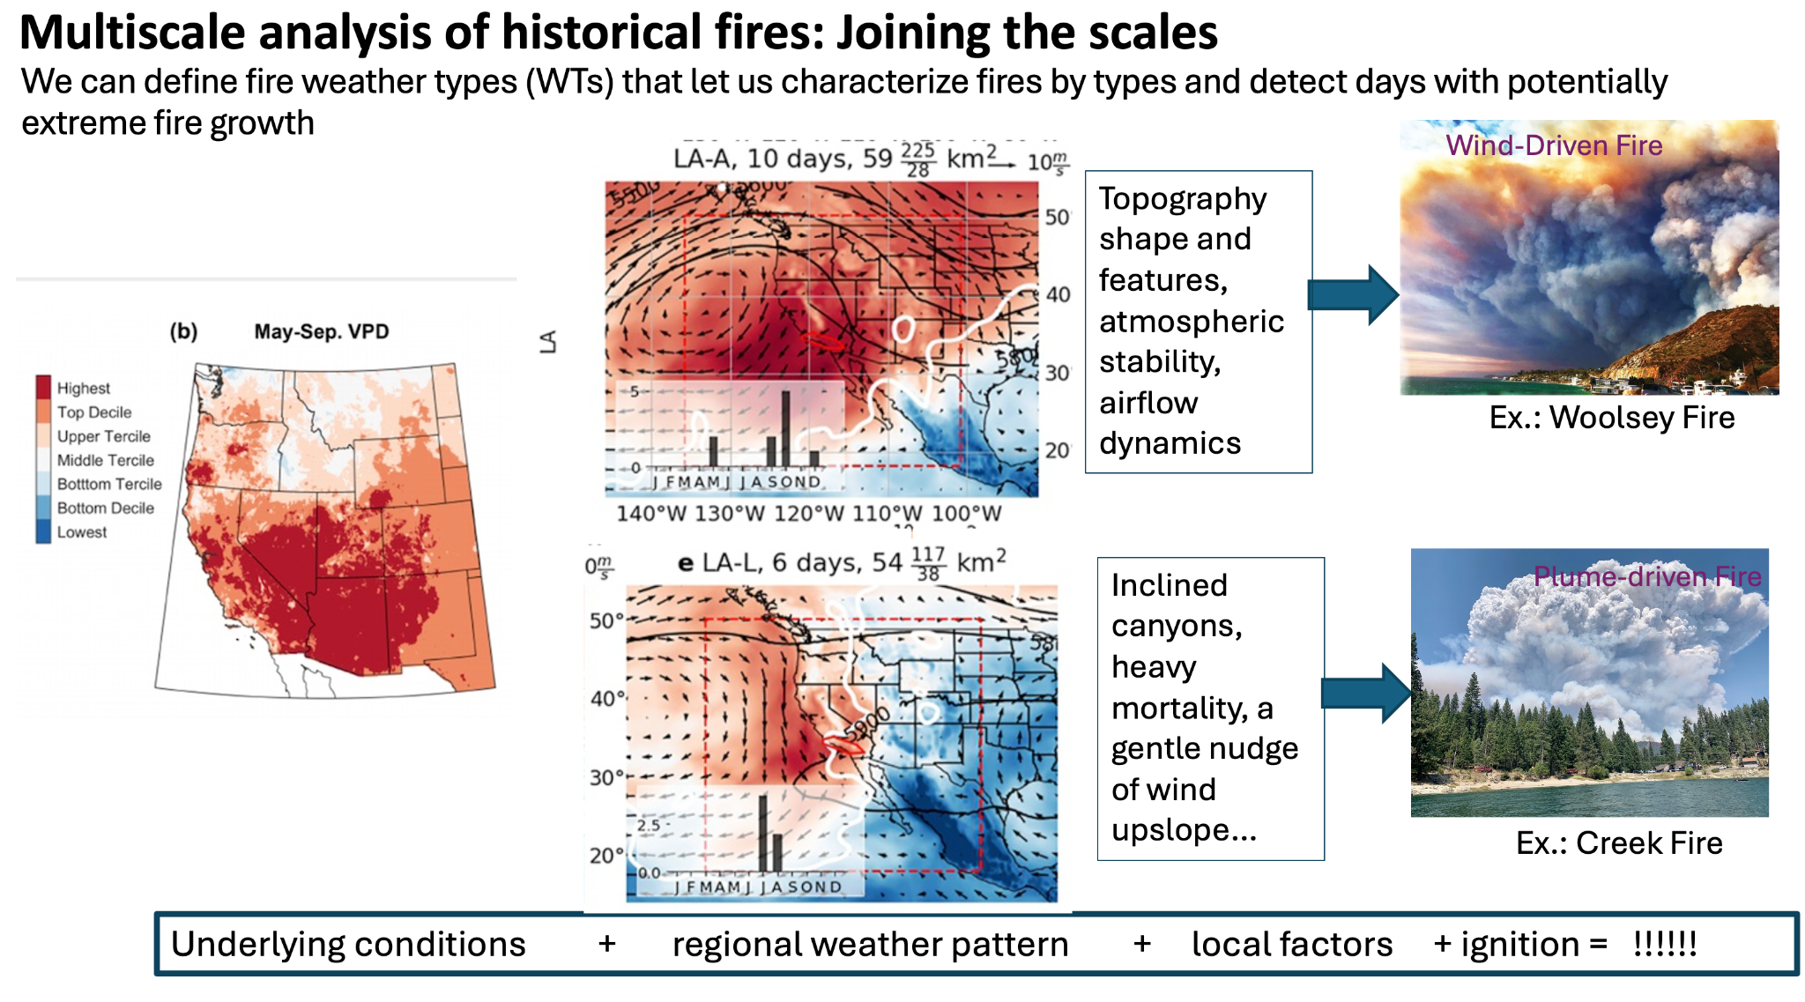
Figure 3. Conceptual diagram illustrating how alignment of broad susceptibility and a locally specific weather pattern that supports rapid fire spread produce distinct fire behavior types.

These findings challenge overly simplistic narratives that link wildfire risk solely to warming or drought. Instead, they underscore the need to track how climate change is shifting the character, seasonality, and geographic distribution of fire-conducive weather types—which, in turn, will influence whether future fires are primarily plume-driven or wind-driven, and how frequently the weather opportunity for these type of events, in conjunction with other factors such as fuels and ignitions, occur.

Understanding these evolving dynamics is vital for strengthening wildfire preparedness, improving grid resilience, and informing long-term community protection strategies. Anticipating shifts in atmospheric behavior allows for more targeted adaptation and forecasting systems that can better respond to the increasing complexity of fire risks in a changing climate.

4. Addressing User Needs and Stakeholder Engagement

4.1 Methodology for Identifying Optimal Location and Configurations of Weather Stations
To support the development of accurate and reliable wildfire models, it is essential to optimize the placement and configuration of weather stations. Interviews with stakeholders highlighted several needs and concerns:
- Analytical Methods for Weather Station Placement: Users expressed the need for improved analytical methods to identify optimal locations for weather stations, addressing deficiencies in the existing Remote Automatic Weather Stations (RAWS) network.
- Weather Data Availability and Quality: Concerns were raised about the availability and quality of weather data, particularly the low height of wind sensors at RAWS and the need for finer-resolution spatial fire weather data.
- Standardization of Weather Station Configurations: The lack of standardization in weather station configurations, especially regarding wind sensor placement, was identified as a critical issue.
- Coordination with Land Management Agencies: Stakeholders emphasized the need for streamlined coordination with land management agencies to expedite the permit approval process for weather station installations.

Identified Needs from Stakeholder interviews
- Improved weather station placement algorithms based on model-informed wind hotspots
- Standardization of sensor configuration and height
- Finer-scale vertical profiling and upper-air data collection
- Redundancy and coverage during PSPS events and in urban-wildland interfaces

Recommendations from Stakeholder interviews
- Deploy stations in canyons, saddles, and ridge gaps identified by CAWFE as wind maxima zones
- Prioritize station siting informed by archetypal CAWFE fire scenarios, particularly for regions with recurrent infrastructure impacts
- Use model-informed diagnostics to supplement NWP-based Fire Weather Watches with regionally defined WT alerts.

Understanding the Relationship Between Weather Extrema and Damaging Wildfires
Our analysis aims to develop a comprehensive understanding of the relationship between extreme weather conditions and wildfire behavior:
- Weather Input Uncertainties: Improving forecast models to account for uncertainties in weather inputs is crucial for accurate wildfire prediction.
- Upper Air Profiler Pilot Test: Learning from the upper air profiler pilot test can enhance our understanding of 3-D atmospheric measures and their role in evaluating fire spread and smoke dispersion.
- Vertical Profile: Further research is needed on vertical profiles and atmospheric layers to inform weather station siting and extreme weather conditions.

Improved Methods and Guidance for Weather Station Placement
Across various organizations, there is a need for improved methods and guidance to ensure that the weather stations are strategically placed:
- Coverage for Monitoring Service Areas: Ensuring that the network of weather stations provides necessary coverage for monitoring service areas and surrounding lands.
- Optimal Density of Weather Stations: Balancing the efficient allocation of resources with data collection needs to determine the optimal density of weather stations.
- Redundancy During PSPS Events: Placing stations on separate circuits for redundancy during Public Safety Power Shutoff (PSPS) events.
- Monitoring Urban Areas: Addressing the specific needs of urban areas under various weather conditions.

Summary of User Needs and Recommendations
By addressing these needs and incorporating stakeholder feedback, we can enhance the effectiveness of wildfire models and improve the resiliency of the electrical grid:
- Develop and implement analytical methods for optimal weather station placement.
- Standardize weather station configurations to improve data quality and availability.
- Improve coordination with land management agencies for timely permit approvals.
- Enhance forecast models to account for weather input uncertainties and provide finer-resolution spatial fire weather data, including vertical structure.

5. Discussion: Rethinking Climate-Wildfire Relationships - Beyond Heat and Drought
Current methods for assessing climate impacts on wildfire risk often place excessive emphasis on broad, slowly changing variables such as temperature, vapor pressure deficit (VPD), drought indices, and ignition counts. While these factors are relevant, they oversimplify the complex, nonlinear drivers of wildfire behavior by implying a direct, linear relationship between warming or drying and fire frequency or severity.
This oversimplification introduces several risks. First, statistical correlations between climate variables and fire activity are frequently misinterpreted as causal relationships, potentially leading to flawed conclusions. Second, the inherently dynamic and nonlinear nature of the climate-fire system is often reduced to trend-based projections, which can distort estimates of future wildfire risk. These assumptions may result in misleading forecasts, inaccurate risk assessments, and suboptimal mitigation strategies.
In reality, fire growth is not governed by background temperature or dryness alone. Instead, short-term weather events - including wind shifts, jet stream configurations, and localized pressure systems - often play a more decisive role in determining whether an ignition escalates into an extreme wildfire. While fires occur frequently, large fire growth events are rare. In California, for example, just 3–5% of fire days result in growth exceeding 100 hectares, yet the largest 1% of fires are responsible for as much as 85–93% of total area burned.
This research advances a more accurate framework: extreme wildfire events result from a multiscale convergence of factors—a combination of long-term susceptibility (e.g., dry fuels), a short-term, location-specific weather window (typically lasting 1–5 days), and a well-timed ignition. Future fire risk is best conceptualized as the joint probability of these factors aligning, rather than as a simple function of rising temperatures.
Within this framework, the Fire Weather Types (WTs) identified in this project serve as an important diagnostic filter or “mask”. They isolate the specific atmospheric conditions under which ignitions are most likely to escape containment and grow rapidly. While variables like temperature and drought are correlated with fire activity, this is a property of the few percent of fires that passed the WT screen, rather than the primary control on fire activity.

6. Conclusions: Advancing Wildfire Resilience Through Integrated Fire-Weather Research
The Pyregence Consortium’s research represents a major advancement in understanding how regional and fine-scale weather conditions contribute to rapid wildfire growth in California. By identifying region-specific Fire Weather Types (WTs) and applying high-resolution, physics-based simulations (such as the CAWFE model), the project provides critical insight into the mechanisms driving extreme fire behavior—insights that are essential for improving wildfire forecasting, planning, and response.

This work demonstrates the value of combining large-scale fire weather pattern analysis with localized modeling of terrain, wind, and fire-atmosphere feedbacks. This multiscale integration allows for a more accurate and predictive framework for understanding where and when dangerous fire conditions are likely to occur.

Importantly, the research shows that future wildfire risk is shaped not only by temperature and dryness, but by changes in atmospheric circulation, including shifts in the jet stream and synoptic pressure patterns. These changes influence the timing, frequency, and type of fire-supportive conditions and are critical to long-term risk forecasting and climate adaptation.

The findings also reveal that current forecasting tools—such as the RAWS sensor network and standard mesoscale models—lack the resolution to detect critical microscale dynamics, particularly in complex terrain. In contrast, dynamically coupled models like CAWFE can identify key atmospheric features tied to past disasters and help anticipate future wildfire scenarios.

By strengthening our understanding of how weather, climate, and terrain interact to produce extreme fires, this research supports more informed wildfire management strategies, grid infrastructure planning, and climate-resilient adaptation. It also underscores the importance of strategic sensor placement and the development of advanced modeling tools to address evolving wildfire threats across California.

7. References
Prein, A. F., J. Coen, A. Jaye, 2022: The character and changing frequency of extreme California fire weather. J. Geophys. Res. Atmos. 127, e2021JD035350. https://doi.org/10.1029/2021JD035350.

