

DRAFT FINAL PROJECT REPORT

Next Generation Near- and Long-term Wildfire Risk Forecast Models for Enhanced Electricity Grid Resiliency and Public Safety (Pyregence)

Agreement Number: EPC-18-026

Author(s):
Shane Romsos and David Saah
Spatial Information Group, LLC

California Energy Commission Project Manager:
David Stoms
Energy Research and Development Division

August 2024

Prepared By:
Shane Romsos, David Saah et al.

Prepared For:
David Stoms, Ph.D. Project Manager, California Energy Commission

Agreement Number: EPC-18-026

Kevin Uy
Branch Manager
ENERGY GENERATION RESEARCH OFFICE

Jonah Steinbeck, Ph.D.
Director
ENERGY RESEARCH AND DEVELOPMENT DIVISION

Drew Bohan
Executive Director

DISCLAIMER
This report was prepared as the result of work sponsored by the California Energy Commission. It does not necessarily represent the views of the CEC, its employees, or the State of California. The CEC, the State of California, its employees, contractors, and subcontractors make no warrant, express or implied, and assume no legal liability for the information in this report; nor does any party represent that the uses of this information will not infringe upon privately owned rights. This report has not been approved or disapproved by the California Energy Commission, nor has the California Energy Commission passed upon the accuracy or adequacy of the information in this report.

ACKNOWLEDGEMENTS
Funding for this study was provided by the California Energy Commission under contract agreement number EPC-18-026. The project team would like to sincerely thank the California Energy Commission for its support of this research and in particular Susan Wilhelm (Program and Project Supervisor, Sustainability and Health Energy Research and Development Division) and Commission Agreement Managers Alex Horangic and David Stoms for their guidance throughout the project.

Pyregence Project Team
Name | Organization/Affiliation
Christiana Darlington, JD | Clere
Zeke Lunder | Deer Creek Resources
Andrea Drew | Drew Consulting
Owen Doherty, PhD | Eagle Rock Analytics
Grace Di Cecco, PhD | Eagle Rock Analytics
Mariko Geronimo Aydin, MS | Lumen Energy Strategy
Phil Dye | Prometheus Fire Consulting, LLC
Joe Scott, MS | Pyrologix
Chris Lautenberger, PhD | Reax Engineering
Delaney Seeberger, PE | Reax Engineering
Maria Theodori, MS | Reax Engineering
MaryAnne Peters | Reax Engineering
Chris Anderson, PhD | Salo Sciences
David Marvin, PhD | Salo Sciences
Bryan Penfold, MBA | Sonoma Technology
Kenneth Craig, MS | Sonoma Technology
ShihMing Huang, MS | Sonoma Technology
Steve Irwin | Sonoma Technology
Tami Lavezzo, MBA | Sonoma Technology
Andrea Raschke | Spatial Informatics Group
Alice Liquori | Spatial Informatics Group
Ashley Conrad-Saydah, MA | Spatial Informatics Group
Carrie Levine, PhD | Spatial Informatics Group
Gary Johnson, PhD | Spatial Informatics Group
Jean Pierre (JP) Wack | Spatial Informatics Group
Jonathan Baldwin, PhD | Spatial Informatics Group
Justine Bui, MBA | Spatial Informatics Group
Kenny Cheung | Spatial Informatics Group
Kim Carr, MS | Spatial Informatics Group
Mark Essig | Spatial Informatics Group
Matt Spencer, P.E. | Spatial Informatics Group
Oliver Baldwin-Edwards | Spatial Informatics Group
Paul Lackovic | Spatial Informatics Group
Richard (RJ) Sheperd | Spatial Informatics Group
Shane Romsos, MS | Spatial Informatics Group
Taro Pusina | Spatial Informatics Group
Teal Dimitrie, MS | Spatial Informatics Group
Charles Maxwell | Spatial Informatics Group, Oregon State University
Elliot Kuskulis | Spatial Informatics Group, UC Berkeley
Ian Moore, MS | Spatial Informatics Group, UC Berkeley
David Saah, PhD | Spatial Informatics Group, University of San Francisco
Brandon Collins, PhD | University of California - Berkeley
Carlos Fernandez-Pello, PhD | University of California - Berkeley
Danny Foster, PhD | University of California - Berkeley
John Battles, PhD | University of California - Berkeley
Luca Carmignani, PhD | University of California - Berkeley
Michael Gollner, PhD | University of California - Berkeley
Scott Stephens, PhD | University of California - Berkeley
Andrew Notohamiprodjo, MS | University of California - Merced
Jeanette Cobian-Iñiguez, PhD | University of California - Merced
Jonathan Baldwin, PhD | University of California - Merced
Jonathan Sam, PhD | University of California - Merced
Leroy Westerling, PhD | University of California - Merced
Qingqing Xu, PhD | University of California - Merced
Samrajya Thapa, PhD | University of California - Merced
Andreas Prein, PhD | University Corporation for Atmospheric Research (UCAR), National Center for Atmospheric Research (NCAR)
Matt Hurteau, PhD | University of New Mexico
Janice Coen, PhD | University of San Francisco, UCAR/NCAR
Mark Finney, PhD | US Forest Service, Missoula Fire Science Laboratory
Ben Sleeter, MS | US Geological Survey
Todd Hawbaker, PhD | US Geological Survey

Technical Advisory Committee
The thank the following individuals on the project’s Technical Advisory Committee (TAC) who provided valuable feedback on all aspects of the project.

Name | Background/Expertise | Organization/Affiliation
Adam Moreno | Terrestrial Carbon Modeler | California Environmental Protection Agency – Air Resources Board
Bereket Habtezion | Meteorologist | Pacific Gas and Electric
Brian D’Agostino | Director of Fire Science and Climate Adaptation | San Diego Gas and Electric
Dave Sapsis | Wildland Fire Scientist | California Dept. of Forestry and Fire Protection – FRAP
David Weise | Research Forester | US Forest Service – Pacific Southwest Research Station
Heide Caswell | Transmission & Distribution Asset Performance/Wildfire Mitigation | PacifiCorp (Pacific Power)
Koko Tomassian | Program Manager, Senior Utilities Engineer | California Public Utility Commission, Safety Management Systems Branch
Michael Peterson | Deputy Commissioner on Climate and Sustainability | California Department of Insurance
Randy Striplin | Regional Fuels Planner | US Forest Service, Region 5
Robert LeMoine | Director Risk Management, Insurance and Data Analytics | Southern California Edison

Match Funding
Several organizations provided generous match funding contributions that significantly enhanced the project team’s ability to complete various tasks. Namely, we thank and recognize the contributions from the following:
- Eagle Rock Analytics
- Lumen Energy Strategy
- Reax Engineering
- Salo Sciences
- Spatial Informatics Group
- United States Forest Service – Missoula Fire Science Laboratory
- United States Geological Survey - Geosciences and Environmental Change Science Center
- United States Geological Survey - Western Ecological Research Center
- University Corporation for Atmospheric Research (UCAR)
- University of California - Merced

Ancillary Contributions
We thank the following individuals for their contributions to the project in the form of field logistical support, administrative support, knowledge exchange, and/or data sharing.
- Adrian Das, PhD - United States Geological Survey - Western Ecological Research Center
- Bin Chen, PhD - University of California - Davis, Center for Ecosystem Climate Solutions
- Constance May – University of California - Irvine, Center for Ecosystem Climate Solutions
- James Randerson, PhD – University of California - Irvine, Center for Ecosystem Climate Solutions
- Lisa Rosenthal, United States Geological Survey - Western Ecological Research Center
- Michael Goulden – University of California - Irvine, Center for Ecosystem Climate Solutions
- Hudson Northrup – University of California - Berkeley
- Raiven Greenberg – University of California - Irvine, Center for Ecosystem Climate Solutions
- Shane Coffield, PhD. - University of California - Irvine, Center for Ecosystem Climate Solutions
- Yang Chen, PhD – University of California - Irvine
- Yufang Jin, PhD – University of California - Davis, Center for Ecosystem Climate Solutions

PREFACE
The California Energy Commission’s (CEC) Energy Research and Development Division supports energy research and development programs to spur innovation in energy efficiency, renewable energy and advanced clean generation, energy-related environmental protection, energy transmission, and distribution and transportation.

In 2012, the Electric Program Investment Charge (EPIC) was established by the California Public Utilities Commission to fund public investments in research to create and advance new energy solutions, foster regional innovation, and bring ideas from the lab to the marketplace. The EPIC Program is funded by California utility customers under the auspices of the California Public Utilities Commission. The CEC and the state’s three largest investor-owned utilities— Pacific Gas and Electric Company, San Diego Gas and Electric Company, and Southern California Edison Company—were selected to administer the EPIC funds and advance novel technologies, tools, and strategies that provide benefits to their electric ratepayers.

The CEC is committed to ensuring public participation in its research and development programs that promote greater reliability, lower costs, and increase safety for the California electric ratepayer and include:
- Providing societal benefits.
- Reducing greenhouse gas emission in the electricity sector at the lowest possible cost.
- Supporting California’s loading order to meet energy needs first with energy efficiency and demand response, next with renewable energy (distributed generation and utility scale), and finally with clean, conventional electricity supply.
- Supporting low-emission vehicles and transportation.
- Providing economic development.
- Using ratepayer funds efficiently.
For more information about the Energy Research and Development Division, please visit the CEC’s research website (www.energy.ca.gov/research/) or contact the Energy Research and Development Division at ERDD@energy.ca.gov.

ABSTRACT
This project addresses the escalating wildfire risks in California and the Western United States, driven by climate change, past forest management practices, and the expansion of human development near wildlands. The primary goal was to advance wildfire science and develop next-generation wildfire models and decision support tools to enhance the resiliency and safety of California's electric grid. The project was structured around four workgroups, each focusing on different aspects of wildfire modeling, such as extreme weather, tree mortality, and near- and long-term wildfire hazard forecasting.
Key achievements include the optimization of weather station placement using novel modeling techniques, the development and enhancement of near-term wildfire risk and spread models, and the creation of PyreCast, an open-source wildfire situational awareness platform. The project also made significant strides in understanding the influence of climate change on fire weather patterns, predicting future wildfire risks associated a changing climate and with tree mortality and fuels.
The findings underscore the importance of region-specific adaptation strategies, improved weather monitoring, and the integration of advanced fire behavior models to better predict and manage wildfires. This work provides critical insights and tools that will aid in protecting California’s electric grid and communities from the increasing threat of wildfires.

Keywords: wildfire risks, climate change, forest management, wildland-urban interface (WUI), electric grid resilience, extreme weather, weather station optimization, tree mortality, fire behavior models, PyreCast platform, wildfire modeling, upper-air wind measurements, public safety power shutoff (PSPS), fuel accumulation, coupled atmosphere-wildland fire environment (CAWFE) model, next-generation wildfire risk projections, machine learning models, ecoregion variability, long-term wildfire projections, decision support tools, California fifth climate change assessment.

Please use the following citation for this report:
Romsos, J. Shane Next Generation Near- and Long-Term Wildfire Risk Forecast Models for Enhanced Electricity Grid Resiliency and Public Safety (Pyregence)

TABLE OF CONTENTS
ACKNOWLEDGEMENTS i
Pyregence Project Team i
Technical Advisory Committee iii
Match Funding iii
Ancillary Contributions iv
PREFACE v
ABSTRACT vi
EXECUTIVE SUMMARY 1
Background 1
Project Purpose and Approach 1
Key Results 3
Extreme Weather and Wildfire (Workgroup 1) 3
Tree Mortality, Fuel Measurement, and Fire Physics (Workgroup 2) 5
Near-term Wildfire Forecast Models (Workgroup3) 7
Long-term Wildfire Projections (Workgroup 4) 10
Knowledge Transfer Activities 11
Next Steps 11
Benefits to Ratepayers 13
INTRODUCTION 15
Background 15
Project Objectives 15
PROJECT APPROACH 17
Overview 17
Extreme Weather and Wildfire (Workgroup 1) 18
Tree Mortality, Fuel Measurement, and Fire Physics (Workgroup 2) 22
Near-term Wildfire Forecasting Models (Workgroup 3) 25
Long-term Wildfire Projections (Workgroup 4) 30
SUMMARY OF RESULTS 35
Extreme Weather and Fire (Workgroup 1) 35
Weather Station Optimization Modeling 35
Extreme Weather Types Analysis 40
Upper Air Profiler Pilot Study 42
Tree Mortality, Fuels and Fire Physics (Workgroup 2) 43
Small- and Large-Scale Laboratory Experiments 43
Fuels Measurements System 45
Forecasting Surface Fuel Loads 45
Contemporary Tree Mortality Mapping 46
Near-term Wildfire Forecasting Models (Workgroup3) 47
PyreCast Near-term Fire Forecasting Platform 47
Evaluation of PyreCast Model Performance 51
Cost/Benefit Assessment of PyreCast – Case Study 52
Pyrecast Data and Code Repositories 52
Long-term Fire Projections 53
Coupled Statistical/Dynamical Fire-Climate-Vegetation Models 53
LANDIS II Forest Landscape Model 54
Application of Machine Learning Models 54
CONCLUSIONS AND RECOMMENDATIONS 57
Extreme Weather and Wildfire - Workgroup 1 57
Conclusions 57
Recommendations 58
Tree Mortality, Fuel Measurement and Fire Physics (Workgroup 2) 59
Conclusions 59
Recommendations 60
Near-term Wildfire Forecasting Models (Workgroup 3) 61
Conclusions 61
Recommendations 61
Long-term Wildfire Risk Models - Workgroup 4 62
Conclusions 62
Recommendations 63
LIST OF ACRONYMS 65
PROJECT PRODUCTS AND DELIVERABLES 66
Overarching Tasks/Deliverables 66
Technical Tasks by Workgroup 66
REFERENCES 68

EXECUTIVE SUMMARY

Background
This project is set against the backdrop of escalating wildfire risks in California and the Western United States, driven by climate change, other factors related to past forest management, and increasing human development near wildlands. Over the past several decades, these regions have experienced shifts in climate patterns, leading to more frequent and severe wildfires. The expansion of the wildland-urban interface (WUI) has further exacerbated the vulnerability of communities and infrastructure, particularly the electricity grid. Existing wildfire modeling systems need updating because they are unable to accurately predict extreme fire behaviors that are now more common. Investor-owned utilities (IOUs) face increased costs, reduced safety, and weakened reliability due to the impacts of wildfires on the grid, a situation likely to worsen as climate change progresses. To address these challenges, the project aimed to advance wildfire science and inform the development of next-generation wildfire models that can provide actionable insights for both short-term and long-term wildfire risk forecasting, ultimately enhancing the resiliency and safety of California’s electric grid.

Project Purpose and Approach
The purpose of the project was to advance wildfire science and inform the next generation of wildfire models and decision support tools for use at multiple spatial and temporal scales to enhance the resiliency and safety of California's electricity grid. With stakeholder input, the project aimed to address the increasing extreme weather conditions posed by climate change, including more frequent and severe wildfires, particularly in areas with high tree mortality, near the wildland-urban interface (WUI) and electric infrastructure. The tools and models developed through project were designed to provide actionable information for both near-term and long-term wildfire hazard forecasting, enabling better decision-making and planning for investor-owned utilities (IOUs) and supporting California’s Fifth Climate Change Assessment. The project team also focused on transferring technology and knowledge to utilities and other stakeholders as a knowledge base for practitioners to mitigate wildfire impacts on the grid, with the goal to improve the reliability, safety, and cost-effectiveness of the electricity system.
The project approach was structured around a series of tasks designed to advance wildfire science and inform the development of next-generation models and tools to improve electric grid resilience. The approach included establishing a multidisciplinary project team partitioned into four workgroups focused on different aspects of wildfire modeling, such as extreme weather, tree mortality and fuels, and near-term and long-term wildfire hazard forecast tools and models.

Workgroup 1 of the project team focused on developing methods to inform the optimal configuration of weather stations to collect critical data on wildfire risk factors, particularly in areas that could affect electric grid assets. This involved the development of novel modeling techniques to identify the best locations for weather stations and understanding the application of upper air profiler technologies (sensors that measure weather conditions above the earth’s surface). In addition, the workgroup focused on conducting historical analysis of extreme weather conditions and their relationship to past wildfires to improve the accuracy of future risk forecasts and to understand how weather patterns may shift under a changing climate. This effort included evaluating the application of an atmospherically coupled wildfire model, creating datasets and developing reports that summarize findings to guide future wildfire modeling efforts.

Workgroup 2 focused on advancing wildfire sciences related to mapping tree mortality, fuels measurement, and fire physics by conducting mapping, field studies, and laboratory experiments to understand how current and projected dead and decaying trees will likely affect fire behavior. Findings from this research were translated into opportunities for improving wildfire behavior models.

Workgroup 3 focused on developing and refining wildfire risk and spread models that could be operationalized for use by utilities risk managers and used to inform wildfire threat conditions over a near-term forecasting horizon (up to 14 days). A major element of the workgroup’s effort was designing (with stakeholder input), developing, testing and deploying software to support an open-source, near-term wildfire situation awareness platform called PyreCast. Once developed and deployed several stakeholder engagement webinars and workshops were held to showcase the platform’s capabilities and inspire its use by electric utilities and other stakeholders.

Workgroup 4 focused on developing next generation long-term wildfire risk projection models as well as deploying an existing forest landscape model called Landis II. One modeling approach used included the integration (coupling) of a computationally efficient statistical fire model developed by UC Merced scientists with a dynamic vegetation model (LUCAS). The models developed and/or deployed were used to simulate future larger-scale wildfire events based on climate trajectories from recently available downscaled CMIP6 climate data, vegetation management scenarios, and urban development scenarios. The dynamic vegetation models used incorporated complex feedback loops between climate, ecosystems, and fire dynamics. In a separate effort, Workgroup 4 completed a historic analysis of wildfire risks across ecoregions in California using advanced machine learning methodologies to assess the factors driving future fire occurrence, size, and severity. Workgroup 4 efforts produced several publications on methodologies used as well as a library of simulated fire events and a series of digital maps surface representing projected future vegetation, biomass, carbon and wildfire hazards. All model code and data produced through this effort was posted in repositories to provide access to electric utilities and other stakeholders.

Key Results

Extreme Weather and Wildfire (Workgroup 1)
Timely information about weather conditions is critical for the operation of and planning of California’s electric grid. Weather critically impacts the reliability and safety of California’s electricity system, informing the occurrence of PSPS events, wildfire interruption of transmission and distribution, and by extreme weather events damaging aging and vulnerable electricity infrastructure. As California decarbonizes through adoption of renewable generation capacity – weather and direct and indirect effects of wildfire can impact the supply of electricity. As California considers major investment in climate resilient and adaptation measures, having appropriate weather information is important. Consequently, the Extreme Weather and Wildfire Workgroup (Workgroup 1) of the project team completed research to help fill knowledge gaps related to 1) identifying appropriate locations to invest in new weather monitoring station across the State and within IOU service territories, 2) improving understanding of the relationship between extreme wildfire and weather and the use of an advanced coupled atmospheric model application, and 3) demonstrate the value of upper-air sensor measurements to supplement surface wind observations.

Weather Station Optimization
Workgroup 1 used a Maximum Entropy (MaxEnt) modeling approach to assess current and future climate conditions and their similarity to areas covered by weather stations to identify gaps in the State’s weather station network. The analysis completed provides a foundation for enhancing California's weather station network, aiming to improve resilience against climate change and wildfires through better data collection and utilization. Key findings of this work included:
- The analysis identified significant dissimilarity in climate conditions in rural and high-elevation areas, underscoring the need for more targeted weather station placements in these locations.
- Optimal placement should consider the needs for timely wildfire predictions, climate modeling, and coverage of disadvantaged communities. A more coordinated statewide approach is required to address the current unstructured deployment of weather stations.
- The research completed and methodology used in the analysis will benefit the following stakeholders:
  - Electric Utilities: helps identify areas with insufficient weather station coverage, providing information that allows for more strategic and cost-effective placement of new stations.
  - State and Federal Fire Agencies: Helps to coordinate efforts to create a comprehensive and standardized statewide weather station network.
  - Electric Utility Regulators: Help to ensure sufficient weather station density to meet climate monitoring goals and wildfire management needs.

Extreme Weather and Wildfire

Weather Types
As part of the project a study was conducted and published that investigated weather patterns (weather types) that lead to large wildfires across eight different regions of California (see Prein et al. 2022). The study used historical weather data and fire records to understand past weather/large wildfire interactions and conducted climate simulations to estimate potential future changes in weather types due to climate change. Key findings of the work included:
- Historical Weather Patterns: During the 20th century, the frequency of weather types conducive to the propagation of large wildfires, such as Santa Ana and Diablo events, increased due to natural climate variability.
- Climate Change Impacts: Climate change is expected to alter the frequency and types of weather. The study found that the occurrence of Santa Ana and Diablo events are projected to decrease, and there will likely be an increase in weather types associated with thermal-low-pressure systems, especially in southern California.
- Hotter, Drier Summers: The changing climate is anticipated to create conditions that are more favorable for large fires, particularly during the summer months, characterized by higher temperatures and drier conditions.
- Regional Variations: The study found that different regions in California will experience varying impacts from future changing weather patterns, suggesting the need for region-specific adaptation and mitigation strategies.

Coupled Atmosphere-Wildland Fire Environment (CAWFE) Model – Case Studies
The CAWFE model, developed by Janice Coen of Workgroup 1, was applied to 19 historical wildfires, both within and outside California, that occurred between 2002 and 2020 to better understand the model’s strengths and limitations. A strength of CAWFE is that is a sophisticated tool designed to simulate the complex interactions between wildfires and atmospheric conditions. The model excels in dynamically coupling fire spread with atmospheric feedbacks, allowing it to simulate phenomena such as fire-induced vortices, extreme wind patterns, and pyrocumulonimbus clouds (i.e., plume dominated fires) — critical factors in the escalation of extreme fire behavior. For example, as part of this project, CAWFE accurately modeled the rapid spread of the Tubbs Fire and the extreme behaviors observed during the 2020 Creek Fire and the 2018 Carr Fire.

The model's high spatial and temporal resolution enables it to capture fine-scale variations in fire behavior, particularly in complex terrains and varying meteorological conditions. Its effectiveness was validated in this project through simulations of high-profile fires like the 2020 East Troublesome Fire, the 2017 Tubbs Fire, and the 2018 Camp Fire, where it successfully reproduced observed spread patterns and extreme behaviors.

The project team also identified some limitations. Its complexity and high resolution require significant computational resources and extensive data inputs, making it less practical for real-time operational use. The accuracy of its simulations is highly dependent on the quality of input data and model parameterization, which can pose challenges, especially in fast-evolving fire situations. Additionally, CAWFE's operational use has been limited due to the specialized expertise required to run and interpret its outputs, which may not be readily available to fire managers who need clear, actionable information during emergencies. While CAWFE is highly effective in simulating extreme fire behaviors, its application in lower-intensity fire scenarios remains less explored.

Upper Air Profiler Pilot Test
Workgroup 1 deployed and operated a sodar wind profiler instrument in northern California, which was used to collect upper-air data from July through October 2020. The purpose of the pilot study was to demonstrate the value of upper-air wind measurements to supplement surface wind observations, allowing utilities to better predict the onset of strong winds. It was reasoned that type of data could inform Public Safety Power Shutoff (PSPS) decisions and improve situational awareness during extreme wind events.
The data collected by the profiler showed wind speed and direction by time and vertical height, with a vertical resolution of approximately 20 m from about 80 to 600 m above ground level (AGL). While the deployment experienced some unforeseen challenges, the Sodar collected useful data and provided insights for use of upper-air instrumentation in high wind areas.
Pilot study results, as well as analysis of nearby upper-air and surface wind measurements, found that aloft wind data collected during a PSPS event can provide advance information and improve forecast capabilities to better predict high wind events that impact the surface conditions and influence fire behavior. In addition, the research indicated aloft observations are useful in validating the real-time performance of predictive meteorological models. The pilot research concluded that the addition of upper-air instrumentation to the meteorological measurement network would enhance the ability to make more informed decisions regarding electric utility shutoffs and would improve situational awareness during extreme wind events – aiding in improved protection for communities, fire fighter’s safety, and wildfire resource allocations.

Tree Mortality, Fuel Measurement, and Fire Physics (Workgroup 2)
Existing wildfire models, primarily based on the Rothermel spread equation, have been found to be inadequate for predicting the behavior of large, complex wildfires driven by contemporary fuel conditions. Current models do not account for the effects of large woody fuels, deep duff layers, and the extreme fire behaviors that result from large-scale heat release and fire-induced winds. The Tree Mortality, Fuel Measurement and Fire Physics Workgroup (Workgroup 2) of the project team completed several evaluations to help fill knowledge gaps associated with current wildfire models, which included conducting controlled experiments to quantify fuel burning rates, creating new fuel measurement and tree mortality mapping systems, projecting the future occurrence of surface fuels in areas with high tree mortality, and evaluation of wildfire behavior associated with the 2020 Creek Fire – an area that contained a relatively high density of dead trees and excessive fuel loading.

Small- and Large-Scale Fire Experiments
Small-scale fire experiments showed that wind speed significantly influences smoldering combustion, with a marked increase in burning rate as wind speed rises. This suggests that wind plays a critical role in transitioning from smoldering to flaming combustion, a factor not currently accounted for in existing fire behavior models. For large-scale fire experiments, although still ongoing at the end of the project, revealed that wind can dramatically increase reaction temperature and burning rates of larger fuels, contributing to more severe and unpredictable wildfire behavior.

Fuel Measurements and Tree Mortality Mapping
A new fuel measurement system was developed as part of the project, capturing fine-scale spatial patterns of fuel loads. Data developed as part of the measurement system found that forests with higher tree mortality exhibited significant increases in surface fuels, particularly in coarse woody debris, which will likely increase wildfire severity in these areas.
Tree mortality mapping across California from 2016-2018 used advanced satellite mapping methods and showed a continuous increase in dead tree cover, particularly in regions affected by drought.

Surface Fuels and Wildfire Behavior
Data collected as part of a separate long-term study provided data to help predict future fuel accumulations and wildfire hazards in areas affected by drought induced tree mortality and refined knowledge around dead tree fall rates and subsequent recruitment as surface fuel. By 2040, surface fuel loads in areas with higher tree mortality are projected to increase significantly, potentially leading to more severe wildfires.
Analysis of the 2020 Creek Fire demonstrated that high levels of dead biomass combined with live tree density were critical in generating mass fire behavior. The study highlighted the challenges of current fire behavior models to accurately predict wildfire behavior associated mass fire events driven by excessive fuel loads.

Near-term Wildfire Forecast Models (Workgroup3)
Wildfire situation awareness tools are essential technologies that enable real-time monitoring, prediction, and management of wildfire events. These tools provide critical information to firefighters, emergency responders, and utility companies, helping them anticipate fire behavior, assess risks, and make informed decisions to protect lives, property, and infrastructure. By integrating advanced data analytics, weather forecasts, remote sensing, and predictive wildfire behavior modeling, these tools can offer a comprehensive understanding of wildfire dynamics, allowing for timely interventions and more effective resource allocation. As wildfires become increasingly larger, more frequent and severe due to climate change and other factors, the development and deployment of these tools are vital for enhancing situational awareness of risk managers in the electric utility and emergency management sectors. To meet the project goal to develop and deploy and advanced decision support tool, Workgroup 3, based on stakeholder input, produced the PyreCast platform, evaluated associated wildfire behavior model performance, and prepared a use case cost/benefit analysis.

Near-term Fire Forecasting Models and Tools (PyreCast)
PyreCast is a web-based near-term wildfire situational awareness and decision support platform developed and deployed by Workgroup 3 that provides a suite of tools designed to meet the needs of a range of risk and emergency management sectors. Through product development, the project team demonstrated the ability to scale the technology, expanding forecasting capabilities from California to the lower 48 states of the United States. The tools within the platform use efficient software programming practices, wildfire behavior models developed by the project team, and are based on the best available operational fire science. PyreCast satisfied these needs through a web-enabled user interface that allows users to visualize data from three primary wildfire related forecasting tools and an interface that displays landscape information, including:
- Active Fires - This tool allows users to access near real-time information about the location and size of actively burning fires and provides an animated forecast of how the fire is predicted to spread across the landscape over a 14-day forecast horizon. This tool addressed users' needs for understanding wildfire spread characteristics and impending wildfire impacts to critical infrastructure and communities and informs the pre-positioning of wildfire suppression actions and/or ordering of evacuation actions.
- Risk Forecast - The tool works by igniting hundreds of millions of hypothetical fires across the landscape and modeling their spread under forecasted weather conditions over a five-day time horizon. This tool helps users to understand which areas (e.g., communities) and positions along the electric transmission grid are at greatest risk of wildfire if an ignition were to occur at a selected location.
- Fire Weather Forecast – This tool allows users to track different weather variables and associated forecasts to understand how intense/damaging an active fire might get or to forecast wildfire related vulnerabilities into the near future. The tool provides up to sixteen-day forecasts of crucial weather parameters and fire-weather indices that influence wildfire behavior. Forecasts are updated every six hours to ensure the most up-to-date information is available for users.
- Fuels – This interface in the platform allows users to explore historic and current fire behavior fuel model data along with other landscape information, such as canopy and topographic characteristics from different data sources.
The PyreCast user interface includes other features and functionality including: 1) AlertCalifornia and AlertWildfire live camera integration, 2) National Weather Service - Red Flag warning areas, 3) 3-deminsional terrain pan and tilt, 4) National Incident Feature Service (NIFS) historic and current year fire perimeters, 5) VIIRS and MODIS hotspot layers, and 6) Live GOES16 satellite imagery. In addition to the web-based user interface, Workgroup 3 developed software infrastructure (e.g., data and code repositories, APIs, GeoServers, microservices) for advanced users to access data and wildfire behavior model outputs for preferred or proprietary computer systems.

Evaluation of PyreCast System and Active Fire Spread Model Performance
The project team conducted a performance evaluation of models within PyreCast and highlighted challenges of wildfire prediction models, particularly with spread models in the context of extreme fire events like the 2020 Creek Fire and 2021 Dixie Fire and provided recommendations for improving these models. Key findings of the performance evaluation included:
Active Fire Initiation - Erroneous fire initialization data, particularly from MODIS satellite data for on-going fires or initial fire start locations from fire agency information, impacted forecasted fire spread accuracy. These issues were resolved over the course of the project by using different, more accurate fire initiation data.
Post-Precipitation Fire Behavior – There was at least one instance (e.g., the 2023 SRF Complex Fire) were spread model did not adequately predict the rekindling of fire after precipitation events, leading to gaps in forecast availability when fires started spreading after the fire was assumed over. Recommendations included developing models to better estimate when a fire will reignite after rain – information that could be explored through large scale burn experiments conducted by Workgroup 2.
Computational Scalability – Although the project team was successful in demonstrating system functionality, the system reached some computational limits during peak fire seasons when a large number of fires were in the system simultaneous, causing delays in issuing forecasts. A recommendation was made to implement an approach that utilized more extensive cloud computing resources to handle high-demand periods.
Fire Suppression Model Scenarios – Models originally deployed in the PyreCast system represented “unsuppressed’ fire behavior and in some stages of a fire did not accurately account for on the ground conditions. Over the course of the project, an algorithm was developed and deployed in the system to respond to this deficiency. The new fire suppression algorithm deployed still requires additional validation along with a recommendation to generate near real-time validation metrics (based on comparisons of actual fire perimeters with forecasted fire perimeters) to improve confidence in forecast accuracy.
Forecast Spatial Domain – Although the original project scope was limited to the spatial domain of California, the project team was able to scale spread forecast to the Continental US. Even with the expansion in the forecast spatial domain and due to recent severe fire seasons in Alaska and Hawaii, the project team recommended the system be expanded to include all the US and perhaps Canada.
Accuracy – Fires experienced over the course of the project allowed for the project team to better pinpoint accuracy issues associated with the models used in PyreCast. Notably, a retrospective look at 2020 Creek found that extensive tree mortality due to drought and bark beetles, combined with high live tree densities, created conditions conducive to mass fire behavior. The spread and intensity of the fire was not predicted well by the ELMFIRE model used in PyreCast – likely because of the influence of complex fire-atmosphere interactions and large and dense fuels not captured by underlying landscape data and/or model algorithms. Qualitative observations of model performance during the 2021 Dixie Fire also highlighted some shortcomings, including 1) down-canyon wind resulting in the under prediction of spread, 2) over estimated fire behavior in wet meadows, suggesting a need to integrate higher resolution fuel moisture data, 3) heavy smoke inversion caused a dampening of fire behavior and 4) underprediction of fire behavior in ‘non-burnable’ urban landscapes.
Case Study on Cost-Benefits of PyreCast – Utility Pole Pre-treatment associated with the 2020 Glass Fire
A case study that evaluated the benefits of the PyreCast tool, particularly its impact on reducing data latency in wildfire risk simulations, which enhanced utility pole pretreatment strategies during active wildfires. The open-source PyreCast platform offers significant improvements over the status quo subscription-based wildfire forecasting tool (such as Technosylva’s ‘Wildfire Analyst’) by providing up to four updated wildfire risk simulations per day, compared to just one. This increased forecast data refresh rate allowed for more timely and accurate decision-making in mitigating fire risks to critical infrastructure. Key findings of the case study included:

Improved Decision-Making - The PyreCast tool's ability to produce sub-daily updates allows utility companies to make more informed decisions regarding pole pretreatments, significantly reducing the likelihood of treatment cancellations due to outdated forecasts.

Cost-savings - During the 2020 Glass Fire, PyreCast enabled more effective emergency pole pretreatments, resulting in the treatment of 1,747 poles compared to 1,242 under the status quo, saving an estimated $0.5 million in pole replacement costs for a single ~70,000-acre fire. Scaling these benefits across California's annual average wildfire burn area, the tool is projected to save $5.9 million per year in utility costs, with $5.0 million of that benefiting IOU ratepayers.

Overall, the cost benefit analysis found that the PyreCast platform represents an advancement in wildfire risk management, offering cost savings, enhanced reliability in fire mitigation efforts, and increased safety for utility infrastructure. By reducing data latency and improving the accuracy of fire risk forecasts, PyreCast provides a critical tool for utilities to better protect their assets and ensure more resilient electricity service during wildfire events.

Long-term Wildfire Projections (Workgroup 4)
Wildfires pose significant risks to human life, property, and ecosystem services, particularly in California. Understanding the drivers of wildfire occurrences is essential for predicting future wildfires and mitigating their impacts.

Coupled Statistical/Dynamical Fire-Climate-Vegetation Models
Final results for coupled statistical/dynamical fire-climate-vegetation modeling efforts were not completed in time for draft report production.

LANDIS II Forest Landscape Model
Final results for LANDIS II forest landscape modeling efforts were not completed in time for draft report production.

Application of Machine Learning Models
Workgroup 4 completed an historical analysis of wildfire risks across ecoregions in California (Hawbaker et al. in prep). The analysis used advanced machine learning modeling techniques to assess the factors driving fire occurrence, size, and severity. The study integrated a wide array of data sources, including weather patterns, land cover, human influence, and topographical features, to predict wildfire behavior and provide insights for fire management and mitigation. Key findings from this effort included:
Wildfire Probability - The models identified good predictors of wildfire ignition, with weather-related factors such as temperature and precipitation, along with human activities, playing a critical role. High ignition probabilities were particularly noted in areas with dense human populations and specific climatic conditions.
Ecoregion Variability - There was substantial variability in wildfire risk across different ecoregions. The Central Basin and Range and the Klamath Mountains, for instance, exhibited higher probabilities for large wildfires and severe burns, while other regions, like the Coast Range, had less predictive accuracy due to data constraints.
Model Performance - The models generally demonstrated strong predictive power, particularly at the decadal scale, though some regions faced challenges due to limited data availability. Error metrics such as root mean squared error (RMSE) and correlation coefficients indicated high accuracy in most cases, with some discrepancies in regions with more complex environmental factors.
Predictor Importance - The importance of various predictors varied by ecoregion, with weather factors dominating in some areas and human influence being more significant in others – underscoring the need for region-specific fire management strategies. Findings from this research is recommended for use in long-term wildfire projection models.

Knowledge Transfer Activities
The goal of this aspect of the project was to make knowledge gained through this project available to the public, research community, and decision makers. Throughout the duration of the project, many individuals from the project team contributed to transferring knowledge to a broad suite of stakeholders through technical advisory committee meetings, print, radio and television media outlets, professional conferences and workshops, peer-reviewed journal publications, social media posts, webinars and several one-on-one meetings between the project team and representatives of electric utilities and fire managers and researchers. Data and code repositories were established and maintained during the project as an additional measure to transfer data and technology developed over the course of the project to stakeholders.

Next Steps
The conclusions and recommendations from the project highlight several key insights and next steps for advancing wildfire risk management and enhancing the resiliency of California's electricity grid. The project successfully developed advanced wildfire models and tools, such as PyreCast, that significantly improved access to near-term wildfire forecast model outputs through web-based user interface. PyreCast models demonstrated promising potential in providing actionable insights for utilities, allowing for better planning and decision-making in mitigating wildfire risks. The integration of these tools into utility operations has shown promise in reducing costs, improving reliability, and enhancing public safety.
However, the project also identified areas where further improvements are needed. For instance, the CAWFE model, while highly sophisticated, requires significant computational resources and specialized expertise, limiting its practical application in real-time scenarios. Additionally, the evaluation of wildfire behavior models in PyreCast revealed some challenges in accurately predicting fire spread in complex environments, highlighting the need for further refinement of these models. The project recommends continued development and validation of these models, particularly in incorporating new data sources and improving computational scalability.
The recommendations emphasize the importance of expanding the geographic scope of forecasting tools, such as PyreCast, to include all of the United States and potentially Canada. The project also suggests enhancing the accuracy of fire behavior models by integrating higher-resolution fuels data and refining algorithms to better account for real-time fire suppression efforts.
Insights from Workgroup 1 research provided a valuable foundation for improving wildfire models. By enhancing weather data collection, expanding the range of measured variables, improving spatial resolution, and standardizing weather data, wildfire models can become more robust and accurate. Such improvements weather monitoring and data dissemination would allow for better predicting wildfire behavior and mitigating the impact of wildfires in California.
Large-scale burn experiments underway by the USFS Fire Lab or otherwise completed by Cobian-Iñiguez et al. (2022) highlighted the importance of understanding the transition from smoldering to flaming combustion, which is not well-represented in current wildfire models. By incorporating these dynamics, models could better predict heat release rates and fire spread under varying wind and moisture conditions.
The research conducted by Foster (2022), Northrup (2022) and Northrop et al. (2024) as part of this project offers advanced methods for characterizing fine-scale spatial patterns of fuels. Integrating these detailed fuel measurements as input for wildfire models can lead to more accurate simulations of fire behavior, particularly in heterogeneous landscapes where fuel distribution strongly influences fire spread and intensity.
Workgroup 2 research on tree mortality mapping and fuel accumulation provides empirical data and predictive models that describe how fuel loads change over time due to factors like drought and tree mortality. This information can be used to improve the temporal accuracy of fire behavior models, allowing them to predict not just immediate fire risk, but how that risk evolves over years or decades. The development of high-resolution tree mortality maps and surface fuel projections can be directly integrated into wildfire behavior models, providing up-to-date and spatially explicit inputs that reflect current forest conditions. This integration can enhance the models' ability to forecast fire spread and intensity in areas with significant tree mortality. ​Additionally, the work by Stephens et al. (2022) suggests the need for models that incorporate atmospheric interactions, such as those modeled by CAWFE, are crucial for understanding and predicting extreme fire behaviors, such as mass fires, that occur under specific environmental conditions with dense fuel loads – such as the 2020 Creek Fire.
Overall, the project's outcomes underscore the need for ongoing research, development, and collaboration to further enhance wildfire risk management and ensure the resilience of critical infrastructure in the face of increasing wildfire threats.

Benefits to Ratepayers
The project offers several benefits to ratepayers by enhancing wildfire risk management for electric utilities and other stakeholders. The project’s data, models, and tools, such as the PyreCast forecasting system and long-term wildfire risk datasets (once published), improve the ability to anticipate and respond to destructive wildfires, thereby supporting safer, more reliable, and cost-effective electricity services. Specific potential and realized benefits from this project included:

Lower Costs - More accurate wildfire risk forecasts enable cost-effective mitigation strategies, reducing the financial burden on utilities and ratepayers. Advanced models can guide preventive measures, avoid the high costs associated with wildfire damage, including infrastructure repairs, legal liabilities, and compensation claims.

Greater Reliability – PyreCast, for example, can enhance the user situational awareness and thus the effectiveness of Public Safety Power Shutoffs, minimizing unnecessary outages and preventing infrastructure damage during active fires. Long-term wildfire hazard related model outputs can help to identify areas of future elevated fire activity under different scenarios and thus inform impending grid vulnerabilities and/or opportunities for infrastructure hardening or the placement of new infrastructure.

Increased Safety: Improved spatially explicit information on extreme fire behavior allows for better safety measures in both the near-term and long-term planning horizons.

Regulatory Compliance: As regulatory bodies require utilities to take proactive steps to prevent wildfires, using advanced models (e.g., weather station optimization, PyreCast) can help utilities demonstrate their commitment to safety and compliance. This can include meeting state or federal mandates for wildfire prevention and response.

Economic Development: The research and tools can help residents and businesses manage risks and support job creation in vegetation management (e.g., Tree mortality mapping and fuels research), particularly in disadvantaged communities.

Environmental Benefits: By improving wildfire risk management, the project helps reduce the environmental impacts of megafires.

Public Health and Electricity Production: PyreCast includes a smoke forecast model that informs communities of health impacts and potential disruptions to solar energy production. Long-term models help to identify future sources of wildfire related smoke emissions.

Energy Security: Interactive risk forecasts and projection data aid in understanding wildfire-related vulnerabilities to the electricity grid, supporting climate-resilient infrastructure planning.

Customer and Stakeholder Appeal: The open-access nature of the tools, code and data makes wildfire risk analysis more accessible to a wider audience.

INTRODUCTION

Background
This project was rooted in the escalating challenges posed by wildfires in California and other parts of the western United States, driven by changes in climate patterns, past forest management, and the expansion of human infrastructure into wildland areas. Over the past several decades, California has experienced increasingly severe wildfires, exacerbated by factors such as prolonged droughts, rising temperatures, and the accumulation of dead and dry vegetation. These conditions have strained the capabilities of existing wildfire modeling systems, which are now insufficient to predict extreme fire behaviors emerging under these new realities.
The project team was organized by the Spatial Informatics Group (SIG), with the goal of developing knowledge to inform and create next-generation wildfire models that are more accurate, computationally efficient, and capable of providing actionable insights for managing the wildfire risks to and from the electric grid. Traditional models have struggled to keep pace with the evolving nature of wildfires, particularly in predicting the impact of extreme weather events and areas with high tree mortality and fuels. The resulting wildfires have had severe consequences for the investor-owned utilities (IOUs), leading to increased costs, reduced safety, and weakened grid reliability for ratepayers.
In response to these challenges, the project’s interdisciplinary team comprised of experts from academia, industry, and government came together to create a comprehensive, open-source knowledge base for wildfire modeling. The project was structured in two phases: the first phase focused on advancing the science of wildfire behavior and developing computationally efficient risk forecasting models, while the second phase aimed to integrate datasets, code, new scientific discovery and models into the operations of IOUs and support broader climate adaptation efforts.
This project highlighted the urgent need for improved tools and strategies to address the growing wildfire threat, particularly in the context of climate change. By leveraging existing and new research and fostering collaboration across multiple sectors, the project attempted to transform how wildfire risks can be assessed, measured and monitored, ultimately enhancing the resilience and safety of critical infrastructure in fire-prone regions.

Project Objectives
The overarching goals of the project were to 1) advance wildfire science to support improved grid resilience, 2) contribute to the develop the next generation of wildfire models, and 3) integrate models into utility management and planning.

To advance wildfire science, the project focused on enhancing the understanding of wildfire behavior, particularly in extreme weather conditions and areas of high tree mortality. This involved developing new scientific insights to inform the next generation of wildfire models with the ultimate objective of improving the foundational knowledge required to forecast wildfire risks under changing climate conditions and at various spatial and temporal scales.

For next generation wildfire models, the project team sought to create computationally efficient and scalable wildfire models that can assess the risks to and from the electric grid from wildfires both in the near term (with fine-scale spatial and temporal resolution) and in the long term (at a finer-scale spatial resolution then previously modeled). The models developed were designed to be capable of incorporating the latest advances in wildfire science, including factors like tree mortality, fuels, wildland-urban interface (WUI), and extreme fire weather.

Finally, an important goal of the project was to transfer the technology and knowledge gained from this project to Investor-Owned Utilities (IOUs) and other stakeholders. This integration was intended to support IOUs in their efforts to manage and mitigate wildfire risks more effectively, ultimately leading to a safer, more reliable, and resilient electric grid. Additionally critical, this project aimed to support California’s Fifth Climate Change Assessment with outputs associated with future fire projections and scenario analysis.

PROJECT APPROACH

Overview
The project approach was structured around a series of tasks executed over two phases by a multidisciplinary team, which was divided into four technical workgroups, with each workgroup addressing different aspects of wildfire science and modeling. This structure enabled the project to address the complexities of wildfire behavior and its impacts on electric grid infrastructure. The collaboration among workgroups through regular team meetings ensured that the research findings, models, and tools developed were scientifically robust, practical, applicable, and aligned with the operational needs of IOUs. The project team interacted with a Technical Advisory Committee to enhance scientific rigor and engagement with stakeholders over the course of the project ensured project outputs were appropriately targeted. Importantly, core to the project team’s philosophy was the production of open-source science products, with all research, models, software code, data, and tools made available to stakeholders and the public through various outlets and repositories to encourage broader adoption and contribution to wildfire science community.
Workgroup 1 of the project team was tasked with optimizing the configuration of weather stations to improve the accuracy of wildfire risk assessment. This involved developing novel modeling techniques to determine the best locations for weather stations, particularly those affecting electric grid assets. This workgroup explored the use of upper air profiler technologies and its application to informing wildfire situational awareness, as well as conducting research on regional weather types that drive wildfires across California. Workgroup 1 efforts also included evaluating the application of the advanced Coupled Atmosphere-Wildland Fire Environment (CAWFE) model by conducting a series of model runs to understand the role of extreme weather events and their relationship to past damaging wildfires. The workgroup's outputs, such as the "Optimal Location of Weather Stations Report" and a publication entitled “The Character and Changing Frequency of Extreme California Fire Weather” (Prein et al. 2022) provided important contributions for risk managers at IOU and elsewhere.
Workgroup 2 focused on advancing the understanding of tree mortality, fuels and fire physics and its impact on wildfire behavior. The workgroup conducted extensive mapping, field studies, and laboratory experiments to assess how fuels, current and projected dead and decaying trees affect fire dynamics. These findings can be used to refine current-day wildfire behavior models, particularly in areas with elevated tree mortality. The group published several research papers which can be used to inform the development of the next generation near-term and long-term fire models. The workgroup's outputs, such as the “Tree Mortality Evaluation Summary” and publications on laboratory burn experiments (Cobian-Iñiguez et al. 2022), fuels measurement (Foster 2022), and mass fire (Stephens et al. 2022) provided important insights for improving wildfire behavior models.
Workgroup 3 was responsible for developing and refining near-term wildfire risk and spread models, focusing on a forecasting horizon of up to 14 days. This workgroup played a central role in the design, development, and deployment of PyreCast, an open-source near-term wildfire situation awareness platform. The platform was developed with input from stakeholders, including IOUs, and was tested and refined before being showcased in webinars and workshops to encourage its adoption. The workgroup also developed comprehensive data archives, including the "Near-term Risk Forecast Data Archive" and "Near-term Risk Forecasts User’s Guide," to ensure that the models and tools could be effectively deployed and used by utilities and other stakeholders.
Workgroup 4 focused on developing next-generation long-term wildfire risk projection models, which are essential for planning and mitigating future wildfire risks. This included developing modeling methodologies and deploying the Landis II forest landscape model, and coupling a dynamic vegetation model (LUCAS) with a statistical wildfire projection model to simulate future wildfire events under various climate, vegetation management, and urban growth scenarios. The workgroup's efforts also included the use of advanced machine learning models to identify robust predictors of wildfire hazard across California's diverse ecoregions.
Through this approach, the project team focused on products and outputs to advance scientific understanding, striving for their practical application. Through the series of tasks carried out by the workgroups, the project provided IOUs and other stakeholders with tools and knowledge that could be directly integrated into operational practices.

Extreme Weather and Wildfire (Workgroup 1)
Timely information about weather conditions is critical for the operation of and planning of California’s electric grid. Weather critically impacts the reliability and safety of California’s electricity system, informing the occurrence of PSPS events, wildfire interruption of transmission and distribution, and by extreme weather events damaging aging and vulnerable electricity infrastructure. As California decarbonizes through adoption of renewable generation capacity – weather and direct and indirect effects of wildfire can impact the supply of electricity. As California considers major investment in climate resilient and adaptation measures, having appropriate weather information is important. Consequently, the Extreme Weather and Wildfire Workgroup (Workgroup 1) of the project team completed research to help fill knowledge gaps related to 1) identifying appropriate locations to invest in new weather monitoring station across the State, weather regions, and within IOU service territories, 2) improving understanding of the relationship between wildfire and weather and the use of an advanced coupled atmospheric model application, and 3) demonstrate the value of upper-air sensor measurements to supplement surface wind observations.

Weather Station Optimization Modeling
The goal of the weather station optimization modeling component of the project was to identify the most appropriate placement of weather stations across California by identifying areas where existing weather stations either adequately cover or fail to capture the full range of climate conditions, especially in relation to wildfire risk and electric grid infrastructure. A Maximum Entropy model (MaxEnt; Phillips et al. 2006, Merow et al. 2013) was used to identify areas where weather stations are currently underrepresented.
The analysis utilized bioclimatic variables from WorldClim (Fick and Hijmans 2017), which included 19 variables derived from monthly temperature and precipitation data from 1970-2000. These variables captured aspects such as annual mean temperature, precipitation seasonality, and extreme conditions like the temperature of the warmest/coldest periods and precipitation during the wettest/driest months. Future climate conditions were modeled using data from the Weather Research and Forecasting (WRF) Model, downscaled from Global Climate Models (GCMs) under the RCP 8.5 scenario for the late 21st century. This data included temperature, humidity, precipitation, wind speed/direction, soil moisture, and canopy moisture, with a spatial resolution of approximately 4 km² across California.
The MaxEnt model was trained using the locations of existing weather stations as "presence points" and 1,000 randomly selected background points within the region of interest. The model also incorporated various environmental predictor variables, primarily related to fire weather. To fit the model, MaxEnt uses machine learning techniques to fit a series of features (mathematical transformations, both linear and non-linear) to the environmental variables, thereby distinguishing presence points (weather stations) from background points. This fitting is done by maximizing a gain function, which allowed the model to predict areas where weather stations should be placed based on the similarity of climate conditions.
The output of the MaxEnt model was a relative occurrence rate (ROR), referred to in this analysis as a "similarity score." These similarity scores indicated how similar the climate conditions at any given location are to those where weather stations are already present. High similarity scores suggested that an area has climate conditions well-represented by existing stations, while low scores indicate areas where the climate conditions differ significantly from those already monitored.
The project team used k-fold cross-validation to evaluate the model’s performance, where 11% of the weather station location data was reserved for testing in each model fit. The performance of the model was measured using Area Under the Curve (AUC) scores, which range from 0 to 1. A score of 0.5 indicated that the model is no better than random chance at distinguishing presence of a weather station from background points, while scores closer to 1 indicate better model performance.
The similarity scores generated by the MaxEnt model were used to create continuous surface maps of California and of different utility service territories, displaying areas with varying degrees of similarity to the climate conditions where weather stations are currently located. This mapping allowed users of the information to identify specific regions within an area if interest (e.g., a utility service territory) that are underrepresented in terms of weather station coverage, particularly those with unique or extreme climate conditions relevant to wildfire risk.

Extreme Weather and Fire – Regional Weather Types Across California
For this task, members of Workgroup 1 used a methodology that included a combination of observational data analysis, reanalysis data, and climate model simulations to identify and examine fire weather types (WTs) that contribute to large daily burned areas in California (see Prein et al 2022 for details). For fire observations, daily burned area estimates were derived from satellite active fire-detection data provided by the Global Wildfire Information System (GWIS) dataset (Artés et al. 2019). This dataset spans from January 2001 to November 2019 and was primarily based on the Moderate Resolution Imaging Spectroradiometer (MODIS) burnt area product. To identify days associated with large fire growth, the study utilized daily atmospheric fields from the European Centre for Medium-Range Weather Forecasts (ECMWF) fifth-generation global reanalysis (ERA5) data (Hersbach et al., 2020). The study tested 31 different atmospheric variables to determine their suitability in identifying days with large burned areas, focusing on variables relevant to synoptic-scale flow conditions that impact fire behavior (Amiro et al. 2005, Haines 1989, and Van Wagner 1974). To analyze historic and future changes in WT frequencies across eight Californian fire regions, the study used:
- ERA20C reanalysis data (Poli et al. 2016), providing data from 1900 to 2010.
- NOAA-CIRES-DOE 20th Century Reanalysis (NCD20C; Slivinski et al. 2019), which allows for statistical analysis with 80 ensemble members covering 1900 to 2015.
- Community Earth System Model (CESM) Large Ensemble (LENS; Kay et al. 2015), covering 1920–2100, with a focus on both natural variability and forced climate change.
- CESM Single Forcing Runs (SFR; Deser et al. 2020), used to isolate the effects of greenhouse gases and aerosols.
Workgroup 1 members (i.e., Prein et al. 2022) identified WTs by clustering daily atmospheric variables using a combination of hierarchical clustering and K-means clustering. This approach was optimized by testing all possible combinations of up to three variables out of the 31 tested, with the final WTs selected based on their skill in identifying large fire growth days. The skill of the WTs in predicting large fire growth days was assessed by using metrics such as the Area Under the receiver operating characteristic (ROC) Curve (AUC) and the Average Precision-Recall (APR) score. These metrics were used to evaluate the ability of the WTs to distinguish between days with large burned areas and other days. To evaluate changes in WT frequencies over time using a 41-year moving average. This analysis was extended to forecast future changes in WT frequencies under different climate scenarios, focusing on the impact of greenhouse gases and aerosols.

Testing of Advanced Coupled Atmospheric Wildfire Model
In addition to research on weather types across California, Workgroup 1 conducted several modeling case studies of past damaging wildfires (n = 19) within and outside of California that occurred between 2002 and 2020 using an advanced atmospheric coupled wildfire behavior model – the Coupled Atmosphere-Wildland Fire Environment (CAWFE) model. The CAWFE model, developed by Workgroup 1 lead Janice Coen, is an advanced modeling environment designed to simulate the intricate interactions between wildland fires and atmospheric conditions. The model was applied to a range of historical fire events as a means to demonstrate its capability to capture complex fire behaviors that are often missed by traditional fire models. Its application to the list of fires examined was used to highlight both its strengths and limitations of the modeling approach, offering insights into its overall application for operational situational awareness and risk management.

Upper Air Profiler Pilot Test
The primary goal of the pilot test was to demonstrate how upper-air profiler data can improve short-term forecasts of high wind events and enhance situational awareness during extreme weather events, which are crucial for making informed Public Safety Power Shutoff (PSPS) decisions and improving fire weather forecasts. This objective aligned with previous research on the importance of accurate wind profiling in weather forecasting (Benjamin et al. 2004). A secondary objective of the pilot study was to explore how upper-air data could be integrated into the operational data management systems used by utilities and next-generation fire models, indicating a forward-looking approach aimed at long-term improvements in fire weather forecasting (Clements et al. 2018).
The methods used in the pilot study involved data collection, processing, and analysis. Workgroup 1 team members deployed a sodar wind profiler instrument (Atmospheric Systems Corporation Model 2000; Figure 1) to gather upper-air wind data in Northern California at Cobb Mountain. This instrument was installed following a detailed site selection process based on historical weather data and specific siting criteria, which included factors like land ownership, access, and potential noise interference.
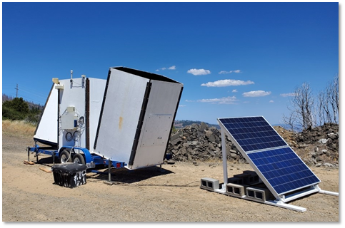
Figure 1. Photograph of the ACS Model 2000 Sodar system used at the upper-air monitoring site near Cobb Mountain, California.

Before deployment, the sodar instrument underwent extensive testing to ensure that all systems, including power sources, data management, and communications, were functioning correctly. After installation at the field site on July 25, 2020, the sodar was remotely monitored and maintained throughout the study period to October 26, 2020. Data was collected continuously and transmitted hourly to an FTP server, where it was processed and stored in a Microsoft SQL Server database.

The data collected by the sodar, including wind speed and direction across various heights, was periodically reviewed for quality by trained data analysts. Additionally, real-time data was made accessible via a dedicated website linked to the Pyregence project website, allowing stakeholders to monitor the wind conditions throughout the pilot study. Challenges, such as noise interference from nearby structures, were addressed through several corrective measures, including repositioning the sodar and software adjustments.

Following the data collection phase, the research team conducted different data analyses to demonstrate the value of upper-air wind data in improving short-term wind forecasts.

Tree Mortality, Fuel Measurement, and Fire Physics (Workgroup 2)
The approach Workgroup 2 used involved a multi-disciplinary strategy to assess tree mortality and its impact on wildfire behavior and fuel loads in California. This approach included fire physics laboratory experiments, advanced high-resolution tree mortality mapping, detailed fuels measurements and predictive fuels modeling to generate new insights into fire dynamics, tree mortality, fuels measurement, and fuel succession in forest ecosystems experiencing extensive tree mortality.

Laboratory Experiments
Cobian-Iñiguez et al. (2022) from Workgroup 2 focused on investigating the smoldering behavior of simulated wildland fuels under varying wind speeds and fuel bed porosities. The researchers conducted a series of small-scale controlled laboratory experiments using wooden cribs to represent wildland fuel beds. These cribs were burned inside a bench-scale wind tunnel, and the smoldering behavior was characterized by measuring both mass loss and emissions throughout the combustion process.
The experiments were designed to simulate the conditions that occur after the passage of a flaming wildfire front, where large woody fuels continue to burn in a smoldering state. The study explored how different wind speeds (ranging from 0.5 m/s to 1.25 m/s) and fuel bed porosities affected the smoldering combustion rate. To analyze the experimental data, theoretical models of mass transfer and heat transfer were applied.
In addition to small scale burn experiments conducted by Workgroup 2, a large-scale burn chamber was constructed over the course of the project at the US Forest Service – Missoula Fire Science Laboratory (Figure 2). The burn chamber, called Grain Bin-Ventilation Controlled Combustion Facility, was designed to accommodate fire experiments on larger-scale fuels, such as large logs, duff and organic materials. COVID-related supply chain interruptions slowed the facilities construction, which in turn delayed the team’s ability to fully execute a complete set of experiments for this project at the time of this report. However, preliminary pilot experiments were completed successfully, following similar methodologies used by Cobian-Iñiguez et al. (2022) using larger sized fuel particles.
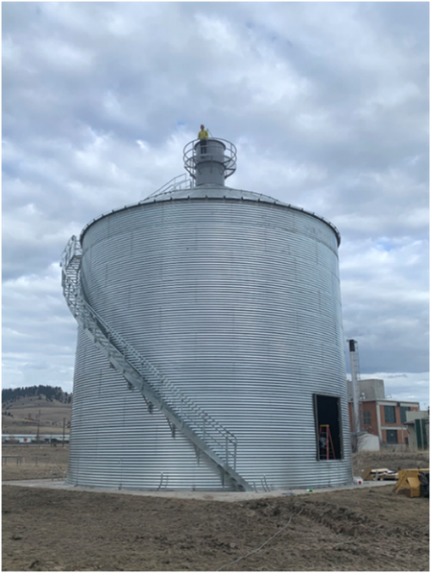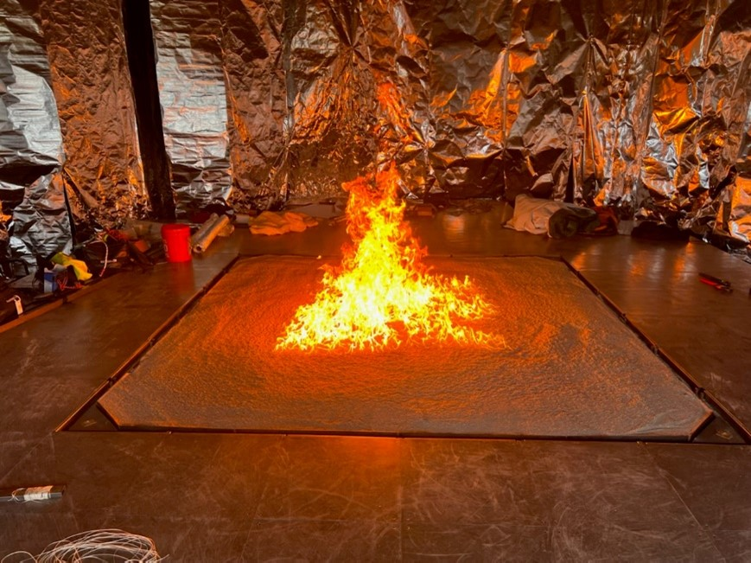
Figure 2. Photos showing the exterior and interior of the Grain Bin-Ventilation Controlled Combustion Facility at US Forest Service – Missoula Fire Science Laboratory.

Fuel Measurement System
The approach used for developing a fuels measurement system involved the application of hierarchical spatial statistical models and intensive field data collection to analyze the fine-scale spatial patterns of wildland fuels. The study focused on Sierra Nevada mixed conifer forests, particularly those impacted by the 2012-2016 drought.

The team collected detailed data on various wildland fuel components, including duff, litter, fine woody debris, coarse woody debris, understory vegetation, trees, and saplings. This was done using a modified forest inventory protocol that emphasized spatially explicit sampling at a fine scale (sub-meter to tens of meters). The sampling protocol developed and used aimed to capture the spatial heterogeneity of these components across plots stratified by different levels of drought mortality severity.
Hierarchical spatial statistical models were used to evaluate field data, incorporating Gaussian process spatial random effects, to quantify and describe the fine-scale spatial patterns of the collected fuel load data. These models accounted for the spatial autocorrelation within each fuel component and allowed for the generation of realistic simulations of fuel beds that could be used to predict fire behavior under varying conditions. The models were validated against three criteria: their ability to make pointwise predictions, reproduce fine-scale observations, and replicate coarse-scale mean fuel loads. The study found that while some models performed well, particularly for duff and fine woody debris, others struggled with infrequent events, such as the presence of coarse woody debris or saplings. The approach provided a framework for integrating observational field data with predictive fuels modeling, offering insights that could improve forest management practices aimed at mitigating fire risks​.

Forecasting Surface Fuel Loads
Workgroup 2 used a combination of field data collection and modeling techniques to assess the progression of snag fall (standing dead trees) and fuel succession following a significant tree mortality event caused by the 2012-2016 drought in California. The team used data from two key studies, including: the Drought Mortality Network and the Forest Demography Study, both of which provided extensive, long-term datasets on tree mortality and forest dynamics in the southern Sierra Nevada.
Field data collection involved monitoring tree and fuel inventory plots established across the Sierra Nevada to quantify how recently dead trees influenced fuel loads and fire hazards. These plots were strategically placed across different levels of drought mortality severity to capture the variation in fuel accumulation and snag fall rates. The team used snag fall models using the long-term data from the Forest Demography Study, which tracks tree mortality and fuel dynamics annually. The data from the Drought Mortality Network allowed for the documentation of immediate impacts and provided predictions for future fuel accumulation and snag fall rates.
To analyze and predict fuel load changes over time, Workgroup 2 used hierarchical spatial statistical models, integrating the empirical (field) data with predictions of future snag fall rates. These models accounted for species-specific and size-dependent variations in snag longevity and decay rates, offering insights into how fuel loads might evolve in the coming decades. The study's findings were used to refine vegetation simulation models, such as the Forest Vegetation Simulator (FVS), particularly in its snag fall algorithms, to improve predictions of fuel load dynamics in response to tree mortality events.

Contemporary Tree Mortality Mapping
The objective of the contemporary tree mortality mapping effort was to provide detailed, high-resolution maps of tree mortality that could be integrated into wildfire behavior models to assess and mitigate the risks posed by elevated tree mortality. The primary method involved training a deep learning model using multi-temporal satellite data from multi-spectral and radar sensors. Researchers from Workgroup 2 first created a response variable from 1-meter resolution maps of red-phase conifer mortality (i.e., dead conifers with reddish-brown needles still attached), which was then averaged to a 10-meter resolution to match the satellite covariates. These covariates included 10-band multi-spectral data from Sentinel-2 and 2-band radar backscatter data from Sentinel-1. The model incorporated 24 bands of data from different seasons and sensors to capture the necessary biophysical changes associated with tree mortality.
The deep learning model used was a U-net model, a type of 2D Convolutional Neural Network (CNN) architecture, which is particularly effective in ecological contexts due to its ability to quantify spatial orientations of nearby objects and include contextual information about the surrounding environment. The model was trained on over 91,000 samples, validated on approximately 16,000 samples, and tested on nearly 19,000 samples, with measures to adjust for sample imbalance to minimize under-prediction.
Model validation was conducted by comparing the satellite-based mortality predictions with field data collected by the USGS Western Ecological Research Center and high-resolution training data. The results showed that the model provided conservative estimates of tree mortality, with lower prediction biases in areas of extreme mortality. The study's findings were consistent with independent US Forest Service mapping of tree mortality and demonstrated the potential of these maps to improve predictions of mortality-driven wildfires

Near-term Wildfire Forecasting Models (Workgroup 3)
The original objective of workgroup 3 was to develop computationally efficient models to provide near-term risk forecasts at a 0-to-7-day temporal scale and at a fine (30m) spatial scale to simulate spread of extant fire ignitions. Additionally, the workgroup was tasked to work with electric utilities to integrate models into their respective wildfire situational awareness programs. The overarching approach that the team used to accomplish these objectives was to refine, test, and evaluate the performance of near-term fire forecasting models that were developed by team members. Following guidance provided through stakeholder engagement early in the project, the team developed and deployed an easy-to-use, open-source, near-term fire forecasting platform called Pyrecast and evaluated its potential benefits to electric utilities using a case study.

Near-term Fire Forecasting Models and Tools
Stakeholder input provided at the beginning of the project indicated a need for improved wildfire behavior model, but also a platform that could display a range of wildfire risk related model outputs. Accordingly, the workgroup developed a framework that was used to guide the development of near-term fire forecasting platform (Figure 3). The framework identified datasets required for wildfire model inputs, the underlying modeling and analysis methods, and data outputs and final products (Figure 3). The framework was deliberately structured for modularity and accessibility, meaning that data and models within the framework could be easily updated to reflect the latest available science, users could customize back-end or front-end functionality as desired through additional software enhancements, and the geographic scope of forecasts could be scaled.
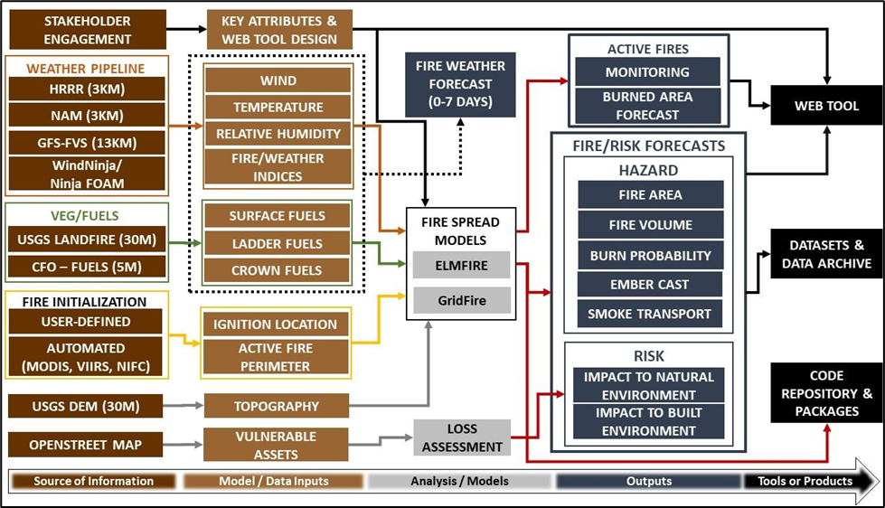
Figure 3. The framework used to guide the development of the PyreCast near-term fire forecasting platform.

Since its inception in 2020, the PyreCast platform has undergone several iterations of software development and enhancements to its user interface. Through its development, different sources of data have been integrated into the platform to improve the skill of risk and fire spread forecasts and/or to incorporate user needs identified through stakeholder engagement sessions. Currently, the PyreCast platform leverages a wide range of data from a variety of open-source services. In many instances, these data are viewable in the PyreCast user interface or otherwise used as wildfire model inputs. Repositories were created to allow advanced users access to data and model code used in the platform.

Wildfire Behavior Models Used in PyreCast
The wildfire computational engines (i.e., wildfire risk/spread models, shown in Figure 3) currently used for the PyreCast ‘Risk’ and ‘Active Fire’ spread forecast tools are ELMFIRE (Eulerian Level set Model for FIRE spread; Lautenberger 2013, Lautenberger 2017) and ‘GridFire’ developed by Gary Johnson from Spatial Informatics Group (Johnson et al. 2022). Some progress was made in refining software code for integrating the CAWFE model (developed by Janice Coen of Workgroup 1), however, the CAWFE model is not yet available in PyreCast.

ELMFIRE
The ELMFIRE (Eulerian Level Set Model of FIRE spread) wildfire behavior model (Lautenberger 2013, Lautenberger 2017), developed by Chris Lautenberger of Workgroup 3, utilizes advanced mathematical and computational techniques to simulate the spread of wildfires in both real-time and historical contexts. The model is built on the principles of level set methods, which allow it to accurately track the progression of complex fire fronts across various terrains. ELMFIRE incorporates a combination of wind, topography, and fuel conditions to predict fire behavior, employing the Rothermel model to calculate the spread rate in the direction of maximum spread (head fire). The model further refines this by adopting the elliptical wavelet approach, which considers each point along the fire front as an independent elliptical wavelet, thus providing more detailed and accurate predictions of fire spread in different directions. ELMFIRE includes features for estimating annual burn probability, fire severity, and quantifying landscape-scale fire behavior potential. The model has undergone extensive verification and validation, including comparisons with observed fire perimeters and simulation of canonical fire scenarios to ensure its accuracy and reliability.

GridFire
The GridFire wildfire behavior model was developed by Gary Johnson and other members of Workgroup 3 with a focus on leveraging existing fire science literature and computational methods to create an accurate and computationally efficient tool for simulating wildfire spread. The model is implemented using the Clojure programming language, running on the Java Virtual Machine (JVM), and is integrated with spatial databases like PostGIS for handling raster-formatted GIS layers. GridFire employs a series of well-established fire behavior formulas, including those for surface fire spread (Rothermel 1972), crown fire initiation (Van Wagner 1977), and flame length and fireline intensity (Byram 1959). The model was designed to handle complex environmental inputs such as fuel models, weather data, and topography, translating them into detailed fire spread simulations. One of its key features is the use of a raster grid system, originally developed in the HFire model by Morais (2001), which allows for adaptive time steps and fractional distances in fire spread calculations. The development approach of GridFire also includes dynamic fuel loading adjustments, wind adjustment factors, and sophisticated algorithms for translating 1D fire spread equations into 2D spatial simulations.

Coupled Atmosphere-Wildland Fire Environment (CAWFE)
Progress was made over the course of the project to integrate (through software code refinements) the Coupled Atmosphere-Wildland Fire Environment (CAWFE) model into PyreCast, however additional work is needed to fully operationalize it. Notably, there are plans to finalize software development and integration of CAWFE through a different funding source.

CAWFE was developed by Janice Coen of Workgroup 1 to simulate the complex interactions between wildfires and atmospheric conditions. The CAWFE model integrates a high-resolution, nonhydrostatic numerical weather prediction model with a fire behavior module, enabling it to capture the two-way interactions between wildfires and the surrounding atmosphere. The development of CAWFE focused on coupling the Clark-Hall weather model with a detailed wildfire behavior model. The atmospheric component simulates winds and weather patterns at scales relevant to wildfire behavior, while the fire module simulates surface and crown fires, accounting for factors such as fuel properties, terrain, and the heat released by the fire. This heat release, in turn, affects local atmospheric conditions, creating feedback loops that influence the spread and intensity of the fire.

The fire module employs a combination of empirical, semi-empirical, and physical models to represent processes like the rate of spread, post-frontal heat release, and smoke production. The model also uses a tracer method to define and track the fireline at subgrid scales, allowing for detailed simulation of fire spread and its impacts on the atmosphere. This approach enables CAWFE to provide insights into both fire behavior and its broader environmental impacts.

Evaluation of PyreCast Fire Model Performance
The approach to evaluating the performance of wildfire behavior models used in the PyreCast system involved both qualitative and quantitative methods and can be generally summarized as follows.

Data Collection and Model Initialization: The evaluation process began with gathering extensive data from previous fires, including satellite-based hotspot data, infrared perimeters from aircraft, and other fire polygons, to initialize the models. This data served as the foundation for forecasting fire spread and behavior in the PyreCast system​.

Retrospective Analysis: The evaluation involved retrospective assessments of model performance by comparing forecasted fire spread and behavior with the actual observed fire perimeters (from previous fires modeled in PyreCast). This included running hindcasts of historical fires (e.g., 2018 County Fire), and comparing the modeled fire perimeters against the observed data​.

Ensemble Simulations: To address uncertainties in model predictions, the ELMFIRE model, for example, runs in ensemble mode, where multiple simulations with slightly varied inputs (e.g., wind speed, fuel moisture) are conducted. The results from these ensemble runs were then analyzed to determine the overall fitness and accuracy of the model predictions.​

Correlation and Fitness Metrics: The evaluation process included calculating correlation metrics between the modeled and observed fire perimeters, which helps in quantifying how well the model predictions align with the actual fire behavior. This process was critical for identifying areas where the model performs well and where improvements are needed​.

Challenges and Improvements: The evaluation process also qualitatively identified challenges, such as spurious heat detections, fuel moisture data, and the influence of weather conditions like smoke inversions, which can impact model accuracy.

Recommendations: The team considered the results of the different evaluations performed and generated a list of recommendations to improve model performance.

Cost/Benefit Assessment of PyreCast
The approach to evaluating the benefits of the PyreCast system focused on a case study of utility pole pretreatments during the 2020 Glass Fire. The evaluation emphasized the value of reduced data latency in fire forecasts, which allows for more frequent and accurate updates to wildfire risk simulations, ultimately improving decision-making in real-time mitigation efforts. The evaluation compares the traditional, "Status Quo" approach to utility pole pretreatments with the enhanced approach enabled by PyreCast. The status quo referred to Technosylva’s Wildfire Risk Reduction Model (WRRM-Ops; as referred to in different utility wildfire mitigation plans) that relies on once-daily fire spread forecasts, whereas PyreCast allows for multiple updates per day (2+ per day), leading to more responsive and timely actions. By modeling the impact of these different approaches during the 2020 Glass Fire, the evaluation quantified the number of utility poles that could be saved from damage. The benefits were monetized by calculating the avoided costs of pole replacements, considering factors like the probability of pole damage, the cost of pole replacements, and the depreciation of pole value over time. The evaluation scaled the findings from the Glass Fire case study to estimate the potential statewide benefits in reducing the economic impacts of wildfires on utility infrastructure.

Long-term Wildfire Projections (Workgroup 4)
The objectives for this workgroup were to use the best-in-class data and science to develop the next generation of coupled statistical/dynamical fire-climate-vegetation model and produce long-term wildfire risk projections. A modeling framework was used as guide for the workgroup’s approach to integrate a statistical fire model with dynamic land surface model to assess long-term wildfire risks under various climate, land use, and management scenarios (Figure 4). Not shown in the modeling framework was a separate effort to explore the application of machine learning models for projecting wildfire risk. In addition, the project team decided not to couple the statistical fire models with the LANDIS II model because the LANDIS II model contains a coupled fire model subroutine (called ‘SCRPPLE’), and thus it was determined unnecessary to couple with UC Merced statistical fire model. The approach used for machine learning models and LANDIS II are discussed further below.
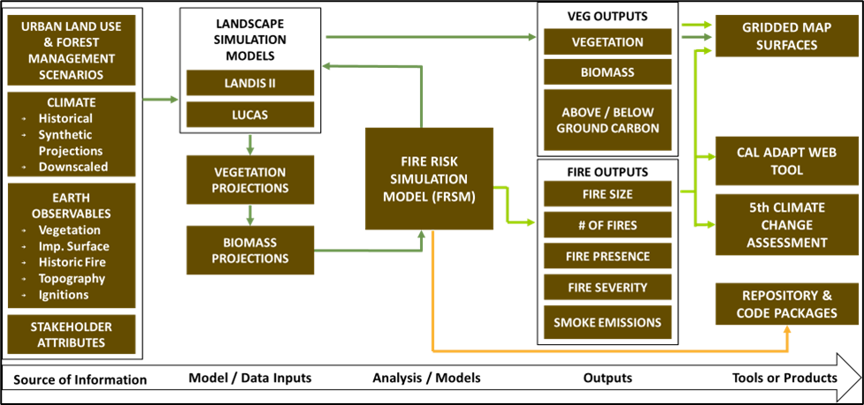
Figure 4. Generalized modeling framework used to guide the development of long-term wildfire projection models.

Coupled Statistical/Dynamical Fire-Climate-Vegetation Model
For coupled statistical/dynamical fire-climate-vegetation model, the project team combined computationally efficient statistical fire models developed by UC Merced with a dynamic vegetation model called ‘Land Use and Carbon Scenario Simulator’ (LUCAS; similar to Sleeter et al. 2022). The statistical fire model (Westerling et al. in prep.), with sub-routine methods developed by Xu et al. (2022a and 2022b) and Sam et al. (2022), were used to simulate large wildfire occurrences, extents, severities, and emissions based on historical and projected climate data. To enhance accuracy of model outputs, the team coupled the statistical fire model with the dynamic vegetation model (LUCAS) each year. This coupling allowed the models to account for annual feedback loops between wildfire disturbances and changes in biomass, vegetation and fuel loads, thereby improving the projection of fire risks over time. The team incorporated available downscaled and bias corrected CMIP6 climate data (from Scripps Institute of Oceanography and UCLA) for future climate simulated variables such as windspeed, direction, and relative humidity.

To select climate simulations for wildfire risk projections, the workgroup screened available climate data to establish a manageable set of wildfire risk projection model runs. In selecting climate scenarios, the team applied the following principles to filter 129 downscaled climate simulations produced by Scripps and UCLA:

- Weather variables (e.g., temperature, precipitation) that are required for wildfire simulation models must be available in climate scenario datasets (this filter reduced the number of climate scenarios from 129 to 68).
- The final number of climate scenarios should be tractable for wildfire simulations to be produced over the next year.
- Climate simulations must span most of the climate scenario outcomes through mid-century (through 2064) and were classified as “Tier 1” (n=5).
- Climate simulations include mid-century climate extremes, such as drought and precipitation extremes (and were classified as Tier 1 & 2a).
- Climate simulations represent high-quality/skilled models as determined by Scripps (Tier 1 & 2a, n=8).
- Climate simulations included at least scenarios that have been dynamically downscaled (i.e., hourly WRF data) and have necessary variables available in both dynamical and statistical downscaling (classified as “Tier 2b,” n = 1).
- Climate simulations represent significant variability in end of century climate (Tiers 1, 2, and 3).

Guided by these principles and an evaluation of plots of temperature and precipitation from climate simulation data, a total of 11 priority climate simulations, representing a range of available emission scenarios (i.e., Shared Socioeconomic Pathways [SSP]), were prioritized for wildfire risk simulations (Table 1). The remaining climate simulations, classified as “Tier 4,” were not prioritized for the project but have the full suite of variables downscaled that are needed wildfire risk models (n = 57 climate simulations). Notably, the workgroup did not explicitly select different SSPs as a principle to include for priority GCM simulations but instead plotted temperature and precipitation values for mid-century and end of century for two locations in California (Lake Tahoe and San Diego) to confirm representation of a full range of possible future conditions, regardless of SSP. Nonetheless, the finalized prioritized list of climate simulation resulted in good representation of SSPs (Table 1).

Table 1. List of downscaled climate model simulations that meet selection principles and range of shared socioeconomic pathways (SSP).
Tier | Climate Simulation/Scenario | Associated SSP
1 | ACCESS-CM2_ssp245_r1i1p1f1 | SSP2-4.5
1 | EC-Earth3-Veg_ssp245_r5i1p1f1 | SSP2-4.5
1 | MPI-ESM1-2-HR_ssp245_r1i1p1f1 | SSP2-4.5
1 | MRI-ESM2-0_ssp370_r4i1p1f1 | SSP3-7.0
1 | HadGEM3-GC31-LL_ssp585_r3i1p1f3 | SSP5-8.5
2a | ACCESS-CM2_ssp585_r1i1p1f1 | SSP5-8.5
2a | INM-CM5-0_ssp245_r1i1p1f1 | SSP2-4.5
2a | HadGEM3-GC31-LL_ssp585_r1i1p1f3 | SSP5-8.5
2b | EC-Earth3-Veg_ssp370_r4i1p1f1 | SSP3-7.0
3 | CNRM-ESM2-1_ssp585_r1i1p1f2 | SSP5-8.5
3 | EC-Earth3-Veg_ssp585_r4i1p1f1 | SSP5-8.5

Through the project’s Technical Advisory Committee and stakeholder engagement, the team identified scenarios related to vegetation management and urban growth intensity to assess how scenarios might affect potential impact trajectories of wildfire risks. For vegetation management, the following two scenarios were identified:
- High Ambition Vegetation Management Scenario - This scenario models forest treatments to meet a goal of one million acres treated per year, a goal identified in a 2018 Executive Order and emphasized in the 2021 California Wildfire and Forest Resilience Action Plan; the plan prioritizes reducing fuels (i.e., through vegetation management) in areas classified by Pyrologix with “high” or “very high” wildfire hazard potential.
- Business-As-Usual (BAU) Vegetation Management Scenario - This scenario represents an attempt to sustain the vegetation management/treatment approach/effort from the previous decade (2010-2019). As such, the total average annual treatment rate across the state is approximately 140,000 acres per year, or 86% less activity than the high ambition scenario.

In addition to vegetation management scenarios, we identified two development footprint scenarios for use in wildfire model simulations, including:
- “Sprawl”: a scenario based on historic urban growth patterns and represents ‘business as usual’ urban sprawl’ development pattern. Under this scenario, development would be allowed to occur throughout areas designated as the Wildland Urban Interface (WUI).
- “Concentrated/Infill”: this scenario represents a concentrated/infill development pattern that limits development to within or directly adjacent to existing development.

Urban growth scenarios were based on the anticipated magnitude of new development (“transition targets”), the adjacency of new urban development relative to existing developed areas (“spatial adjacency”), and the concentration of growth relative to land use type (“spatial multiplier”). Transition targets for scenarios were based on historical rates of development that were specified for each county based on California Farmland Mapping & Monitoring Program (FMMP) data. Future projections would draw stochastically from the full range or a subset of years (to emphasize a future with high growth or low growth) in each time step.

Notably, climate and vegetation management scenarios were also applied to LANDIS II model efforts. That is, urban growth scenarios were not applied in the LANDIS II modeling effort.

The models produce a variety of spatial and tabular outputs, including probability maps of large fire occurrences, projected fire severities, and impacts on vegetation and carbon stocks. These outputs were generated at different spatial resolutions (e.g., 3km and 30m) and timeframes, providing insights into potential future wildfire risks. Projected wildfire risk outputs were archived in local servers at UC Merced as well as a data catalogue managed by the Cal-Adapt Analytics Engine program.

LANDIS II Forest Landscape Model
In addition to coupled models described above, the project team used the LANDIS II model – an open-source landscape simulation tool designed to model forest dynamics over large spatial and temporal scales, ranging from hundreds to millions of hectares and spanning decades to centuries. It simulates forest and shrub species as cohorts within a grid, allowing for the study of processes such as growth, succession, natural disturbances (like fire, wind, and insect outbreaks), and human interventions (such as harvesting and land use changes). The model is customizable, offering different extensions that can simulate different ecological processes, including carbon dynamics, disturbance regimes, and forest management strategies. LANDIS-II is open-source and supported by an active community of users and developers. LANDIS II was applied by simulating only forest dominated landscape dynamics and disturbances in California.

The initial vegetation conditions used as model inputs were derived from various data sources like TREEMAP (Riley et al. 2016) and updated with tree mortality data from this project. The model incorporated historic weather inputs to drive processes such as forest growth and decomposition, tracking carbon dynamics across different pools (live, dead, and soil organic matter).

Wildland fires were simulated using the SCRPPLE extension in LANDIS II, which models fire behavior based on ignitions, fuels, topography, and weather. Insect outbreaks were also modeled, focusing on key pests like the mountain pine beetle, with outbreaks driven by factors such as drought stress and warm winter temperatures. Similar to the coupled statistical/dynamical fire-climate-vegetation modeling effort, LANDIS II modeling included two vegetation management scenarios— as described above. These scenarios were used to assess the impacts of different management strategies on wildfire hazard potential. The spatial resolution that the model operated at was 150m resolution, with climate data input at a 12km grid.

Application of Machine Learning Models
The approach used for predictive machine learning models integrated a variety of data sources, predictive models, and statistical analyses to provide insights into wildfire ignition probabilities, burn severity, and potential impacts on different ecoregions across California (Hawbaker et al., in prep). The study used an array of data sources, including weather data from GridMET, land cover data from LCMAP, and various topographical and human influence factors. These datasets were processed and resampled to a standardized 1-km resolution to ensure consistency across the analyses.

For predictive modeling, machine learning models, specifically random forests, were used to predict ignition probabilities, potential fire sizes, burn probabilities, and burn severities. The models use a wide range of predictor variables, including weather conditions, vegetation types, previous fire history, and human influences such as proximity to powerlines and roads. The research used statistical analysis to evaluate model performance. Metrics such as the area under the curve (AUC), mean error (ME), and root mean squared error (RMSE) were calculated to assess the accuracy of the predictions across different time steps (monthly, annual, and decadal) and ecoregions. The models were validated using cross-validation techniques to ensure their reliability

The research focused on capturing the spatial variability of wildfire risks across California's ecoregions. By downscaling models to a 1-km resolution, the research provided detailed maps of predicted ignition probabilities, burn probabilities, and severities, which are crucial for localized fire management and mitigation strategies.​ Recognizing the significant role of human activities in wildfire occurrences, the research included variables such as housing density, distance from development, and infrastructure proximity. These factors were integrated into the predictive models to better understand how human presence influences fire behavior.​

SUMMARY OF RESULTS
The following provides a summary of results from the various project products by workgroup. Detailed results and discussion and be found in referenced documents and/or from project deliverables linked in the “Project Products and Deliverables” section of this report.

Extreme Weather and Fire (Workgroup 1)

Weather Station Optimization Modeling
The results of this study highlighted areas across California where the current distribution of weather stations is either sufficient or lacking in both present and future climate scenarios. Under present-day conditions, urban regions such as the Bay Area, Los Angeles Basin, and San Diego are well-covered by existing weather stations (Figure 5). These areas show high similarity scores, indicating that the current network of stations adequately captures local climate conditions. However, rural regions like the northeastern Modoc, Basin and Range regions, the Mojave Desert, and the highest elevations of the Sierra Nevada exhibit lower similarity scores, signaling that these areas are not as well-represented by the existing network (Figure 5).

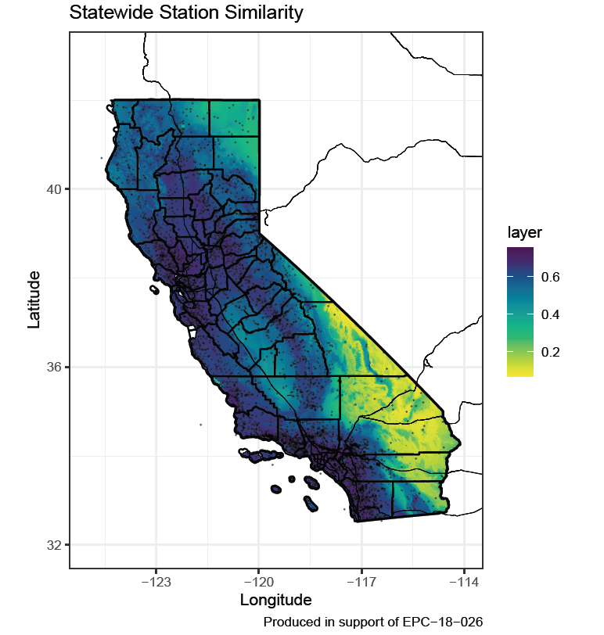
Figure 5. Statewide similarity scores under present-day climate conditions. Similarity scores are shown using color ramp, where higher values indicate more similar climate conditions to areas with weather stations. Weather stations are shown on map as black dots.
Looking toward future climate conditions, the patterns of insufficient coverage largely persist. Areas that are projected to experience significant climatic changes, such as the Modoc region, the San Joaquin Valley, and the Sierra Nevada, continue to show high dissimilarity from conditions captured by current weather stations. Notably, the study found that coastal areas, which may see more variability in future climate conditions, also demonstrate increased dissimilarity in the future scenario, suggesting that additional stations may be necessary along the immediate coastline (Figure 6).

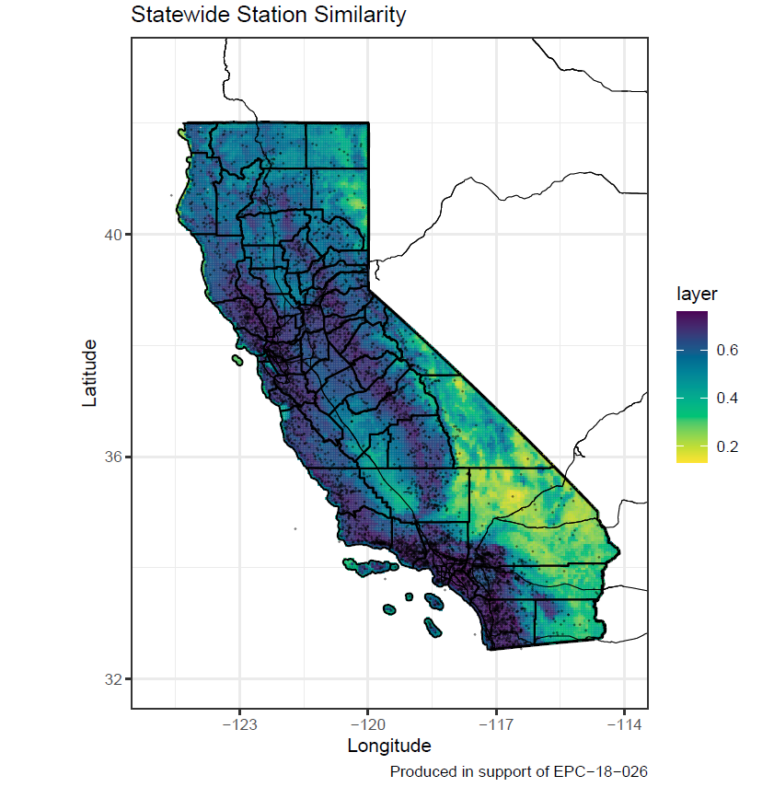
Figure 6. Statewide similarity scores under predicted future climate conditions. Similarity scores are shown in color ramp, where higher values indicate more similar climate conditions to areas with weather stations. Weather stations are shown on map as black dots.
The study also provides a detailed analysis of the coverage within different utility service areas (IOU domains) and fire weather regions. It was found that regions managed by utilities such as Pacific Gas & Electric (PG&E) and Southern California Edison (SCE) have significant areas of dissimilarity, particularly in more remote or complex terrains like the Mojave Desert and the Sierra Nevada (Figures 7 and 8). Similarly, within various fire weather regions, the current network of weather stations fails to adequately cover areas that are crucial for understanding and predicting wildfire behavior, particularly in higher elevation zones and those close to urban-wildland interfaces.
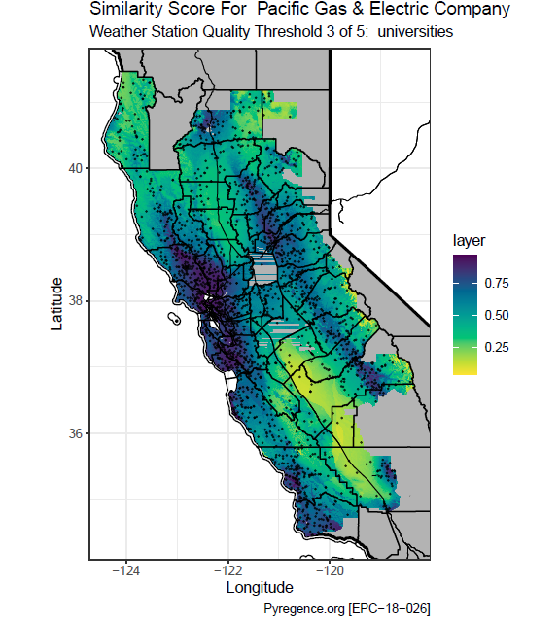
Figure 7. Similarity scores for Pacific Gas & Electric Company service area under present-day climate conditions. Similarity scores are shown using color ramp, where higher values indicate more similar climate conditions to areas with weather stations. Weather stations are shown on map as black dots, including all stations from the three highest quality levels: federally operated, IOU/state operated, and university operated.
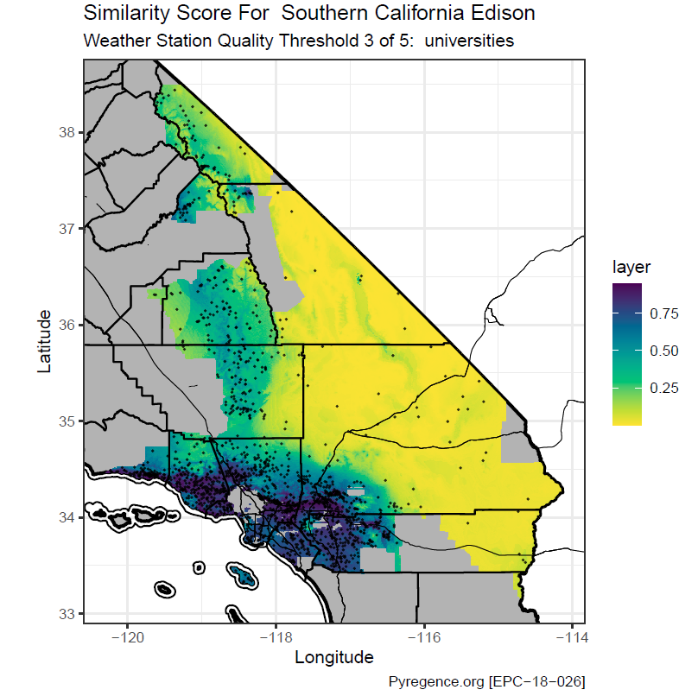
Figure 8. Similarity scores for Southern California Edison service area under present-day climate conditions. Similarity scores are shown using color ramp, where higher values indicate more similar climate conditions to areas with weather stations. Weather stations are shown on map as black dots, including all stations from the three highest quality levels: federally operated, IOU/state operated, and university operated.

The results emphasize the need for a more coordinated and comprehensive approach to weather station deployment across California, particularly in underrepresented areas that are likely to be affected by both current and future climate variability. This approach should consider not only the density of stations but also the specific climatic and topographic challenges that may influence weather patterns and wildfire risk in these regions

Extreme Weather Types Analysis
The results presented in this study were published by Prein et al. (2022). Results were generated from an analysis of the synoptic-scale atmospheric conditions, referred to as weather types (WT), that are most strongly associated with large daily burned areas during California wildfires. The study identified several distinct WTs across eight regions in California (Figure 9), each of which has a significant impact on fire behavior. These WTs include Santa Ana and Diablo wind events, which are characterized by strong, dry downslope winds primarily occurring in the fall. These events have shown an increase in frequency during the 20th century, particularly in regions like San Diego and the Bay Area. However, the study projects a future decrease in the frequency of these events under continued climate change.
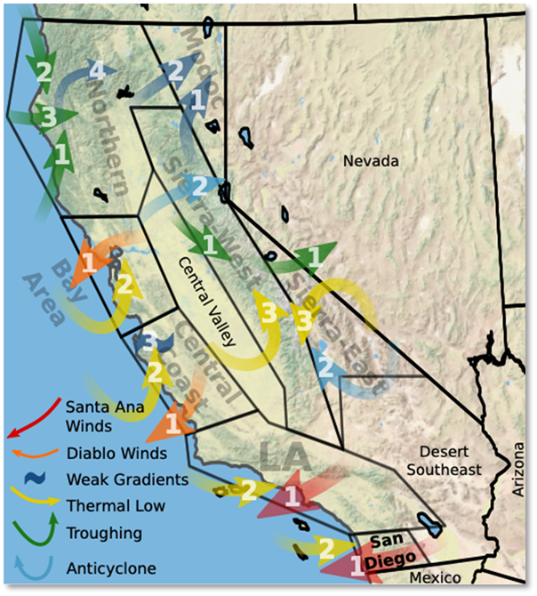
Figure 9. Map showing weather regions and weather types in California.

Additionally, the study found significant future increases in WTs associated with thermal low-pressure systems, particularly along the California coast and in the Sierra West region. These increases are largely attributed to the effects of greenhouse gas forcing, which enhances the ocean-land temperature gradient, and aerosol forcing changes, which reduce relative humidity over land and strengthen low-pressure anomalies along the coast. These changes suggest that future weather patterns will likely create conditions more conducive to large fire growth during the summer months, while reducing fire risk in the fall.

The study's results also highlight the variability in WT frequency across different regions and the influence of natural climate variability versus anthropogenic climate change. For instance, the Modoc and Sierra East regions are expected to experience significant increases in WT frequency due to increased greenhouse gases, while the frequency of traditional WTs like Santa Ana and Diablo winds may decrease. This shift could have important implications for wildfire management and risk assessment in California as climate change continues to alter the atmospheric dynamics that drive extreme fire weather.

Overall, this study underscored the critical need for ongoing monitoring and adaptation strategies to address the changing nature of wildfire risk in California, driven by both natural variability and anthropogenic factors. The detailed analysis of WTs and their projected changes provided in Prein et al (2022) provides valuable insights for improving fire weather forecasting and enhancing the resilience of communities in fire-prone areas.

Coupled Atmosphere-Wildland Fire Environment (CAWFE) model – Case Studies
The modeling and evaluation of nineteen different fire events using the CAWFE model revealed strengths and limitations as a modeling platform. CAWFE's primary strength lies in its ability to dynamically couple the processes of fire spread with atmospheric feedbacks. This coupling allows it to simulate phenomena such as the development of fire-induced vortices, extreme wind patterns, and the formation of pyrocumulonimbus clouds—factors that play a critical role in the escalation of fire behavior during events like the 2020 Creek Fire and the 2018 Carr Fire. The model's ability to operate at high spatial and temporal resolutions enables it to capture fine-scale variations in fire behavior, which are crucial for understanding how fires spread through complex terrains and under varying meteorological conditions. For example, CAWFE accurately simulated the rapid spread of the Tubbs Fire and the dynamic wind patterns that drove it into urban areas. CAWFE has been validated through numerous case studies involving high-profile wildfires, including the 2020 East Troublesome Fire, the 2017 Tubbs Fire, and the 2018 Camp Fire. These simulations have consistently shown that CAWFE can reasonably reproduce the spread patterns and some of the extreme behaviors observed during these fires, lending credibility to its predictive capabilities​.
Some of the limitations identified for CAWFE model included computational requirements, data dependencies, and challenges in operationalizing the model. The complexity and high resolution of CAWFE come with significant computational demands, which can limit its application for real-time operational use. The model requires powerful computing resources and extensive data inputs, making it less practical for rapid deployment during active fire events. The accuracy of CAWFE simulations is heavily dependent on model parameterization and the quality and availability of input data, including detailed meteorological data, fuel characteristics, and initial fire conditions. Inaccuracies or delays in obtaining this data can lead to errors in the model's predictions, potentially limiting its reliability in fast-evolving fire situations.
Despite its advanced capabilities, CAWFE has seen limited use in operational fire management settings. This is partly due to its complexity and the specialized expertise required to run the model and interpret its outputs, which can be a barrier for fire managers who need straightforward, actionable information during emergencies. The case studies explored demonstrated that CAWFE excels in simulating extreme fire behaviors, however, its application in lower-intensity fire scenarios has been less explored.
Animated CAWFE simulation used in this evaluation can be viewed in https://pyregence.org/extreme-weather-and-wildfire-ct/wildfire-simulations.

Upper Air Profiler Pilot Study
The results from the upper-air profiler pilot study demonstrated the value of integrating upper-air wind data with existing surface measurements. The pilot study, which deployed a sodar wind profiler in Northern California from July to October 2020, aimed to improve the accuracy of short-term and very-short-term forecasts of high wind events that contribute to extreme fire weather conditions.
The sodar wind profiler successfully collected vertical wind profile data, capturing wind speed and direction at various heights from 80 to 600 meters above ground level. The study analyzed the data collected during two significant wind events: a thunderstorm-induced event on August 15-16, 2020, and a Diablo wind event on September 26-29, 2020.
During the August thunderstorm event, the sodar data showed rapidly changing wind conditions aloft, but these changes did not immediately translate to increased surface winds. This variability highlighted the complexity of predicting wind behavior during thunderstorms and the challenge of using upper-air data to anticipate surface wind speeds under such conditions.
In contrast, the September Diablo wind event provided more conclusive results. The sodar profiler detected stronger winds aloft well before these winds descended to the surface, demonstrating a clear pattern of wind intensification over several hours. This information could allow utilities and fire weather forecasters to better predict the timing and intensity of surface winds associated with Diablo wind events, which are notorious for exacerbating wildfire risks.
The study's results suggest that upper-air wind profilers, like the sodar used in this pilot, can significantly enhance situational awareness during extreme weather events by providing early warnings of wind conditions that could lead to dangerous fire weather. The pilot study also revealed the importance of carefully selecting profiler locations to maximize the utility of the data, particularly in regions prone to strong, complex wind patterns like those found in Northern California.
Despite some challenges, including interference from nearby structures and noise during high winds, the sodar wind profiler provided valuable data that can be used to improve wildfire prediction models and enhance grid resiliency. The study concludes with recommendations for the development of a more extensive network of upper-air profilers across California, which could provide critical data for predicting and managing extreme fire weather conditions in the future.

Tree Mortality, Fuels and Fire Physics (Workgroup 2)

Small- and Large-Scale Laboratory Experiments
The small-scale laboratory study on the wind effects on the smoldering behavior of wildland fuels conducted a series of bench-scale wind tunnel experiments using wooden cribs to simulate wildland fuel beds (Cobian-Iñiguez 2022). The results demonstrated that wind speed significantly influences the smoldering combustion of these fuels. Specifically, the study found that the mean smoldering burning rate generally increased with wind speed across different fuel porosities, with high porosity cribs showing a gradual and substantial increase in burning rate as wind speed increased. The study also observed a decrease in the CO/CO₂ emission ratio with increasing wind speed, suggesting that higher wind speeds promote more efficient smoldering combustion.
The analysis revealed an exponential decay in the mass loss rate during the smoldering phase, which the researchers attributed to a combination of mass and heat transfer processes. Theoretical models for both heat and mass transfer were able to reproduce the general trend observed in the experiments, though neither alone could fully explain the smoldering behavior. The study concludes that wind plays a crucial role in enhancing smoldering combustion, particularly in large woody fuel beds, and highlights the need for further research to incorporate these findings into practical fire spread models.
At the time of this report, large-scaled experiments associated with the “Grain Bin” burn facility at the US Forest Service – Missoula Fire Sciences Laboratory were on-going. The burn chamber itself was erected and instrumented during the Pyregence project. Some preliminary findings from initial experiments were presented by Mark Finney at the 7th Fire and Fuel Conference in Boise, Idaho (April 15 -19, 2024) as a keynote address “Big Fuels for Big Fires: Experiments to understand burning behavior of forest fuel complexes” (https://boise.firebehaviorandfuelsconference.com/program-schedule). Main findings reported at the conference included:
- Solid phase combustion (char burning) is a significant source of variability in burning rate – with approximately a four-fold increase in burning rate seen among experiments where the wind was varied.
- Wind increases reaction temperature and rate (blowing on the coals) and facilitates smoldering to flaming transition (Figure 10).
- Logs are seen to burn from underneath, with logs rolling when becoming top-heavy; this rolling increases the continued burning.
- Once large woody fuel is ignited, there may not be a need for other fuels to keep them burning (duff, intersections). The sand beneath them gets hot, coals fall from burning logs overhead to produce fuel burning on sand surface, and ventilation of the fuel-sand interface increases burning temperature and hot sand minimizes heat losses.
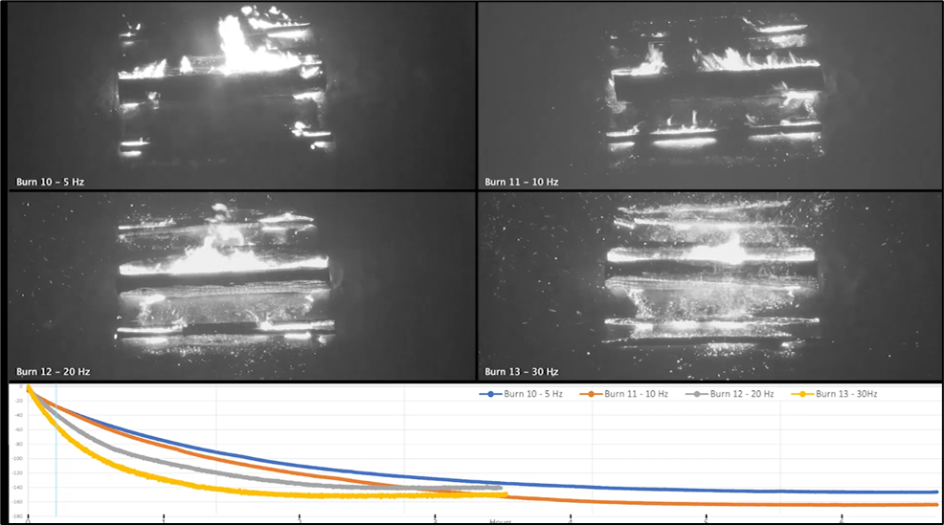Figure 10. Initial large burn chamber results of four separate burn tests with identical fuel configurations. Top left low wind (blower 5Hz speed) which is <2 m/s, top right blower speed 10Hz, bottom left blower speed 20Hz, and bottom right blower speed 30Hz. Bottom graph - Mass loss curves for each burn are shown on the graph and correspond to the video frames.
The US Forest Service fire lab team plans to continue implementation of burns beyond this project and provide findings as they become available to CEC and stakeholders through journal publications. Notably, insights learned from both small- and large-scale burn experiments are critical for improving our understanding of post-frontal smoldering in wildfires and for refining predictive models of fire behavior in wildland fuel beds.

Fuels Measurements System
Foster (2022), from Workgroup 2, developed hierarchical spatial statistical models to quantify fine-scale spatial patterns of various wildland fuel components in Sierra Nevada mixed conifer forests affected by drought-induced tree mortality. The study revealed that different levels of drought mortality do not significantly alter the fine-scale spatial patterns of most fuel components. However, certain components, such as litter depth and understory vegetation, show some variations in spatial patterns across different mortality levels. The models performed well in simulating realistic fuel beds and provide important insights into how fuel load patterns might influence fire behavior​.
The research also explored the impact of prescribed fires on the spatial pattern of wildland fuels. Foster (2022) found that prescribed fires not only reduce mean fuel loads but also significantly alter the fine-scale spatial patterns of fuels such as litter, duff, and fine woody debris. The burns increase the relative strength of spatial autocorrelation for these components, which may influence subsequent fire behavior and ecological processes in the treated areas​.

Forecasting Surface Fuel Loads
The research forecasting surface fuels completed by this workgroup revealed new insights into how the 2012–2016 drought-induced tree mortality in the Sierra Nevada will impact future wildfire risks due to changes in surface fuel loads. The study found that in the short term (2017–2021), fine woody debris and litter, as well as duff, increased substantially across the study sites, with fine woody debris increasing by more than 145% and total fuel loads increasing by up to 69% in some areas. Snag (standing dead tree) longevity was observed to vary by species, with larger trees generally remaining standing longer. However, yellow pine was an outlier, with size playing a minimal role in its fall rates.
By 2040, the study projects that cumulative biomass inputs from future snag falls will range from 49.4 to 136.1 Mg ha−1 (Figure 11), which exceeds current levels and is significantly higher than historical amounts of coarse woody debris in the Sierra Nevada. This increase in surface fuels due to the extensive snag falls is expected to elevate the risk of severe wildfires, particularly in areas with high densities of large yellow pine snags, which are prone to faster fall rates. The study's findings provide empirical data to refine the snag fall algorithm in vegetation simulation models like the Forest Vegetation Simulator (FVS) and highlight the potential need for management interventions, such as salvage logging or prescribed burning, to mitigate the increased wildfire risks posed by these fuel accumulations​
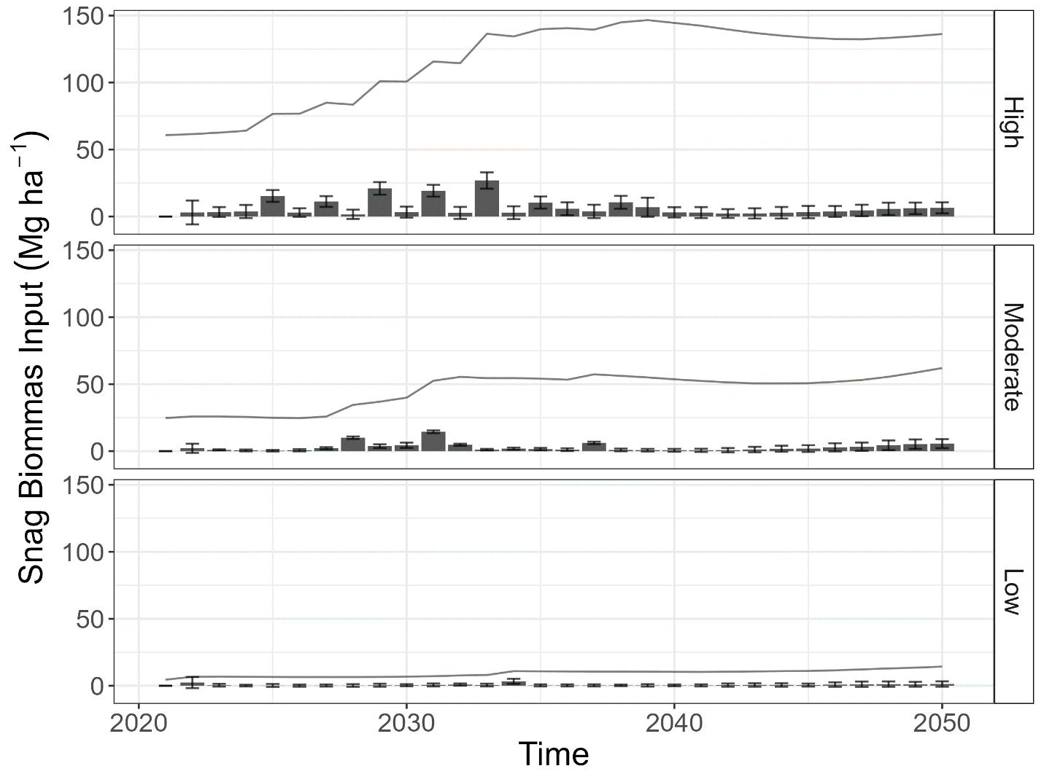
Figure 11. Forecasted biomass inputs over time based on standing snags in 2021 and model predictions by Mortality Class (low, moderate, high), based on median modeled fall rates and wood decay rates. Bars depict forecasted annual biomass input from snag fall, the error bars depict standard error of annual biomass input, and the lines depict total woody fuel load. Mortality classes defined as: High > 18% cumulative mortality; Medium = 7-18% cumulative mortality, and Low = < 7% cumulative mortality.

Contemporary Tree Mortality Mapping
The Salo Science team from Workgroup 2 focused on mapping and analyzing the extent of tree mortality in California from 2016 to 2018, using advanced satellite data and machine learning techniques. The study produced high-resolution maps that quantified dead tree cover across the state, particularly in regions heavily impacted by drought and pest infestations. The results indicated that tree mortality was concentrated in the central and southern Sierra Nevada ecoregions, with dead tree cover reaching up to 30% in some areas (Figure 12).

The satellite-derived maps produced from this effort aligned well with independent measurements from the US Forest Service Aerial Detection Survey, confirming the accuracy of the mortality patterns captured. The research also demonstrated a link between the spatial distribution of tree mortality and the occurrence of high-intensity wildfires, such as the 2020 Creek Fire, which burned through areas with severe, progressive tree mortality.
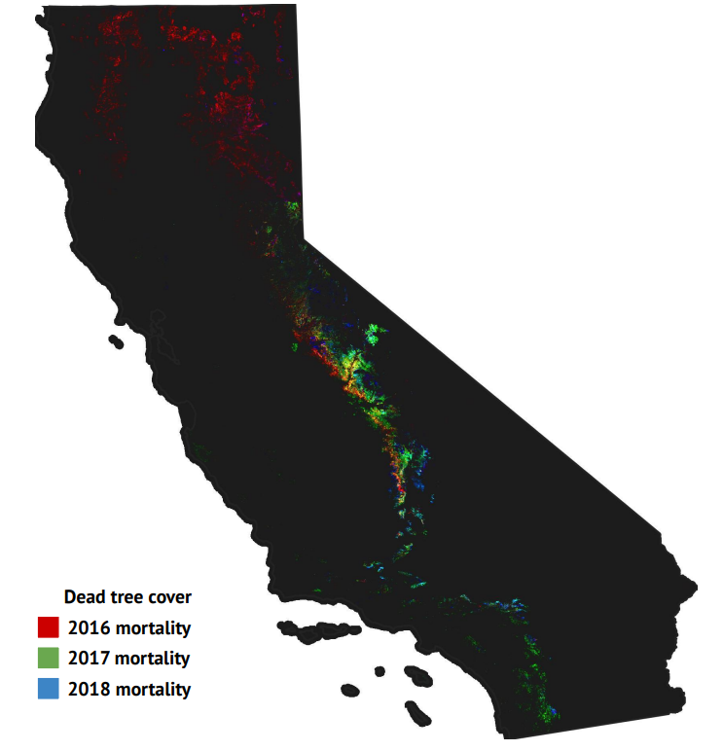
Figure 12. Progressive shifts in tree mortality distributions are mapped here with an RGB composite, where red tracks tree mortality in 2016, green tracks mortality in 2017, and blue tracks mortality in 2018. This map shows how dead tree distributions shifted up-slope in the central and southern Sierra Nevada over this period. Mortality was pronounced in the Klamath and Cascades ecoregions of northern California in 2016 (red) and increased in intensity in the Southern California Mountains ecoregion from 2017-2018 (green, blue).

Near-term Wildfire Forecasting Models (Workgroup 3)

PyreCast Near-term Fire Forecasting Platform
PyreCast was developed as a web-enabled near-term fire forecasting platform that provides tools for visualizing up to 14-day forecasts for: 1) weather (including curated wildfire weather indices), 2) wildfire risk and hazards, and 3) active wildfire spread (Figure 13). PyreCast was developed as a suite of tools to address the rising threat of catastrophic wildfires, with specific emphasis on understanding potential near-term impacts to and from the electricity grid. Using these web-based tools, emergency managers can order more timely evacuations, firefighters can position crews to avoid danger and speed fire suppression, electrical utilities can forecast wildfire impacts to and from to the power grid, and insurance providers can better anticipate and assess impacts to their policy portfolios.
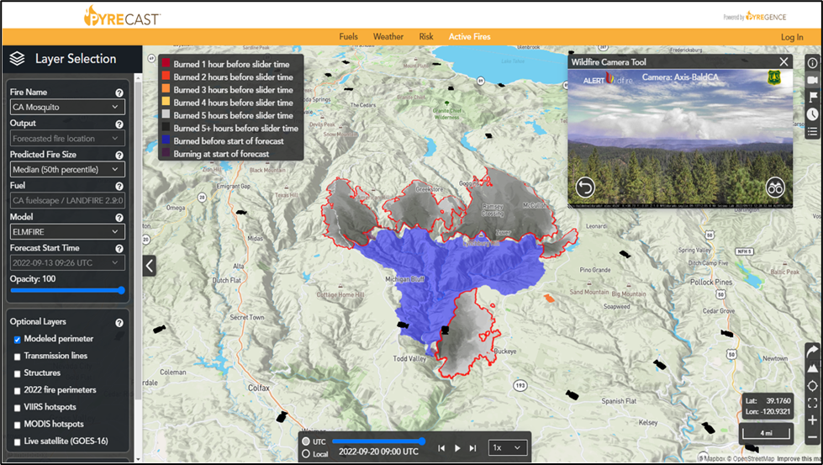
Figure 13. Display of the ‘Active Fires’ tool showing an example of areas already burned (blue polygon) and end of forecast burn perimeters (red outline). An inset of real-time wildfire cameras is also shown.

The PyreCast user interface includes the following features and functionality:
For weather-related forecasts, the system provides animated displays of gridded weather forecasts from several US operational weather models having different spatial resolutions and forecast durations, including:
- HRRR - High Resolution Rapid Refresh at 3 km resolution to 48 hours.
- NBM - National Blend of Models at 2.5 km to 11 days.
- GFS 0.125° - Global Forecast System at 0.125° (~ 13 km) resolution to 16 days.
- GFS 0.250° - Global Forecast System at 0.250° (~ 26 km) resolution to 16 days.
- NAM 12 km - North American Mesoscale Model at 12 km resolution to 84 hours.
- NAM 3 km - North American Mesoscale Model at 3 km resolution to 60 hours.
- Hybrid – Custom blend of HRRR, NAM 3 km, and GFS 0.125° to 8 days.
- CANSAC WRF - California and Nevada Smoke and Air Committee (CANSAC) Weather Research and Forecasting (WRF) forecast model from Desert Research Institute. Two cycles per day (00z and 12z) at very high (1.33 km) resolution.
- RTMA - Real Time Mesoscale Analysis at 2.5 km resolution updated every 15 minutes.

Available animated quantities displayed in the platform include common weather parameters and curated fire weather indices, such as:
- Temperature (F)
- Relative Humidity (%)
- Wind
  - Wind Direction (º)
  - Sustain wind speed (mph)
  - Wind Gust (mph)
- Accumulated precipitation (in)
- 1-hour precipitation (in)
- Total cloud cover (%)
- Fosberg Fire Weather Index (FFWI) - A fuel-independent measure of potential spread rate based on wind speed, relative humidity, and temperature.
- Vapor Pressure Deficit (VPD) - Difference between amount of moisture in air and how much it can hold when saturated.
- Hot Dry Windy Index (HDWI) - Like FFWI but based on VPD.
- Firebrand Ignition Probability - An estimate of the probability that a burning ember could ignite a receptive fuel bed based on its temperature and moisture content.
- Smoke Density (µg/m3) – Density of smoke in microgram/cubic meter.

Sources of landscape data (fuel models, slope, topography, canopy cover, etc.) that are currently viewable through the PyreCast user interface ‘Fuels’ viewer and used as inputs for wildfire behavior models include:
- LANDFIRE – Stock data are provided by USGS LANDFIRE program (versions 1.0.5 through 2.4) at 30m resolution.
- California Forest Observatory – Summer 2020 at 10m resolution. Courtesy of the California Forest Observatory, © Salo Sciences, Inc. 2020.
- 2022 California Fuelscapes data prepared by Pyrologix, LLC (https://pyrologix.com).
- Fire Factor 2023™ - Data provided by Fire Factor, which is used in the First Street Foundation Wildfire Model.

Other data that are viewable in the user interface as selectable layers provide important map context and include:
- Modeled perimeter - modeled fire perimeter of active fires after 14 days of spread.
- Transmission lines - from the Department of Homeland Infrastructure Foundation Level Dataset.
- Structures - Microsoft building footprints.
- Current year fire perimeters - current season fires (e.g., 2024) based on PyreCast model.
- Historic fire perimeters from National Interagency Fire Center (NIFC).
- VIIRS hotspots - Hot spots detected by the Visible Imaging Radiometer Suite sensor on the Terra and Aqua satellites - 375m resolution; source - Fire Information for Resource Management System (FIRMS).
- MODIS hotspots - Hot spots detected by the Moderate Resolution Imaging Spectroradiometer sensor on the Suomi NPP and NOAA-20 satellites. Source - Fire Information for Resource Management System (FIRMS).
- Live satellite (GOES-16) - Real time imagery from the GOES East satellite.
- Mapbox base maps: 1) street topo, 2) satellite, and 3) satellite/street that are viewable in 2d or 3d.
- Live Wildfire Cameras - live feeds from AlertCalifornia and AlertWildfire wildfire detection cameras, with plans to incorporate wildfire cameras from the AlertWest system once revenue is generated beyond CEC project.
- Red Flag Warnings – NOAA-National Weather Service fire weather program – red flag warning polygons.

For near-term risk modeling, the ‘Risk’ tool quantifies and displays potential fire consequences across California at a 5-day forecast horizon, including both risk from fires to the electric grid and as risk from the electric grid to other assets at risk. This is accomplished by modeling 500 million hypothetical fire starts ignited at various locations across the landscape and various times in the future under forecasted weather conditions. Two ignition patterns are selectable in the user interface, including:
- Anthropogenic and natural fires (excluding powerline fires). For this ignition pattern, human footprint and lightning probability are combined with a measure of seasonal dryness to ignite fires in a spatial and temporal pattern that mimics past fire occurrence.
- Powerline-caused fires. In this ignition pattern, fires are ignited in a buffer surrounding overhead electrical utilities so that potential impacts from the grid to other assets at risk are quantified.

Outputs of risk forecasts that are selectable for display in the user interfaces include:
- Relative Burn Probability - Relative likelihood that an area is burned by fires that have not yet ignited within the next six hours of time shown in time slider.
- Impacted Structures - Approximate number of structures within fire perimeter for fires starting at specific location and time in the future.
- Fire Area - Modeled fire size in acres by ignition location and time of ignition.
- Fire Volume - Modeled fire volume (fire area in acres multiplied by flame length in feet) by ignition location and time of ignition.
- Power Line Ignition Rate - Estimated power line ignition rate in ignitions per line-mile per hour.

The ‘Active Fire’ tool in PyreCast calculates and displays hourly forecasted fire perimeters out to 14-days. Initial fire start locations are derived from the US National Guard - FireGuard Program and from other sources (e.g., National Interagency Fire Center (NIFC) and CalFire). Following the initial fire start location, fire spread models are rerun throughout the life of the fire based on satellite-based heat detection data and refreshed approximately every 12 hours (when new VIIRS or MODIS data becomes available for download). Fire spread is modeled using an ensemble forecasting method where model inputs are perturbed from their baseline values. Approximately 1,000 ensemble members are aggregated together so that fire spread forecast outputs can be displayed for a fire event of interest as an animation in the user-interface in terms of burn probability (with selectable hourly outputs for 10th, 30th, 50th, 70th and 90th percentile fire spread probabilities).

Between 2020 and 2024, the PyreCast system has run and generated outputs for hundreds of thousands of active fire spread model simulations for over 500 unique fires events across California and the lower 48 states of the United States. In addition to active fire spread forecasts model simulations and since its launch date in 2020, the PyreCast system produced fire risk model outputs four times per day, continuously, representing millions of risk model simulations. In terms of platform and data usage from 2022, PyreCast has been used by more than 14,000 unique individuals, representing a wide range of users from electric utilities, fire and emergency professionals, research institutions, and the public.

Evaluation of PyreCast Model Performance
The evaluation of PyreCast model performance revealed several key challenges and insights. One major issue was the accuracy of satellite data, such as MODIS and VIIRS, which often contained outliers and errors. These inaccuracies, especially during specific conditions like plume dominated wildfires, led to skewed model predictions, particularly in complex terrains. Additionally, PyreCast models frequently overestimated fire behavior, especially in areas like wet meadows and during the early stages of the fire, due to faulty underlying data and assumptions, such as incorrect lateral fire spread predictions driven by erroneous MODIS data points.
The models also struggled to account for the effects of smoke inversions, which significantly dampen fire activity. This resulted in over-predictions of fire behavior during periods when the fire was actually suppressed by heavy smoke. Specific challenges during the 2021 Dixie Fire included difficulties in predicting fire spread in steep terrains, like the Feather River Canyon, where the model failed to account for fire rollouts and downcanyon winds. Additionally, the models did not accurately integrate the effectiveness of fire suppression efforts, leading to incorrect predictions of fire spread in areas that had already been contained.
To address these issues, several recommendations were made as part of the performance evaluation. Improving data filtering, particularly for MODIS data, was suggested, along with enhancing the model to better handle erroneous initialization data (i.e., hotspot information from satellite sensors). There was also a call for developing better prediction techniques for when fires rekindle after being suppressed by rain, using historical data and machine learning models. The current computational resources for PyreCast were found to be inadequate during peak fire seasons, prompting a recommendation to implement a hybrid computational approach that leverages cloud computing resources to improve the timeliness of forecasts.
The performance evaluation of the underlying spread models, ELMFIRE and GridFire, indicated that while they generally perform well under certain conditions, some challenges remain in accurately modeling fire spread, particularly under rapidly changing weather conditions and during fire suppression efforts. A retrospective assessment of 214 separate 7-day forecasts showed that the model performed better in predicting wind-driven fires than plume-dominated ones, highlighting the need for real-time automated forecast validation to continuously improve accuracy.
Looking forward, the expansion of PyreCast’s forecasting capabilities to include regions like Alaska and Hawaii was recommended, given the recent significant fire events in these areas. Continuous validation and improvement of the underlying models were also emphasized, alongside the development of methods for handling data inaccuracies and improving overall forecast reliability.

Cost/Benefit Assessment of PyreCast – Case Study
The PyreCast system was designed to enhance wildfire modeling and prediction, offering significant improvements over existing models based on outdated methodologies. A case study on the 2020 Glass Fire demonstrated the effectiveness of PyreCast in reducing the latency of wildfire risk data, enabling more timely and accurate utility pole pretreatment strategies.
The assessment showed that PyreCast’s ability to update wildfire spread simulations up to four times per day—compared to the once-daily updates under the status quo—can significantly reduce the number of utility poles that are damaged or destroyed by wildfires.
In the case of the 2020 Glass Fire, PyreCast enabled the treatment and protection of more poles, resulting in an estimated net benefit of $5.9 million per year for California ratepayers, compared to $0.155 million under the status quo. Overall, the assessment underscored the importance of advanced wildfire modeling tools like PyreCast in improving the effectiveness of wildfire risk mitigation strategies, leading to financial savings and enhanced safety for both utility infrastructure and the broader community.

Pyrecast Data and Code Repositories
The archive consists of two main components: open-source repositories and real-time outputs.

Open-Source Repositories:
The PyreCast system is powered by several open-source repositories, which have been made publicly available. These include the ELMFIRE and GRIDFIRE fire spread models, the PyreCast web application, and various helper scripts like Geosync. These repositories provide the foundational software and tools that run the PyreCast web application and its associated data feeds. Pyrecast is powered by software contained in the following open-source repositories that are publicly available:
Description | URL
ELMFIRE fire spread model | Code - https://github.com/lautenberger/elmfire  Instructions and tutorials - https://elmfire.io
GRIDFIRE fire spread model | Code - https://github.com/pyregence/gridfire
Pyrecast web application | Code - https://github.com/pyregence/pyregence
Geosync helper scripts | Code - https://github.com/pyregence/geosync

Real-Time Outputs:
The real-time outputs from PyreCast can be accessed through multiple online platforms, including the PyreCast web application, APIs, and a dedicated web server. These resources offer real-time data related to active fires and other relevant layers, making it possible for users to obtain up-to-date wildfire risk information.
Description | URL
Web application | https://pyrecast.org
Application Program Interface (API) – active fires | https://trinity.pyregence.org/geoserver/web/
Application Program Interface (API) – all other layers | https://shasta.pyregence.org/geoserver/web/
Web server | https://data.pyrecast.org/

Long-term Fire Projections

Coupled Statistical/Dynamical Fire-Climate-Vegetation Models
Final results from the coupled statistical/dynamical fire-climate-vegetation modeling effort are still pending. Notably, Workgroup 4 has completed some preliminary uncoupled UC Merced fire model runs based on priority climate simulations (representing downscaled WRF and LOCA2 data) for fire presence/absence, fire size, fire severity fractions, and a 30m downscaling model based on Xu et al. (2022a, 2022b) and Sam et al. (2022). Preliminary data on fire presence/absence, fire size, and fire fractions have been combined to produce lists of fires based on 2020 LUCAS historical vegetation estimations. The fire lists are based on a 3km grid (Teale Albers projection) and include size in hectares (fire size data present as uncapped (unlimited) in size and a “clean” data set that is capped to a maximum size of 3,000,000 Ha) and severity fractions (low, moderate, high) for both the uncapped and "cleaned" size. Also included in the preliminary data repository are burned area maps at a 3km resolution that annualize and spread fires in the fire lists into one burned area map per year. Preliminary data and associated readme files can be found at http://ungoliant.ucmerced.edu/data/CEC-Preliminary/.

LANDIS II Forest Landscape Model
Final result for LANDIS II forest landscape modeling effort are still pending. Notably, some preliminary LANDIS II model runs based on priority climate simulations (representing downscaled WRF data) have been completed for the two vegetation management scenarios. Preliminary data and associated readme files can be found at http://ungoliant.ucmerced.edu/data/CEC-Preliminary/.

Application of Machine Learning Models
A draft publication titled "Modeling spatial and temporal variability in wildfire patterns for California USA" prepared by Hawbaker et al. (in prep) from Workgroup 4 evaluated the drivers and patterns of wildfire occurrences across different ecoregions in California over a historic 30-year period (1990–2019). The analysis used advanced machine learning models to predict four key components of wildfire regimes: ignition probability, conditional large wildfire size, burn probability, and conditional burn severity, all at a high spatial resolution of 1 km and a temporal resolution of one month.
For this effort, a series of machine learning models were developed to relate wildfire occurrences to various predictors. These predictors included weather conditions (e.g., temperature, humidity, precipitation, and wind speed), land cover, vegetation, topography, human development, and past disturbances. The models were trained and validated using cross-validation techniques to ensure robustness, especially given the challenges of rare events like wildfires. The models performed best in predicting burn probability and ignition probability, with cross-validation AUC values ranging from 0.70 to 0.90. These models effectively captured the spatial and temporal patterns of wildfires, particularly in regions where weather conditions strongly influenced fire activity. However, the models for conditional large wildfire size and conditional burn severity had lower predictive accuracy, with AUC values ranging from 0.36 to 0.78. These models struggled to accurately predict the size of wildfires and the severity of burns, particularly in ecoregions with less frequent fire events.
The importance of different predictors varied significantly across ecoregions and wildfire regime components. Weather-related predictors, particularly relative humidity and precipitation were consistently the most important factors influencing ignition probability and burn probability. However, in some regions, factors such as topography, land cover, and human development were also critical. For example, in the Central California Valley, land cover and vegetation were the most important predictors, likely due to the limited extent of wildland vegetation in this region, which restricts where large wildfires can occur. In contrast, in the Sierra Nevada and Klamath Mountains, topography played a more significant role in influencing large wildfire probabilities.
The study revealed that observed wildfire ignition counts were highly variable over time, with no clear temporal trends in most ecoregions. Despite this variability, the models' predictions for annual wildfire counts correlated well with observed counts, with correlation values ranging from 0.24 to 0.87 on an annual basis. Burn probability predictions were particularly accurate, closely matching observed burned areas across ecoregions. This was evident in regions with extensive fire activity, such as the Sierra Nevada and Klamath Mountains, where the models effectively captured the spatial distribution and temporal trends of burned areas.
The models also provided insights into the spatial distribution of wildfire risks, identifying hotspots of high ignition probability and burn probability in regions like the Cascades, Eastern Cascades, Sierra Nevada, and California Coastal Sage Chaparral and Oak Woodlands.
The study acknowledged some limitations, including the coarse temporal resolution (monthly) and the challenges of representing fine-scale patterns of vegetation and land use at a 1 km spatial resolution. Additionally, the models had difficulty capturing the temporal variability in wildfire sizes and burn severity, particularly in ecoregions with fewer fire events. Additionally, there were uncertainties revealed that were associated with predictions for large wildfire sizes and burn severity, as indicated by the wide percentile bands and high root mean squared error (RMSE) values. These uncertainties suggest that while the models provide valuable insights into general patterns, they may struggle to predict extreme events or accurately capture inter-annual variability.
This machine learning modeling effort identified the potential applications of these models in landscape and ecosystem simulation models (such as LUCAS), which can be used to explore the interactions between wildfire patterns and other landscape changes, such as land use or climate change. Notably, the models were designed to be compatible with other downscaled climate change projections, allowing for future model runs to assess the impacts of climate change on wildfire regimes.
Despite the models' limitations, the approach provides a useful tool for understanding the drivers of wildfire patterns and informing wildfire management and mitigation strategies. Further refinement of the machine learning models could include coupling with more detailed landscape simulation models (such as LUCAS) to enhance their predictive power, particularly for large wildfire size and burn severity

CONCLUSIONS AND RECOMMENDATIONS

Extreme Weather and Wildfire - Workgroup 1

Conclusions

Optimal Weather Station Placement:
The current distribution of weather stations in California is inadequate for comprehensive fire weather monitoring. The coverage is particularly lacking in rural and high-risk fire areas, including the Sierra Nevada foothills and canyons, which are crucial for predicting and managing wildfire spread. Urban areas, while better covered, do not provide sufficient data for predicting fire behavior in more remote regions. The current configuration is driven more by the logistical and operational needs of installing entities (e.g., utilities) rather than a strategic statewide plan.

Upper-Air Profiler Monitoring:
The pilot study demonstrated that upper-air wind data significantly improves the accuracy of short-term and very-short-term forecasts for high wind events, which are critical for predicting fire weather conditions and making informed decisions regarding Public Safety Power Shutoffs (PSPS). Existing surface weather stations alone are insufficient to capture the complex wind patterns, particularly the Diablo and Santa Ana winds, which are major contributors to extreme fire behavior.

Data Standardization and Access:
There is a lack of standardization in data collection and dissemination among different weather stations across California. This inconsistency hampers the ability of stakeholders, including energy companies and wildfire management teams, to utilize the data effectively. A centralized repository for weather data that includes standardized metadata and quality assurance is necessary to maximize the utility of weather station data for both wildfire management and climate resilience planning.

Instrumentation Gaps:
Key meteorological variables, such as upper-atmospheric winds, soil moisture, and solar radiation, are not adequately measured by the current network. This gap is particularly problematic in regions prone to wildfires where microclimates play a significant role in fire behavior.

Weather Type Analysis
There are specific weather types associated with extreme fire behavior in California, such as the Diablo and Santa Ana winds, which have historically driven the largest wildfires. These weather types are projected to change in frequency due to climate change, with a significant increase in thermal low-pressure systems, especially in coastal and Sierra regions. These changes could lead to more frequent and severe fire events during the summer months​
Climate change is expected to alter the frequency and intensity of fire-favorable weather patterns. Greenhouse gas emissions and changes in aerosol concentrations are key drivers of these shifts. Specifically, while Santa Ana and Diablo winds are projected to decrease, thermal lows, which are conducive to large fires, are expected to become more common, particularly in southern California. This shift suggests that fire seasons may become more intense and prolonged in the future.
Research completed on weather types underscores the importance of synoptic-scale atmospheric conditions in driving extreme fire events. These conditions, which include large-scale pressure systems and temperature gradients, are more reliably simulated in climate models than local-scale phenomena. The findings highlight that a limited set of weather types, particularly those associated with high pressure and thermal lows, are responsible for the majority of large fire days​.

Recommendations

Statewide Coordination and Expansion:
Establish a coordinated, statewide network of weather stations that strategically covers high-risk fire areas with a focus on microclimate monitoring. This network should prioritize areas currently underrepresented, such as the Sierra Nevada foothills and rural regions with complex terrain.
Expand the deployment of upper-air monitoring equipment, particularly in regions susceptible to Diablo and Santa Ana winds. This will enhance predictive capabilities and provide critical data for real-time fire modeling and PSPS decisions.
Develop targeted adaptation strategies that address the projected increase in thermal low-pressure systems and the associated fire risks. This could include enhancing early warning systems, updating fire danger indices to reflect changing weather patterns, and increasing investments in fire-resistant infrastructure, particularly in areas projected to experience more frequent extreme fire weather.

Standardization and Centralization:
Implement standardized protocols for weather station instrumentation, data collection, and quality control across all stations in California. This includes creating a centralized, easily accessible data repository that integrates data from all sources, ensuring consistency and reliability.

Enhanced Instrumentation:
Invest in additional weather station equipment that measures currently under-monitored variables such as soil moisture, lightning detection, and upper-atmospheric winds. This will provide a more comprehensive understanding of the factors that influence fire behavior and energy generation potential.

Further Research and Model Improvement:
Conduct further research to improve the MaxEnt model and other species distribution models used for weather station optimization. This includes incorporating finer resolution future climate data and developing ensemble models that combine different algorithms for more robust predictions.
Explore alternative approaches, such as hypervolume analysis, to better capture the multidimensional climate space and identify optimal locations for new weather stations.
Invest in further research to improve the accuracy of climate models in predicting weather type frequencies and fire behavior under future climate scenarios. This should include developing more detailed models that incorporate local-scale weather phenomena and testing different mitigation scenarios to understand their potential impact on fire weather patterns​.

Decision support
There is an opportunity to develop a decision support tool based on the approach and model used for the Optimal Weather Station Placement assessment. Such a tool could be used by utilities throughout California and elsewhere to more cost effectively implement weather monitoring programs.

Tree Mortality, Fuel Measurement and Fire Physics (Workgroup 2)

Conclusions

Tree Mortality and Fuel Accumulation:
The significant tree mortality in California, particularly in the Sierra Nevada region, has led to a considerable increase in surface fuels. The accumulation of dead trees, primarily due to drought, pests, and other stressors, is expected to exacerbate wildfire risks by increasing the available fuel load. This was particularly evident between 2012 and 2016, where large areas of mixed conifer forests experienced high mortality, leading to substantial increases in woody biomass on the forest floor​.

Smoldering Behavior in Wildland Fuels:
The smoldering behavior of large woody fuels, influenced by wind conditions, presents a significant challenge for wildfire management. The presence of wind increases the burning rate of these fuels, particularly in porous fuel beds. This smoldering can transition to flaming combustion under certain conditions, thereby prolonging fire events and complicating suppression efforts.

Spatial Patterns of Tree Mortality:
Satellite-derived maps of tree mortality from 2016-2018 show progressive shifts in dead tree distributions, particularly in the Sierra Nevada and Southern California regions. These patterns correlate with areas of high wildfire risk, highlighting the importance of continuous monitoring and predictive modeling to manage and mitigate wildfire hazards​.

Recommendations

Fuel Management Strategies:
Implement targeted fuel management strategies, including controlled burns and selective thinning, to reduce the accumulation of dead woody fuels. These strategies should focus on areas identified as high-risk for wildfire due to elevated tree mortality and increased fuel loads​.

Use of High-Resolution Tree Mortality Data in Fire Modeling:
Integrate high-resolution satellite data on tree mortality into wildfire behavior models to improve the accuracy of fire risk assessments. These models should be used to guide fuel management practices (appropriate treatments) and prioritize areas for intervention​.

Research Recommendations
Because of warming temperatures, extreme drought, and fire suppression, forests in California are under severe threat from catastrophic wildfires. Such fires can burn at severities well outside the historical norm and change entire landscapes overnight. Worryingly, the behavior of these wildfires is poorly predicted by current fire models, which do not account for fuel spatial heterogeneity, large fuels, or atmospheric interactions. Managers are tasked with increasing forest resilience to these threats but currently lack critical information about the level and distribution of fuels in their forests and how such fuels will impact fire severity.
To meet these needs, we must be able to accurately map fuels at landscape scales, develop fuels characterizations compatible with next generation fire models, and improve our ability to predict fuel succession. For fuels mapping, since surface fuels lie beneath the forest canopy and cannot be directly measured with satellite or aerial imagery, we need statistical models that link surface fuels measurements to remote sensing. For next generation fire models, we require fuel inputs that quantify not only fuel amounts but also their fine-scale spatial structure—a paradigm shift from current fuel modeling. Finally, for predicting fuel succession, it is unclear how strongly factors such as drought-mediated tree mortality might influence this process and how best time fuel treatments in response, especially in areas near high-priority and imperiled resources such as giant sequoia groves. To address these gaps, four research objectives are forwarded:
- Develop a predictive model linking measurements of surface fuels to remote sensing data.
- Further develop statistical models that capture fine-scale spatial heterogeneity of fuels.
- Identify the sensitivity of next generation fire behavior models to variation in fine-scale fuel heterogeneity.
- Quantify fuel loss rates (i.e., decay rates) by fuel class size (e.g., fine woody debris and 1000+hr fuels) to make the predictions of fuel succession more accurate.

Public Awareness and Preparedness:
Increase public awareness and preparedness efforts in regions identified as high-risk due to tree mortality and fuel accumulation. This includes providing communities with up-to-date information on fire hazards and best practices for fire prevention and evacuation planning​.

Near-term Wildfire Forecasting Models (Workgroup 3)

Conclusions

Significant Advancements in Wildfire Modeling:
The PyreCast system represents an improvement over traditional wildfire modeling tools, particularly in terms of computational efficient models, accuracy for forecasting certain fire types, lower forecast latency, and open access user interface. This advancement is crucial for improving grid resiliency and supporting effective wildfire risk mitigation.

Improved Data Latency and Real-Time Decision-Making:
PyreCast’s ability to reduce data latency and provide multiple daily updates allows for more timely and accurate decision-making, particularly in utility operations like pole pretreatment during active fires. This improvement leads to significant cost savings and enhanced safety for utility infrastructure.

Open-Source Accessibility:
The development of open-source repositories and real-time outputs enhances the accessibility and transparency of wildfire risk data. This approach fosters better interagency coordination and a broader understanding of wildfire risks, contributing to more effective mitigation strategies.

Scalability and Long-Term Impact:
The benefits of PyreCast, such as cost savings and improved safety, are expected to scale effectively across California and potentially other regions. As utilities and stakeholders continue to integrate these tools into their operations, the long-term impact on wildfire risk management is likely to be substantial.

Recommendations

Further Model Refinement and Validation:
Continuous validation and improvement of the underlying models (e.g., ELMFIRE and GRIDFIRE) are recommended to enhance the accuracy of fire spread predictions. This includes addressing current challenges, such as accurately modeling fire behavior in complex terrains and under varying weather conditions.

Expand Geographic Coverage:
Expanding the PyreCast system's forecasting capabilities to include regions beyond California, such as Alaska and Hawaii, is recommended. These areas have experienced significant wildfire events, and extending PyreCast’s coverage could provide critical support in managing these risks.

Leverage Hybrid Computational Resources:
To handle peak wildfire seasons and ensure timely forecast updates, it is recommended that PyreCast adopt a hybrid computational approach that leverages both on-premises and cloud resources. This would prevent delays in issuing forecasts when there are many fires being tracked simultaneously and improve overall system efficiency.

Integrate CAWFE Model into PyreCast
Additional work is needed to update code and integrate CAWFE as a selectable model option into the PyreCast near-term fire forecasting platform. This would further expand the modeling capabilities of the system and address current model limitations associated with accutately forecasting plume driven wildfire events.

Enhance Real-Time Automated Forecast Validation:
Developing and implementing a real-time automated forecast validation system is recommended. This system would compare forecasted fire behavior with actual fire progression data, providing near real time feedback and allowing for rapid adjustments to improve model accuracy.

Active Wildfire Alert Function
This function would allow for authenticated users to receive an alert text message and/or email when an active wildfire is forecasted to spread into a zip code or census tract.

Long-term Wildfire Risk Models - Workgroup 4

Conclusions
[Conclusion related to coupled modeling efforts are not included as work is ongoing.]

Machine Learning Models
Hawbaker (in prep) provides a comprehensive analysis of wildfire patterns across California, utilizing advanced machine learning models to predict key components of wildfire regimes, including ignition probability, burn probability, large wildfire size, and burn severity. The results demonstrate that weather-related factors, particularly relative humidity and precipitation, are the most significant predictors of wildfire occurrences across most ecoregions, underscoring the critical influence of climate on wildfire dynamics. However, the study also reveals significant variability in the importance of other factors such as land cover, vegetation, and topography, which play critical roles in specific regions.
While the models developed in this study perform well in predicting ignition and burn probabilities, they exhibit lower accuracy in predicting large wildfire sizes and burn severity. This discrepancy highlights the challenges of modeling such complex and variable phenomena, particularly in regions with fewer fire events. Despite these challenges, the models provide valuable insights into the spatial and temporal patterns of wildfires, which are crucial for informing wildfire management and mitigation strategies.
The study also highlights the limitations and uncertainties inherent in the modeling approach, particularly concerning the coarse temporal resolution and the difficulties in capturing fine-scale spatial patterns. These limitations suggest that while the models are useful for understanding general trends and patterns, they may require further refinement to improve their accuracy and reliability, especially for extreme events.

Recommendations

Refinement of Models for Large Wildfire Size and Burn Severity:
Future work should focus on improving the accuracy of models predicting large wildfire sizes and burn severity. This could involve exploring finer temporal resolutions (e.g., daily or weekly) to capture more detailed interactions between weather conditions and fire behavior. Additionally, integrating more sophisticated machine learning techniques or alternative modeling approaches could help to better capture the complexities of these wildfire components.

Integration with Landscape Simulation Models:
To enhance the predictive power of the models and better understand the interactions between wildfire patterns and landscape changes, it is recommended to couple the machine learning models with detailed landscape simulation models. Such integration can provide a more holistic view of how fire behavior interacts with vegetation dynamics, land use changes, and climate variability, offering more robust projections for future wildfire risks.

Incorporation of New Data Sources and Climate Projections:
The machine learning models should be updated and retrained using newer gridded weather data and downscaled climate projections, such as the CMIP6 datasets. This will allow for more accurate long-term projections of wildfire activity under various climate change scenarios, providing critical insights for future wildfire management and mitigation planning.

Consideration of Alternative Scenario-Based Approaches:
In regions where model performance is low or uncertainty is high, scenario-based approaches could be employed to bracket a range of potential outcomes. Defining moderate and high fire scenarios using prediction percentiles (e.g., 50th and 90th percentiles) can help decision-makers plan for various possible futures, particularly in areas where wildfire patterns are difficult to predict with existing modeling techniques.

Application in Wildfire Management and Policy Planning:
The insights gained from this study should be applied in wildfire management and policy planning. The models can help identify regions at high risk of wildfire ignitions and burns, allowing for targeted prevention efforts such as public education, enforcement of fire regulations, and strategic vegetation management. Additionally, the findings should inform broader climate change mitigation strategies, given the strong influence of weather predictors on wildfire occurrences.

Continuous Validation and Cross-Validation:
As new data becomes available and climate conditions continue to evolve, it is crucial to continuously validate and cross-validate the models. This ongoing process will help to ensure that the models remain robust and relevant, adapting to changes in the factors that drive wildfire activity in California.

Conduct a Comparative Analysis of Landis II vs LUCAS coupled Models
There are several types of uncertainty inherent in any landscape model, which can arise from the scale and type of processes included within a model and the parameters used to represent those processes. By utilizing more than one model, we can isolate the sources and magnitude of that uncertainty by starting from the same initial conditions.

Evaluation of Disadvantaged Communities Exposure to Future Wildfire Hazards
The State and utilities need focused analysis on the potential exposure and consequences of future wildfire hazard and associated cascading impacts to better target equitable investments in wildfire risk mitigation.

Estimation of Wildfire Smoke Impacts on Air Quality Under Projected Climate
Use a transport model to develop ‘common’ trajectories for smoke for each grid cell. Use these relationships to develop distributions for smoke transport that can be sampled to inform where future smoke from simulated fires could impact and the resulting decrease in AQI. This would allow us to develop a map that took simulation model output to estimate how much smoke impact we would expect given the different management scenarios.

Climate/Wildfire Tools (Update Cal-Adapt Tool to Incorporate Fifth Assessment Wildfire Outputs)
Project to include: 1) Climate Data and Software Architecture Knowledge Transfer, 2) Stakeholder Engagement to Prioritize Use Cases for Tool Enhancements, 3) Incorporate 5th Assessment Climate and Wildfire Risk Data into Cal Adapt Tools, UI/UX Tool Design Enhancements 4) Software development, 5) Tool Testing and Software Debugging.

LIST OF ACRONYMS

CAM Commission Agreement Manager
CAO - Commission Agreement Officer
CAWFE - Coupled Atmosphere-Wildland Fire Environment
CAISO - California Independent System Operator
CEC – California Energy Commission
CPR - Critical Project Review
CMIP6 - Coupled Model Intercomparison Project (Intergovernmental Panel on Climate Change 6th Assessment Report)
ELMFIRE
IOU – Investor-Owned Utility
GIS geographic information system
GPL General Public License
HPC High Performance Computing
IOU Investor-owned Utility

GridFire
NVE – NV Energy
SCE – Southern California Edison
SDG&E – San Diego Gas and Electric
NCAR – National Center for Atmospheric Research
PG&E – Pacific Gas and Electric

LANDIS Landscape Disturbance and Succession model
LUCAS Land Use and Carbon Scenario Simulator
LiDAR Light Detection and Ranging
MaxEnt Maximum Entropy
PMP Product Management Plan
TAC Technical Advisory Committee
WG Workgroup
WUI Wildland-Urban Interface
WRF Weather Research and Forecasting

PROJECT PRODUCTS AND DELIVERABLES
The following provide a list of major project product deliverables and associated links to the products

Overarching Tasks/Deliverables
- Task 2 - Project Team and Product Management Plan
  - Product Management Plan
- Task 8 - User Engagement Workshops: Phase 1
  - User Needs Assessment Summary
- Task 11 - User Engagement Workshops: Phase II
  - Integration Workshop Summary
- Task 13 – Technology/Knowledge Transfer Activities
  - Initial Fact Sheet
  - Final Project Fact Sheet (not yet available)
  - Presentation Materials
  - Technology/Knowledge Transfer Plan
  - Technology/Knowledge Transfer Report (not yet available)

Technical Tasks by Workgroup
- Workgroup 1 – Tasks 3 (Optimal Configuration of Weather Stations)
  - Site Recommendation Methodology Framework and Baseline Needs Assessment Summary
  - Weather Station Network Dataset
    - Inventory Dataset
  - Upper-air Profiler Test Plan
  - Upper-air Profiler Report
  - Weather Station Network Optimization Data Archive
  - Optimal Location of Weather Stations Report

- Workgroup 1 - Task 4 (Extreme Weather Historical Analysis)
  - Extreme Weather Historical Pre-Analysis Spatial Dataset
  - Extreme Weather Historical Data Archive
  - Extreme Weather Historical Analysis Report (not yet available)
    - Publication

- Workgroup 2 – Task 5 (Advancing Wildfire Science of Tree Mortality)
  - State of Wildfire Science Report
  - Tree Mortality Fuel Projection Dataset
  - Contemporary Tree Mortality Archive/Dataset
    - Map Data - Salo Sciences
    - Map Data - EDART
  - Tree Mortality Evaluation Summary
  - Publications

- Workgroup 3 – Task 6 (Near-term Risk Forecast Model Development: Phase I)
  - Near-Term Risk Forecast Baseline Needs Assessment Summary
  - Near-Term Risk Forecast Data Archive
  - Near-Term Risk Forecast Dataset
  - Near-Term Risk Forecast Modelling Framework Summary
  - Decision-support Tool Brief
  - Near-term Risk Forecast Cost Benefit Analysis Fact Sheet
  - Near-term Risk Forecasts User’s Guide
  - Near-term Risk Forecast Outputs
  - Publications

- Workgroup 3 – Task 9 (Near-Term Risk Forecast Integration - Phase II)
  - Near-term Risk Forecast Integration Workplan - Phase II
  - Near-term Risk Forecast Cost-benefit Analysis Factsheet
  - Near-term Risk Forecast: Evaluation of Performance and Recommendations Summary
  - Near-term Risk Forecast Data Archive - Phase II

- Workgroup 4 – Task 7 (Next-Generation of Long-term Fire Risk Projection Models - Phase I)
  - Long-term Risk Projections Baseline Needs Assessment Summary
  - Long-term Risk Projections Modeling Framework Summary
  - Long-term Risk Projections Dataset
  - Long-term Risk Projections Data Archive
  - Planning Support Tool Design Brief

- Workgroup 4 (Long-Term Wildfire Projections - Phase II)
  - Long-term Risk Projections Workplan - Phase II
  - Long-term Risk Projections Technical Summary (not yet available)
    - Machine Learning – Draft Publication
    - Publications
    - Scenario Memos
  - Long-term Risk Projections Data Archive - Phase II (not yet available)

REFERENCES
Artés, T., Oom, D., De Rigo, D., Durrant, T. H., Maianti, P., Libertà, G., & San-Miguel-Ayanz, J. (2019). A global wildfire data set for the analysis of fire regimes and fire behavior. Scientific Data, 6(1), 1–11. https://doi.org/10.1038/s41597-019-0312-2

Amiro, B. D., Logan, K. A., Wotton, B. M., Flannigan, M. D., Todd, J. B., Stocks, B., & Martell, D. (2005). Fire weather index system components for large fires in the Canadian boreal forest. International Journal of Wildland Fire, 13(4), 391–400.

Benjamin S.G., Schwartz B.E., Szoke E.J., and Koch S.E. (2004) The value of wind profiler data in U.S. weather forecasting. Bulletin of the American Meteorological Society, 85(12), 1871-1886, doi: 10.1175/bams-85-12-1871, December 1. Available at https://journals.ametsoc.org/view/journals/bams/85/12/bams-85-12-1871.xml.

Byram, G. B. 1959. Combustion of forest fuels. Forest fire: Control and use, 1:61–89, 1959.

Clements C.B., Lareau N.P., Kingsmill D.E., Bowers C.L., Camacho C.P., Bagley R., and Davis B. (2018) The Rapid Deployments to Wildfires Experiment (RaDFIRE): observations from the fire zone. Bulletin of the American Meteorological Society, 99(12), 2539-2559, doi: 10.1175/bams-d-17-0230.1, December 1. Available at https://journals.ametsoc.org/view/journals/bams/99/12/bams-d-17-0230.1.xml.

Cobian-Iñiguez, J., F. Richter, L. Camignani, C. Liveretou, H. Xiong, S. Stephens, M. Finney, M. Gollner, and C. Fernandez-Pello. Wind Effects on Smoldering Behavior of Simulated Wildland Fuels, Combustion Science and Technology, https://www.fs.usda.gov/rm/pubs_journals/2022/rmrs_2022_cobian_iniguez_j001.pdf.

Coen, J.L.; Johnson, G.W.; Romsos, J.S.; Saah, D. A Framework for Conducting and Communicating Probabilistic Wildland Fire Forecasts. Fire 2024, 7, 227. https://doi.org/10.3390/fire7070227.

Deser, C., Phillips, A. S., Simpson, I. R., Rosenbloom, N., Coleman, D., Lehner, F., et al. (2020). Isolating the evolving contributions of anthropogenic aerosols and greenhouse gases: A new CESM1 large ensemble community resource. Journal of Climate, 33(18), 7835–7858. https://doi.org/10.1175/jcli-d-20-0123.1

Fick, S.E. and R.J. Hijmans. 2017. WorldClim 2: new 1km spatial resolution climate surfaces for global land areas. International Journal of Climatology 37(12): 4302-4315.

Foster, D. E. 2022. Linking Pattern and Process in the Disturbance Ecology of Sierra Nevada Mixed Conifer Forests. PhD Dissertation. UC Berkeley.

Haines, D. A. (1989). A lower atmosphere severity index for wildlife fires. National Weather Digest, 13, 23–27.

Hawbaker et al. (in prep). Modeling spatial and temporal variability in wildfire patterns for California USA. US Geological Survey, Geosciences and Environmental Change Science Center, PO Box 25046, DFC, MS 980, Denver, CO, USA.

Johnson, G. W., D. Saah, M. Moritz, K. Cheung. The GridFire Fire Behavior Model. Copyright © 2014-2022 Spatial Informatics Group, LLC.

Kay, J. E., Deser, C., Phillips, A., Mai, A., Hannay, C., Strand, G., et al. (2015). The Community Earth System Model (CESM) large ensemble project: A community resource for studying climate change in the presence of internal climate variability. Bulletin of the American Meteorological Society, 96(8), 1333–1349. https://doi.org/10.1175/bams-d-13-00255.1

Northrop, H. 2022. Drought Induced Snag Dynamics and Fuel Succession in the Sierra Nevada. UC Berkeley Master’s Thesis.

Northrop, H., J. N. Axelson, A. J. Das, N. L. Stephenson, E. Vilanova, S. L. Stephens, J.J. Battles. 2024. Snag dynamics and surface fuel loads in the Sierra Nevada: Predicting the impact of the 2012–2016 drought. Forest Ecol. and Manage. 551

Lautenberger, C. 2017. Mapping areas at elevated risk of large-scale structure loss using Monte Carlo simulation and wildland fire modeling. Fire Safety Journal, Vol. 91, pgs. 768-775. https://doi.org/10.1016/j.firesaf.2017.04.014.

Lautenberger, C. 2013. Wildland fire modeling with an Eulerian level set method and automated calibration. Fire Safety Journal, Vol. Vol. 62, Part C, Pgs. 289-298. https://doi.org/10.1016/j.firesaf.2013.08.014.

Merow, C., Smith, M.J. and Silander, J.A., Jr. 2013. A practical guide to MaxEnt for modeling species' distributions: what it does, and why inputs and settings matter. Ecography 36: 1058-1069. https://doi.org/10.1111/j.1600-0587.2013.07872.x

Morais, M. E. 2001. Comparing spatially explicit models of fire spread through chaparral fuels: A new model based upon the Rothermel fire spread equation. Master’s thesis, University of California, Santa Barbara, 2001.

Phillips, S. et al. 2006. Maximum entropy modeling of species geographic distributions. Ecological Modeling 190: 231259.
Poli, P., Hersbach, H., Dee, D. P., Berrisford, P., Simmons, A. J., Vitart, F., et al. (2016). ERA-20C: An atmospheric reanalysis of the 21th century. Journal of Climate, 29(11), 4083–4097. https://doi.org/10.1175/jcli-d-15-0556.1

Prein, A. F., J Coe, A. Jaye. 2022. The Character and Changing Frequency of Extreme California Fire Weather. JGR Atmospheres Vol. 127, Issue 9. https://doi.org/10.1029/2021JD035350.

Rothermel, R. C. 1972. A mathematical model for predicting fire spread in wildland fuels. Research paper/Intermountain forest and range experiment station. USDA (INT-115).

Sam. J. A., W. J. Baldwin, A. J. Westerling, H. K. Preiser, Q. Xu, M.D. Hureau, B. M. Sleeter, and S. B. Thapa. 2022. Simulating burn severity maps at 30 meters in two forested regions in California. Environ. Res. Lett. 17:10. https://doi.org/10.1088/1748-9326/ac939b.

Sleeter, B.M, L. Frid, B. Rayfeld, C. Daniel, Z. Zhu and D. C. Marvin. 2022. Operational assessment tool for forest carbon dynamics for the United States: a new spatially explicit approach linking the LUCAS and CBM-CFS3 models. Carbon Balance and Management (2022) 17:1 https://doi.org/10.1186/s13021-022-00201-1

Slivinski, L. C., Compo, G. P., Whitaker, J. S., Sardeshmukh, P. D., Giese, B. S., McColl, C., et al. (2019). Towards a more reliable historical reanalysis: Improvements for version 3 of the 21th Century Reanalysis system. Quarterly Journal of the Royal Meteorological Society, 145(724), 2876–2908. https://doi.org/10.1002/qj.3598

Stephens, S. L., A. A. Bernal, B. M. Collins, M. A. Finney, C. Lautenberger, D. Saah. 2022. Mass fire behavior created by extensive tree mortality and high tree density is not predicted by operational fire behavior models in the southern Sierra Nevada. Forest Ecol. and Manage. 518. https://doi.org/10.1016/j.foreco.2022.120258.

Van Wagner, C. (1974). Structure of the Canadian forest fire weather index (Vol. 1333). Environment Canada, Forestry Service Ontario.

Van Wagner, C. E. 1977. Conditions for the start and spread of crown fire. Canadian Journal of Forest Research, 7(1):23–34, 1977.

Xu, Q., A. L. Westerling, A. Notohamiprodjo, C. Wiedinmyer, J. J. Picotte, S. A. Parks, M. D. Hurteau, M. E. Marlier, C. A. Kolden, J. A. Sam-, W. J. Baldwin, and C. Ade. 2022a. Wildfire burn severity and emissions inventory: an example implementation over California. Environ. Res. Lett. 17:8. https://doi.org/10.1088/1748-9326/ac80d0.
Xu, Q., A. L. Westerling, A. and W. J. Baldwin. 2022b. Spatial and temporal patterns of wildfire burn severity and biomass burning-induced emissions in California. Environ. Res. Lett. https://doi.org/10.1088/1748-9326/ac9704

Mass fires are fires that burn over large areas with high intensity for long periods of time.
AlertCalifornia (https://alertcalifornia.org/) and AlertWildfire – (http://www.alertwildfire.org/index.html)
National Weather Service - https://www.weather.gov/mqt/redflagtips
National Wildfire Coordination Group - https://www.nwcg.gov/publications/pms936/nifs
Fire Information for Resource Management System (FIRMS) https://firms.modaps.eosdis.nasa.gov/
NOAA https://www.star.nesdis.noaa.gov/GOES/index.php
MODIS Burned Area Product (https://modis.gsfc.nasa.gov/data/dataprod/mod45.php)
Volger, K. C., A. Brough, C. J. Moran, J. H. Scott, and J. W. Gilbertson-Day. 2021. Contemporary Wildfire Hazard Across California. Prepared by Pyrologix, LLC. for the Pacific Southwest Region, USDA Forest Service.
A plume-driven wildfire is a type of wildfire where the fire's behavior and spread are significantly influenced by the convection column or "plume" of hot air, smoke, and gases that the fire generates. These plumes can create their own weather patterns, making plume-driven wildfires particularly dangerous and unpredictable.

